# Instructional Guide to Support 2023 Grade 5 Mathematics *Standards of Learning*



Copyright © 2025

by the

Virginia Department of Education

P.O. Box 2120

Richmond, Virginia 23218-2120

[http://www.doe.virginia.gov](http://doe.virginia.gov/)

All rights reserved. Reproduction of these materials for instructional purposes in public school classrooms in Virginia is permitted.

**Superintendent of Public Instruction**

Emily Anne Gullickson, M.Ed. J.D.

**Office of Math and Science**

Dr. Anne Petersen, Director of Math and Science

Dr. Angela Byrd-Wright, Director of Humanities (Former Mathematics Coordinator)

Ms. Victoria Bohidar, Mathematics Coordinator

Dr. Jessica Brown, Elementary Mathematics Specialist

Dr. Regina Mitchell, Mathematics and Special Education Specialist

Mrs. Donna Snyder, Mathematics Division Support Specialist

**NOTICE**

The Virginia Department of Education does not unlawfully discriminate on the basis of race, color, sex, national origin, age, or disability in employment or in its educational programs or services.

Table of Contents

Introduction 3

Understanding the Standard 3

Skills in Practice 3

Concepts and Connections 3

Number and Number Sense 4

5.NS.1 4

5.NS.2 16

Computation and Estimation 24

5.CE.1 24

5.CE.2 35

5.CE.3 47

5.CE.4 54

Measurement and Geometry 58

5.MG.1 58

5.MG.2 65

5.MG.3 76

Probability and Statistics 88

5.PS.1 88

5.PS.2 99

5.PS.3 107

Patterns, Functions, and Algebra 113

5.PFA.1 113

5.PFA.2 119

## Introduction

The Mathematics Instructional Guide, a companion document to the 2023 Mathematics *Standards of Learning*, amplifies the Standards of Learning by defining the core knowledge and skills in practice, supporting teachers and their instruction, and serving to transition classroom instruction from the 2016 *Mathematics Standards of Learning* to the newly adopted 2023 Mathematics *Standards of Learning.* Instructional supports are accessible in #GoOpenVA and support the decisions local school divisions must make concerning local curriculum development and how best to help students meet the goals of the standards. The local curriculum should include a variety of information sources, readings, learning experiences, and forms of assessment selected at the local level to create a rigorous instructional program.

For a complete list of the changes by standard, the [2023 Virginia Mathematics *Standards of Learning – Overview of Revisions*](https://www.doe.virginia.gov/home/showpublisheddocument/49329/638325360068970000) is available and delineates in greater specificity the changes for each grade level and course.

The Instructional Guide is divided into three sections: Understanding the Standard, Skills in Practice, and Concepts and Connections aligned to the Standard. The purpose of each is explained below.

### Understanding the Standard

This section includes mathematics understandings and key concepts that assist teachers in planning standards-focused instruction. The statements may provide definitions, explanations, or examples regarding information sources that support the content. They describe what students should know (core knowledge) as a result of the instruction specific to the course/grade level and include evidence-based practices to approaching the Standard. There are also possible misconceptions and common student errors for each standard to help teachers plan their instruction.

### Skills in Practice

This section outlines supporting questions and skills that are specifically linked to the standard. They frame student inquiry, promote critical thinking, and assist in learning transfer. Curriculum writers and teachers should use them to plan instruction to deepen understanding of the broader unit and course objectives. This is not meant to be an exhaustive list of student expectations.

### Concepts and Connections

This section outlines concepts that transcend grade levels and thread through the K through 12 mathematicsprogram as appropriate at each level. Concept connections reflect connections to prior grade-level concepts as content and practices build within the discipline as well as potential connections across disciplines.

# Grade 5

## Number and Number Sense

In K-12 mathematics, numbers and number sense form the foundation building blocks for mathematics understanding. Students develop a foundational understanding of numbers, their properties, and the relationships between them as they learn to compare and order numbers, understand place value, and perform numerical operations. Number sense includes an understanding of patterns and the relationships between numbers and being able to apply this knowledge to real world problems. Throughout K-12, students build on their number sense to develop a deeper understanding of mathematical concepts and reasoning.

In Grade 5, students explore relationships between fractions and decimals and their representations to provide meaning and structure. In turn, this allows them to quantify, measure, and make decisions in life. At this grade level, students identify and represent equivalency between fractions and decimals, and compare and order sets of fractions and/or decimals. Students demonstrate an understanding of the number characteristics of prime and composite numbers and determine prime factorization for whole numbers up to 100.

### 5.NS.1

##### The student will use reasoning and justification to identify and represent equivalency between fractions (with denominators that are thirds, eighths, and factors of 100) and decimals; and compare and order sets of fractions (proper, improper, and/or mixed numbers having denominators of 12 or less) and decimals (through thousandths).

1. Students will demonstrate the following Knowledge and Skills:
2. Use concrete and pictorial models to represent fractions with denominators that are thirds, eighths, and factors of 100 in their equivalent decimal form.*
3. Use concrete and pictorial models to represent decimals in their equivalent fraction form (thirds, eighths, and factors of 100).*
4. Identify equivalent relationships between decimals and fractions with denominators that are thirds, eighths, and factors of 100 in their equivalent decimal form, with and without models.*
5. Compare (using symbols <, >, =) and order (least to greatest and greatest to least) a set of no more than four decimals and fractions (proper, improper) and/or mixed numbers using multiple strategies (e.g., benchmarks, place value, number lines). Justify solutions orally, in writing, or with a model.*

* On the state assessment, items measuring this objective are assessed without the use of a calculator.

###### Understanding the Standard

* Conceptual understanding of decimal and fraction equivalencies should be built using manipulatives and models (e.g., fraction bars, base 10 blocks, 10-by-10 grids, decimal squares, number lines, and hundredths discs). These models can also be valuable tools when students are comparing and ordering decimals and/or fractions.
* Base-ten models (e.g., 10-by-10 grids, meter sticks, number lines, decimal squares, money) demonstrate the relationship between fractions and decimals.

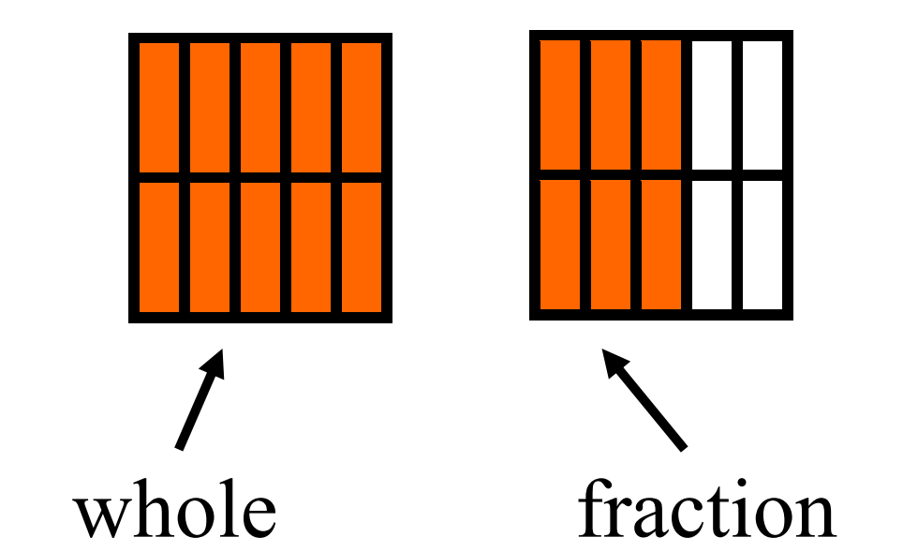

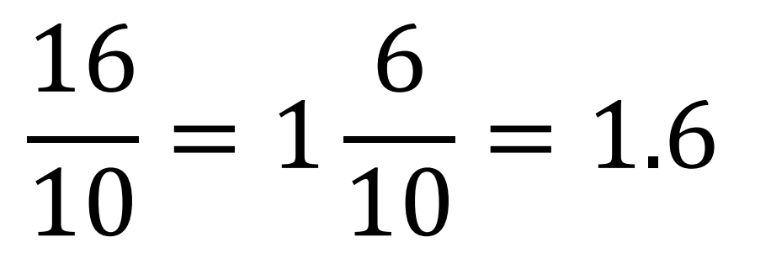

* The focus should be on determining equivalent decimals of fractions with denominators that are factors of 100, allowing students to make connections to tenths and hundredths (e.g., $\frac{2}{5}$ = $\frac{4}{10}=$ 0.4 and $\frac{7}{20}$ = $\frac{35}{100}$ = 0.35).

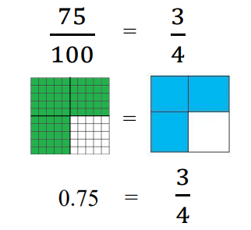

* There are repeating decimals and terminating decimals.
* Fractions such as $\frac{1}{3}$, whose decimal representation does not end (e. g., $\frac{1}{3}$ = 0.333…) are referred to as *repeating decimals*. A repeating decimal can be written with an ellipsis (three dots) as in 0.333… or denoted with a bar above the digits that repeat as in 0. $\overline{3}$.
* Decimals that have a finite number of digits (e.g., 0.25, 0.4) are referred to as terminating decimals.
* Proper fractions, improper fractions, and mixed numbers are terms often used to describe fractions. A proper fraction is a fraction whose numerator is less than the denominator. An improper fraction is a fraction whose numerator is equal to or greater than the denominator (e.g., $\frac{7}{4})$. An improper fraction may be expressed as a mixed number. A mixed number is written with two parts: a whole number and a proper fraction (e.g., 3 $\frac{5}{8}$).
* Strategies used for comparing and ordering fractions (proper and improper) and mixed numbers may include:
  + more than 1 whole
  + less than 1 whole
  + comparing fractions to familiar benchmarks (e.g., 0, $\frac{1}{2}$ , 1)
  + distance from or to 0, $\frac{1}{2}$, 1
  + determining equivalent fractions
  + using like denominators
  + using like numerators
* To help students compare the value of two decimals through thousandths, use manipulatives, such as place value mats/charts, 10-by-10 grids, decimal squares, base-ten blocks, meter sticks, number lines, and money.

###### Skills in Practice

While the five process goals are expected to be embedded in each standard, the Skills in Practice highlight the most prevalent process goals in relation to the content presented.

**Mathematical Representations:** Using context and physical models to help students understand equivalencies amongst and between fractions and decimals helps them to understand that fixed quantities can have multiple names. For example, a region/area model helps students visualize parts of the whole. A length/measurement model shows that there is always another fraction to be found between any two numbers. Some students can make sense of one representation, but not another. More importantly, students need to experience fraction and decimal contexts that are meaningful to them. These contexts may align well with one representation and not as well with another. For example, if students are being asked to determine who walked the farthest, a linear model is more likely to support their thinking than a region/area model.

* There are several models that define the wholes and their related parts. Using appropriate representations and different categories of models broaden and deepen students’ understanding of fractions and decimals.
* **Region/area model**: In a region/area model (e.g., fraction circles, pattern blocks, geoboards, grid paper, color tiles), the whole is continuous and divided or partitioned into parts with areas of equivalent value. The area of the defined region defines the whole. Equal area defines the parts. The fraction or decimal is defined as the part of the area covered as it relates to the whole unit. Region/area models for equivalent fractions have been provided below to support visualization of the model; however, it is important to note the parameters of this standard – represent equivalency between fractions (with denominators that are thirds, eighths, and factors of 100) and decimals.

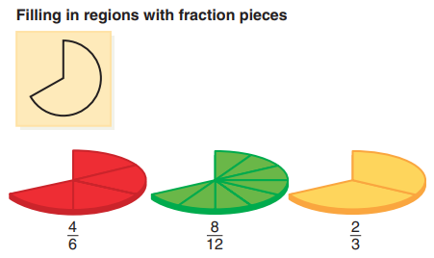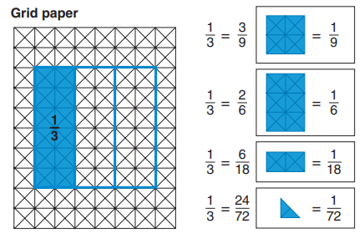

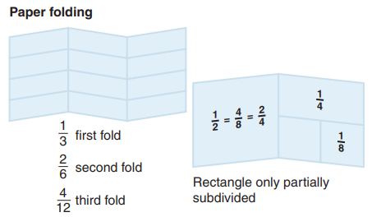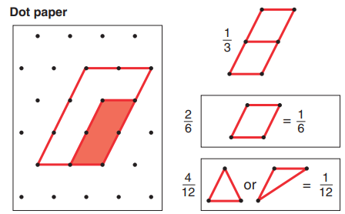

* **10 × 10 grid**: A 10 × 10 grid can be used to convert familiar fractions to decimals as shown below:

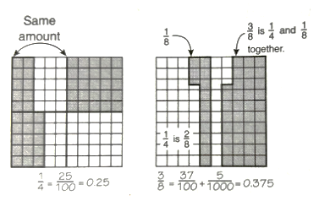

$\frac{1}{4}= \frac{25}{100}=0.25$ $\frac{3}{8}= \frac{37}{100}+\frac{5}{1000}=0.375$

* **Length/measurement model**: In a length/measurement model (e.g., fraction strips, rods, number lines, rulers), each length represents an equal part of the whole. On a number line, the unit of distance or length is what defines the whole. Equal distance or length defines the parts. The fraction or decimal is defined as the location of a point in relation to 0 and other values on the number line.
  + - Use number lines to compare the magnitude of fractions and decimals. Reinforce for students that fraction and decimal magnitude, like whole-number magnitude, is represented by how far to the right or left of zero a number is positioned. Help students compare fraction magnitude by locating “benchmark numbers,” starting with 0, $\frac{1}{2}$, and 1, when thinking of fractions between 0 and 1. Number lines have been provided below to support visualization of the model; however, it is important to note the parameters of this standard – represent equivalency between fractions (with denominators that are thirds, eighths, and factors of 100) and decimals.
    - Number lines can be used to demonstrate the pattern of unit fractions and their corresponding magnitude. The number lines below show the 0 - 1 portion of a number line partitioned into different size parts: halves, fourths, fifths, and eighths. Draw students’ attention to the unit fraction on each number line to help students see the relative magnitude of each unit fraction.

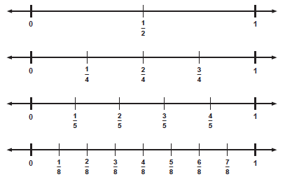

* + - To ensure that students do not assume that all fractions are less than one whole, expand the 0 - 1 segment to 0 - 2 to depict fractions equal to and greater than one. Show students that whole numbers can be represented as fractions and that similar fractions are located between other whole numbers. Discuss how fractions greater than one can be expressed in two ways: with a numerator that is larger than the denominator as in the first number line (improper fractions) and as a way to measure length, as in the second number line, which includes a whole number and a fraction less than one (mixed numbers). This comparison of numbers expands students’ ideas of fractions and measurement.

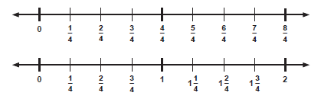

* + - Once students conceptually understand and can articulate that the point where a fraction is located on the number line represents the length of units from zero to that position, then the same teaching steps can be used to concretely introduce the concept of equivalent fractions (Model 1) and equivalent decimals (Model 2). Incorporate other linear representations demonstrating how two fractions with different denominators can be equivalent and occupy the same distance on the number line. Model 3 shows how Cuisenaire rods could be aligned with a number line to reinforce the equivalencies on a number line.

**Model 1**

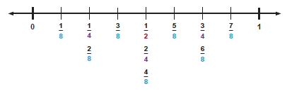

**Model 2**

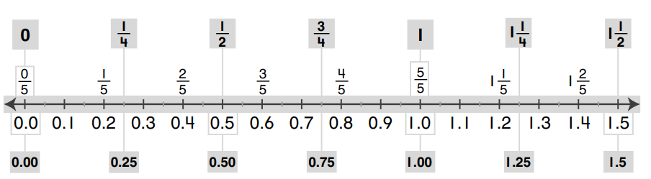

**Model 3**

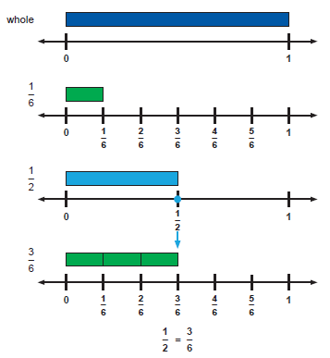

* + - Rods or paper strips can be used to designate both a whole and a part, as shown below –

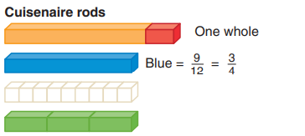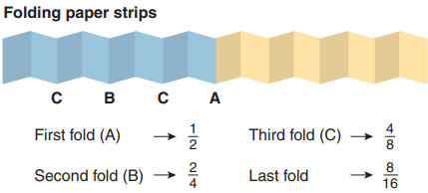

* + - The number line is a good model for helping students develop a better understanding of the relative size of a fraction. For example, if students think about where $\frac{3}{20}$ might be by partitioning a number line between 0 and 1, they will see that $\frac{3}{20}$ is close to 0, whereas $\frac{9}{10}$ is close to 1. Number lines should also go beyond 1, asking students to tell a nearby benchmark fraction — for example, explaining that $3\frac{3}{7}$ is almost $3\frac{1}{2}$. After students have experience with visuals, they should continue to reason about the relative size of fractions using mental strategies or creating their own visuals to reason about the fractions. Finally, comparing fractions can include finding fractions that fall between two given fractions. An important understanding about fractions is that there is always one more fraction between any two given numbers.
* **Set model:** In a set model (e.g., chips, counters, cubes), the whole is made up of discrete members of the set, where each member is an equivalent part of the set. In set models, the whole needs to be defined, and members of the set may have different sizes and shapes. Equal number of objects defines the parts. The fraction or decimal is defined as the count of objects in the subset as it relates to the defined whole. Set models have been provided below to support visualization of the model; however, it is important to note the parameters of this standard – represent equivalency between fractions (with denominators that are thirds, eighths, and factors of 100) and decimals.
  + - In set models, the whole is understood to be a set of objects, and subsets of the whole make up fractional parts. For example, 3 objects are one‐fourth of a set of 12 objects. The set of 12 in this example represents the unit, the whole or 1. The idea of referring to a collection of counters as a single entity makes set models difficult for some students. Putting a piece of yarn in a loop around the objects in the set to help students see the whole. The figures below show examples of set models for fractions.

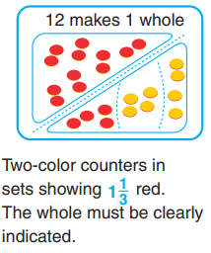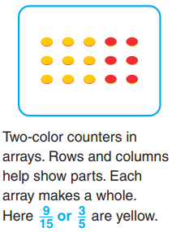

A common misconception with set models is to focus on the size of a subset rather than the number of equal sets in the whole. For example, if 12 counters make a whole, then a subset of 4 counters is one‐third, not one‐fourth, because 3 equal sets make the whole. However, the set model helps establish important connections with many real‐world uses of fractions.

**Mathematical Reasoning:** Teachers may explain why a fraction $\frac{a}{b}$ is equivalent to a fraction $\frac{(n × a)}{(n × b)}$ by using visual fraction models with attention to how the number and size of the parts differ even though the two fractions are the same size. Use this understanding and algorithm to recognize and generate equivalent fractions.

* Explanations why either multiplication or division is applied to find an equivalent fraction should begin with visual representations and then connect to the algorithm. For example –

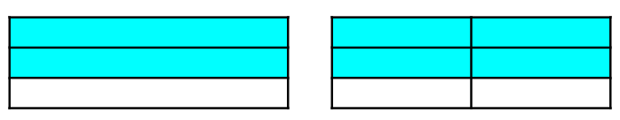

$\frac{2}{3}$ $\frac{(2 × 2)}{(2 × 3)}= \frac{4}{6}$

* There are multiple misconceptions that students may experience when working with fractions.
  + Students may believe that numbers with the most digits have the greatest value. For example, students would say that 0.478 is greater than 0.79 because 0.478 has three digits and 0.79 only has two digits. This is an incorrect application of whole-number reasoning (i.e., looking at the number beyond the decimal point and evaluating it as a whole number). Using a place value chart will help students to compare, as well as order numbers correctly.
  + Students may think that because the digits far to the right represent very small numbers, the longer numbers must be smaller. For example, students may state that 0.4 is larger than 0.95 because “tenths are larger than hundredths.”
  + Students may not transfer their understanding of regrouping whole numbers to decimals and fractions. For example, they may not recognize that 4 tenths are equivalent to 40 hundredths or 400 thousandths. This misconception causes students to believe that 0.4 is not close to 0.375 and/or that 0.3 is smaller than 0.30.

Each of these misconceptions reflects a lack of conceptional understanding of how decimals are constructed. Knowing these misconceptions in advance of instruction will help to develop questions that elicit discussions about the relative sizes of decimals.

* Make a list of four decimal numbers that are close, but not exactly equal to a familiar fraction equivalent (e.g., 1.57, 0.86, 3.128). Students must try to decide on a decimal number that is close to each of these decimals, and that also has a common fraction equivalent. For example, 6.59 is close to 6.6, which is $6\frac{3}{5}$. Students should then justify their reasoning for their choices. Students can select different equivalent fractions, providing for a discussion of which decimals are closer. Examples with common misconceptions follow:
* Circle the decimals that are equivalent to $\frac{2}{8}$. Justify your reasoning.

0.28 0.25 2.8 0.250 0.125

Some students may have the misconception that the numerator and denominator of a fraction are the same digits used in the decimal equivalent (e.g., .28 for $\frac{2}{8}$). These students may lack place value understanding (i.e., that .25 and .250 represent the same value). Place value understanding, recognizing the relationship between adjacent places in a numeral, is key to making sense of decimals. Decimal number sense should be the focus of instruction so that students can determine the reasonableness of their answers.

Students may benefit from using concrete models to build the understanding that a fraction is part of a whole and that a decimal is another way to represent a fraction. Concrete materials (e.g., fraction strips, hundred grids, meter sticks, base 10 blocks) can be used to model fractions and decimals, and to make comparisons and find equivalencies. These materials can also be used to help students develop decimal place value understanding.

* Circle the fractions and decimals that are equivalent to the fraction shaded in the model below.



$\frac{4}{10}$ 0.8 $\frac{45}{100}$ 0.45 $\frac{4}{5}$ 0.80

Students who lack a basic understanding of decimals will likely not choose 0.8 or 0.80 for this model and may choose 0.45 as an answer because there are 4 green parts and 5 total parts. These students may have had limited opportunities to make sense of decimals using various models and may find it difficult to connect this circle model with the same fraction represented in a hundred grid. Some strategies to support these students could be to use concrete models (e.g., base 10 blocks) when modeling fractions and decimals, and to show the relationship between hundredths and tenths.

* What is a number that could be placed in the blank to complete this set from least to greatest?

$\frac{2}{5}$, 0.5, ____, $\frac{6}{8}$

Students may experience difficulty with a problem like this because the numbers are all close to $\frac{1}{2}.$ Students can use a blank number line to order fractions and decimals. This will be helpful when it is time for them to determine the missing number in the set. When comparing and ordering fractions and decimals, students can defend their answer and the strategy they used. Whether they use a number line, models, benchmarks, or equivalent fractions, this can be helpful when they justify their answer. Using benchmark numbers (e.g., knowing that the number that they are finding must be greater than one-half) could be helpful when students determine their answer. They just need to make sure it is also less than the fraction that comes after the missing number in the set.

* Place the following fractions and decimals in order from least to greatest:

$$\frac{13}{3} 4\frac{4}{5} 4\frac{7}{8} 4.49$$

Students may have misconceptions about improper fractions. These misconceptions may include thinking that anything written in fraction form must be smaller than one whole. Use concrete or pictorial models to show the relationship between a mixed number and an improper fraction. Students will benefit from plenty of experiences using benchmarks and placing numbers on a number line that goes beyond one whole.

Students may have difficulty when trying to determine the order for 4 $\frac{4}{5}$ and 4 $\frac{7}{8}$ since both mixed numbers are one part away from the next whole. Students may think they are equivalent fractions. One strategy is to think about the size of the denominator in relation to the size of the missing piece. Use concrete materials, pictorial models and number lines. It may also be helpful to have students practice finding equivalent relationships with common denominators, with and without the use of models.

If students struggle with placing the decimal, it may help to have students think about what benchmark 4.49 is closest to (e.g., 4.00, 4.50, or 5.00). Relate to the equivalent fraction benchmarks (e.g., 4, 4 $\frac{1}{2}$, or 5). Provide students with opportunities to compare decimals using place value mats, base ten blocks, number lines, and 10 by 10 grids.

###### Concepts and Connections

Concepts

Exploring relationships between fractions and decimals and their representations provides meaning and structure and allows us to quantify, measure, and make decisions in life.

Connections

* *Within the grade level/course*:
  + 5.NS.2 – The student will demonstrate an understanding of prime and composite numbers, and determine the prime factorization of a whole number up to 100.
* *Vertical Progression*:
  + 4.NS.3 – The student will use mathematical reasoning and justification to represent, compare, and order fractions (proper, improper, and mixed numbers with denominators 12 or less), with and without models.
  + 4.NS.4 – The student will use mathematical reasoning and justification to represent, compare, and order decimals through thousandths with and without models.
  + 4.NS.5 – The student will reason about the relationship between fractions and decimals (limited to halves, fourths, fifths, tenths, and hundredths) to identify and represent equivalencies.
  + 6.NS.1 – The student will reason and use multiple strategies to express equivalency, compare, and order numbers written as fractions, mixed numbers, decimals, and percents.
  + 6.NS.2 – The student will reason and use multiple strategies to represent, compare, and order integers.

Across Content Areas [Theme – Numbers, Number Sense, and Patterns]

* *Computer Science:* 
  + 5.AP.1 – The student will apply computational thinking to identify patterns, make use of decomposition to break down problems or processes into sub-components, and design algorithms (a) identify patterns and repeated steps in an algorithm, problem, or process; and (b) decompose a problem or process into a subset of smaller problems or groups of sequential instructions.

###### Resources to Support Local Curriculum

* A list of approved textbooks and instructional materials is posted on the VDOE [website](https://www.doe.virginia.gov/teaching-learning-assessment/k-12-standards-instruction/mathematics/2024-mathematics-textbooks).

### 5.NS.2

##### The student will demonstrate an understanding of prime and composite numbers, and determine the prime factorization of a whole number up to 100.

1. Students will demonstrate the following Knowledge and Skills:
2. Given a whole number up to 100, create a concrete or pictorial representation to demonstrate whether the number is prime or composite, and justify reasoning.
3. Classify, compare, and contrast whole numbers up to 100 using the characteristics prime and composite.
4. Determine the prime factorization for a whole number up to 100.

###### Understanding the Standard

* Natural numbers are the counting numbers starting at one.
* A prime number is a natural number, other than one, that has exactly two different factors, one and the number itself.
* A composite number is a natural number that has factors other than one and itself.
* The number one is neither prime nor composite because it has only one set of factors and both factors are one.
* Multiplication can be represented using a dot (⋅) or symbol (×) (e.g., 56 ⋅ 32 or 56 × 32).
* The prime factorization of a number is a representation of the number as the product of its prime factors. For example, the prime factorization of 18 is 2 ⋅ 3 ⋅ 3. Prime factorization concepts can be developed by using factor trees. Students at this level are not expected to represent prime factorization using exponents.

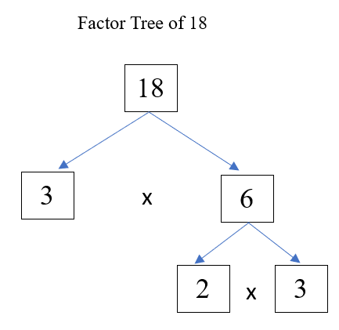

* Prime or composite numbers can be represented by rectangular models or rectangular arrays on grid paper.
* A prime number can be represented by only one rectangular array (e.g., seven can be represented by a 7 ⋅ 1 and a 1 × 7 array).

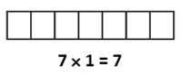

* A composite number can always be represented by two or more rectangular arrays of different size (e.g., nine can be represented by a 9 ⋅ 1 or a 3 ⋅ 3 array; six can be represented by a 1 ⋅ 6 or a 2 ⋅ 3 array).

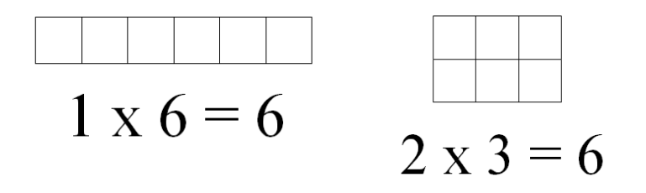

* To prove a number is prime or composite, use the characteristics of prime and composite numbers. Divisibility rules are also useful tools in identifying prime and composite numbers.
  + For a number greater than 2, if the number is even, it is a composite number.
  + If the number has a factor other than 1 and itself, it is a composite number.

###### Skills in Practice

While the five process goals are expected to be embedded in each standard, the Skills in Practice highlight the most prevalent process goals in relation to the content presented.

**Mathematical Communication:**

* Develop mathematical vocabulary including *factor, factor pair, multiple, odd, even, prime,* and *composite*. Identify prime numbers as numbers that have exactly two factors. Identify and describe composite numbers as numbers that have more than two factors.
* Students often confuse the terms *factor* and *multiple*. These terms are important to the development of the understanding of *prime factorization*. Emphasizing the term *factor* as one of the numbers multiplied to get a product throughout all of the work with multiplication, and expecting students to use that term accurately, should decrease confusion. Telling students that they multiply to get a multiple, or defining multiples of a number as products of the number is also beneficial to help strengthen students’ understanding. The more experience students have with these terms, the more accurate they will become when using these words.
* Students may become confused about whether 1 is a prime or composite number, when it is neither prime nor composite because it only has one factor – itself. Developing precise mathematically accurate definitions should help to eliminate this misconception.

**Mathematical Reasoning:**

* There are different ways to find prime numbers. For example –
* **Prime Number Chart:** A prime number chart is a chart that shows the list of prime numbers in a systematic order. It should be noted that all prime numbers are odd numbers except for the number 2, which is an even number. Help students make the connection that not all odd numbers are prime numbers. Remind students to identify prime numbers by their characteristics – numbers that have exactly two factors. For example, 15, 21, 25, 27, 35, 45, and 49 are all odd numbers but they are not prime numbers because they have more than two factors.

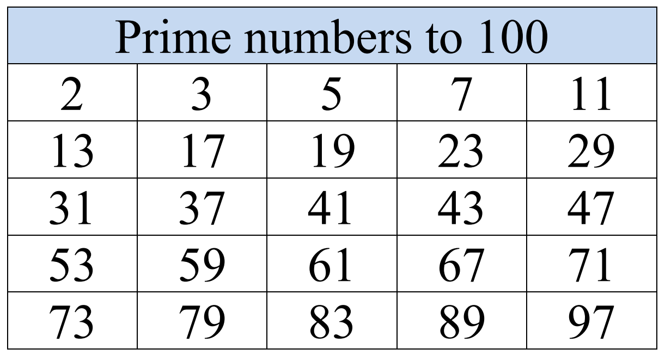

* **The Sieve of Eratosthenes** is an algorithm that helps to find prime numbers up to any given limit. For this standard, students are expected to determine whether a number up to 100 is prime or composite. The following figure shows the prime numbers up to 100. The uncrossed numbers in the figure represent the prime numbers that are left after using the Sieve of Eratosthenes.

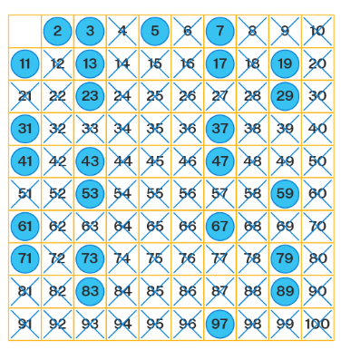

The following steps describe how to find all the prime numbers up to 100 using the Sieve of Eratosthenes:

* Step 1: Create a list of numbers from 2 to 100 (leave out the number 1 because all prime numbers are greater than 1).
* Step 2: Start from the first number 2 on the list. Cross out each number that is a multiple of 2 except the number 2. For example, cross out 4, 6, 8, 10, and so on up to 100.
* Step 3: Move to the next uncrossed number (3). Cross out each number that is a multiple of 3 except the number 3. For example, cross out 6, 9, 12, and so on up to 100. This will include some multiples that have already be crossed out (e.g., 6, 12, 18).
* Step 4: Move to the next uncrossed number (5). Cross out each number that is a multiple of 5 except the number 5. This will include some multiples that are already crossed out (e.g., 10, 15, 20). Cross out the remaining multiples up to 100.
* Step 5: Move to the next uncrossed number (7). Cross out each number that is a multiple of 7 except the number 7. As with previous numbers, this will include a few multiples that are already crossed (e.g., 49). After this step, students will be left with only prime numbers.
* To determine if a number is composite, find the factors of the given number. If the number has factors other than one and itself, it is composite. One way to determine if a number is composite is to perform a divisibility test. Divisibility testing (or applying divisibility rules) helps to determine whether a number is a prime or a composite number. Divisibility means that a number is divided completely (with no remainder) by another number, other than 1 and itself. *Divisibility tests (rules) are explained in greater detail in Mathematical Connections.*

**Mathematical Representations:**

* Prime and composite numbers can be represented by rectangular models or rectangular arrays on grid paper. A prime number can be represented by only one rectangular array. A composite number can be represented by two or more rectangular arrays of different configurations.
* Examples of rectangular models or arrays of prime numbers –

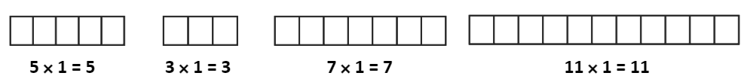

* Examples of rectangular models or arrays of composite numbers –

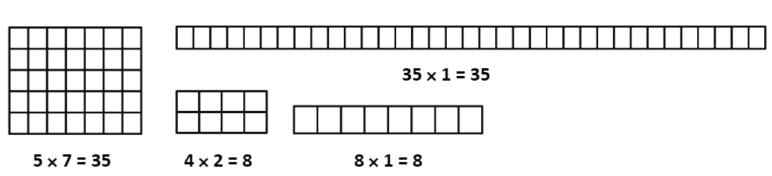

* As students determine whether a number is prime or composite, students must also justify their reasoning. Examples with misconceptions follow –
* Draw a model that shows 7 is a prime number. Explain your thinking.

If a student is unable to answer this question correctly, they may not have a concrete or pictorial understanding of prime and composite numbers. Students should be able to demonstrate and have practice representing these numbers using models. Students can practice by creating a rectangular model or rectangular array on grid paper. Prime numbers can be represented by only one array while composite numbers can be shown with two or more arrays.

* Draw a model that shows 12 is a composite number. Explain your thinking.

Similar to the previous question about a prime number, if students are unable to answer this question correctly, they may not have a concrete or pictorial understanding of prime and composite numbers. Students may benefit from using tiles to create arrays and determining the factors of numbers before transitioning to grid paper or other pictorial representations of arrays.

* Model prime factorization for numbers 1 – 100 using factor trees. As students create these models, be sure to note the multiple ways in which a number can be represented yet will still *yield the same prime factorization*. For example, consider the following two ways to factor the number 24 –

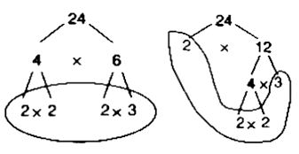

**Mathematical Connections:** Students should make connections to multiplication and division facts to determine the factors of a given number. The intentional use of timed activities such as flash cards and/or supplemental handouts to support automaticity connects concepts learned in Grades 3 and 4 to the number sense needed to classify and compare whole numbers up to 100 using the characteristics prime and composite.

* **Prime factorization** is the process of writing a number as the product of prime numbers. Students should make the connection that when prime numbers are multiplied to obtain the original number, it is defined as the prime factorization of the number. Applying divisibility tests (rules) helps students to determine the prime factorization of composite numbers. For example, the number 40 is divisible by 2 because it ends in 0. Applying this understanding, 40 can be divided by 2 to obtain 20. The number 20 is also divisible by 2 because it ends in 0, resulting in 10 using the same application and so on. The prime factorization of 40 can be done in the following way:

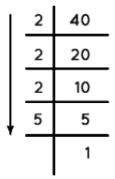

The prime factorization of 40 = 2 × 2 × 2 × 5.

* Divisibility means that a number is divided completely (with no remainder) by another number, other than 1 and itself. **Divisibility tests** (rules) help students determine whether a number is prime or composite while giving students the ability to break down numbers with automaticity.

To perform a divisibility test, students should check to see if the number can be divided by these factors: 2, 3, 5, 7, 11, and 13. If the given number is even, start checking with the number 2. If the number ends with a 0 or 5, check it with the number 5. If the number cannot be divided by any of these given numbers, the number is a prime number. For example, 28 is divisible by 2, which means it has factors other than 1 and 28 (its factors are 1, 2, 4, 7, 14, and 28) so, we can say 28 is a composite number. The divisibility rule of 1 is not required since every number is divisible by 1. For example –

| **Divisibility by Number** | **Divisibility Rule** |
| --- | --- |
| Divisible by 2 | If a number is even or a number whose last digit is an even number (i.e., 0, 2, 4, 6, and 8), the number is divisible by 2. |
| Divisible by 3 | If the sum of all the digits in the number is divisible by 3, the number is divisible by 3. |
| Divisible by 4 | If the number formed by the last two digits of the number is divisible by 4 (or is 00), the number is divisible by 4. |
| Divisible by 5 | If the number has 0 or 5 as the digit in the ones place, the number is divisible by 5. |
| Divisible by 6 | If a number is divisible by both 2 and 3, the number is divisible by 6. |
| Divisible by 7 | If subtracting twice the last digit of the number from the remaining digits gives a multiple of 7, the number is a divisible by 7. |
| Divisible by 8 | If the number formed by the last three digits of the number divisible by 8 (or is 000), the number is divisible by 8. |
| Divisible by 9 | If the sum of all the digits of the number is divisible by 9, the number is divisible by 9. |
| Divisible by 10 | If the number has a 0 in the ones place, the number is divisible by 10. |
| Divisible by 11 | If the difference of the sums of the alternative digits of a number is divisible by 11, the number is divisible by 11. |
| Divisible by 12 | If a number that is divisible by both 3 and 4, the number is divisible by 12. |

###### Concepts and Connections

Concepts

Exploring relationships between fractions and decimals and their representations provides meaning and structure and allows us to quantify, measure, and make decisions in life.

Connections

* *Within the grade level/course*:
  + 5.NS.1 – The student will use reasoning and justification to identify and represent equivalency between fractions (with denominators that are thirds, eighths, and factors of 100) and decimals; and compare and order sets of fractions (proper, improper, and/or mixed numbers having denominators of 12 or less) and decimals (through thousandths).
  + 5.CE.2a – Determine the least common multiple of two numbers to find the least common denominator for two fractions.
* *Vertical Progression*:
  + 2.NS.1hij – h) Represent even numbers (up to 50) with concrete objects, using two equal groups or two equal addends. i) Represent odd numbers (up to 50) with concrete objects, using two equal groups with one leftover or two equal addends plus 1. j) Determine whether a number (up to 50) is even or odd using concrete objects and justify reasoning (e.g., dividing collections of objects into two equal groups, pairing objects).
  + 4.CE.2e –Determine all factor pairs for a whole number 1 to 100, using concrete, pictorial, and numerical representations.
  + 8.NS.2 – The student will investigate and describe the relationship between the subsets of the real number system.

Across Content Areas

Reference 5.NS.1.

###### Resources to Support Local Curriculum

* A list of approved textbooks and instructional materials is posted on the VDOE [website](https://www.doe.virginia.gov/teaching-learning-assessment/k-12-standards-instruction/mathematics/2024-mathematics-textbooks).
* Finding the Parts: Prime Factorization Mathematics Instructional Plan ([Word](https://www.doe.virginia.gov/home/showpublisheddocument/51813/638507500464700000) | [PDF](https://www.doe.virginia.gov/home/showpublisheddocument/51815/638507500834930000))

## Computation and Estimation

In K-12 mathematics, computation and estimation are integral to developing mathematical proficiency. Computation refers to the process of performing numerical operations, such as addition, subtraction, multiplication, and division. It involves applying strategies and algorithms to solve arithmetic problems accurately and efficiently. Estimation is the process of obtaining a reasonable or close approximation of a result without performing an exact calculation. Estimation is particularly useful when an exact answer is not required, especially in real-world situations, and when assessing the reasonableness of an answer. Computation and estimation are used to support problem solving, critical thinking, and mathematical reasoning by providing students with a range of approaches to solve mathematics problems quickly and accurately.

In Grade 5, the operations of addition, subtraction, multiplication, and division, and estimation, allow us to model, represent, and solve different types of problems with whole number and positive rational numbers (not including integers). At this grade level, students estimate, represent, solve, and justify solutions to single-step and multistep contextual problems using addition, subtraction, multiplication, and division with whole numbers. Students will add and subtract fractions with like and unlike denominators, and solve single-step and multistep contextual problems. Students will solve single-step contextual problems involving multiplication of a whole number and a proper fraction. Further, students will add, subtract, multiply, and divide with decimal numbers and solve single-step multistep contextual problems. Lastly, students will simplify whole number numerical expressions using the order of operations.

It is critical at this grade level that while students build their conceptual understanding through concrete and pictorial representations, that students also apply standard algorithms when performing operations as specified within the parameters of each standard of this strand. At this grade level, students become more efficient with problem solving strategies. Fluent use of standard algorithms not only depends on automatic retrieval (automaticity learned from first through fourth grade) but also reinforces them. Practice provides the foundation allowing students the ability to achieve mathematically accurate and systematic use of basic skills at a reasonably quick pace – freeing up working memory to solve complex problems in later grades. Automaticity further grounds students’ entry points and the structures needed to solve contextual problems and execute mathematical procedures with positive rational numbers.

### 5.CE.1

##### The student will estimate, represent, solve, and justify solutions to single-step and multistep contextual problems using addition, subtraction, multiplication, and division with whole numbers.

1. Students will demonstrate the following Knowledge and Skills:
2. Estimate the sum, difference, product, and quotient of whole numbers in contextual problems.
3. Represent, solve, and justify solutions to single-step and multistep contextual problems by applying strategies (e.g., estimation, properties of addition and multiplication) and algorithms, including the standard algorithm, involving addition, subtraction, multiplication, and division of whole numbers, with and without remainders, in which:
   1. sums, differences, and products do not exceed five digits;
   2. factors do not exceed two digits by three digits;
   3. divisors do not exceed two digits; or
   4. dividends do not exceed four digits.
4. Interpret the quotient and remainder when solving a contextual problem.

###### Understanding the Standard

* In problem solving, emphasis should be placed on thinking and reasoning rather than on key words. Focusing on key words such as *in all, altogether, difference,* etc.,encourages a particular operation rather than make sense of the context of the problem. A keyword focus leads to solving a limited set of problems and often leads to incorrect solutions as well as challenges in upcoming grades and courses.
* The problem-solving process is enhanced by modeling contextual problems using acting out, charts, number lines, manipulatives, drawings, and bar diagrams.
* Bar diagrams serve as a model that can provide ways to visualize, represent, and understand the relationship between known and unknown quantities and can be used to solve problems. Four examples of bar diagrams are shown below:

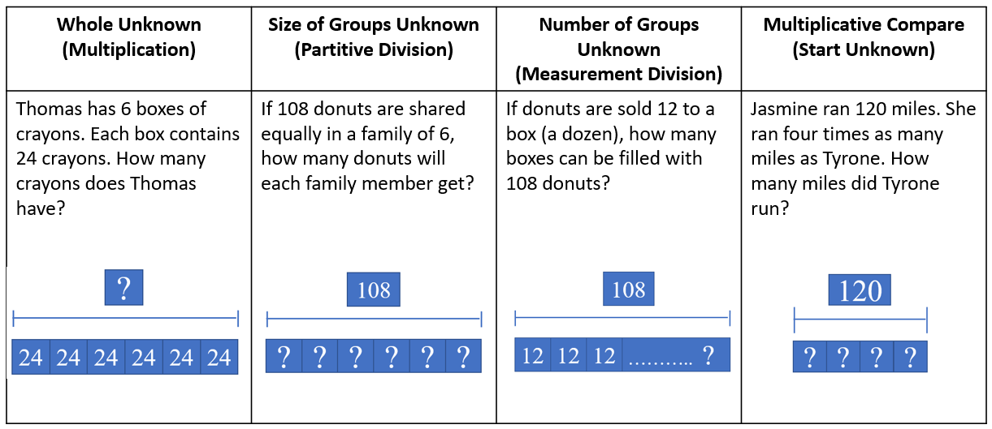

* Estimation skills are valuable, time-saving tools, particularly in practical situations when exact answers are not required, and can be used in determining the reasonableness of the sum or difference when solving for the exact answer.
* An estimate is a number that lies within a range of the exact solution, and the estimation strategy used in a particular problem determines how close the estimate is to the exact solution. Estimates involve using friendlier numbers to mentally compute a reasonable answer before any exact computation is calculated.
* Students should explore reasons for estimation, using practical experiences, and using various estimation strategies to solve contextual problems. Estimation strategies include rounding, using compatible numbers, and front-end estimation.
* When estimating, students should consider whether it is important that the estimate is greater than or less than the exact answer. In the following examples using the same addends, each estimation strategy results in a different sum, so opportunities should be given to examine the context and the demand for precision when deciding which estimation strategy to use.
  + Rounding numbers is one estimation strategy and may be introduced using a number line. When given a number to round, use multiples of ten, hundred, thousand, ten thousand, or hundred thousand as benchmarks and use the nearest benchmark value to represent the number. For example, using rounding to the nearest hundred to estimate the sum of 255 + 481 would result in 300 + 500 = 800.
  + Using compatible numbers is another estimation strategy. Compatible numbers are pairs of numbers that are easy to add and subtract mentally. For example, using compatible numbers to estimate the sum of 255 + 481 could result in 250 + 450 = 700.
  + Using front-end estimation is another estimation strategy. Front-end estimation involves truncating numbers to the highest place value to compute. For example, using front-end estimation to estimate the sum of 255 + 481 would result in 200 + 400 = 600.
* Students would benefit from hearing the estimation strategies of other classmates and from discussions about how different estimation strategies produce different answers (e.g., rounding numbers may produce an estimate closer to the actual answer than using front-end estimation).
* When an exact answer is required, opportunities to explore whether the answer can be determined mentally or must involve paper and pencil, or calculators help students select the most efficient approach.
* Give opportunities to explore and apply the properties of addition and multiplication as strategies for solving addition, subtraction, multiplication, and division problems using a variety of representations (e.g., manipulatives, diagrams, symbols).
* The properties of the operations are “rules” about how numbers work and how they relate to one another. Formal terms for these properties are not expected at this grade level, but utilization of these properties develops further flexibility and fluency in solving problems. The following properties are most appropriate for exploration at this level:
  + The commutative property of addition states that changing the order of the addends does not affect the sum (e.g., 4 $+$ 3 = 3 $+$ 4). Similarly, the commutative property of multiplication states that changing the order of the factors does not affect the product (e.g., 2 $×$ 3 = 3 $×$ 2).
  + The identity property of addition states that if zero is added to a given number, the sum is the same as the given number (e.g., 4 + 0 = 4). The identity property of multiplication states that if a given number is multiplied by one, the product is the same as the given number (e.g., 7 × 1 = 7).
  + The associative property of addition states that the sum stays the same when the grouping of addends is changed (e.g., 15 + (35 + 16) = (15 + 35) + 16).
  + The distributive property states that multiplying a sum by a number gives the same result as multiplying each addend by the number and then adding the products. Several examples of the distributive property are shown below:
* 3(9) = 3(5 + 4) = (3 × 5) + (3 × 4) = 15 + 12 = 27
* 3(54 + 4) = (3 × 54) + (3 × 4) = 162 + 12 = 174
* 5 × (3 + 7) = (5 × 3) + (5 × 7) = 15 + 35 = 50
* (2 × 3) + (2 × 5) = 2 × (3 + 5) = 2 × 8 = 16
* 9 × 23 = 9(20 + 3) = 180 + 27 = 207
* The distributive property can be used to illustrate the multiplication algorithm, as shown in the two examples below.

8 × 34 = 8 (30 + 4)

= (8 × 30) + (8 × 4)

= 240 + 32

= 272

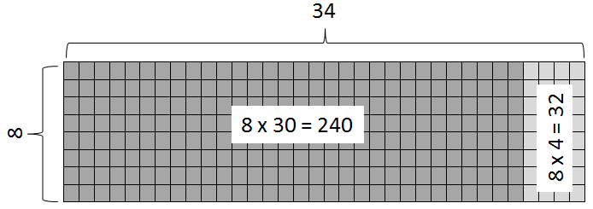

12 × 23 = (10 + 2) × (20 + 3)

= 10 (20 + 3) + 2 (20 + 3)

= (10 × 20 + 10 × 3) + (2 × 20 + 2 × 3)

= 200 + 30 + 40 + 6

= 276

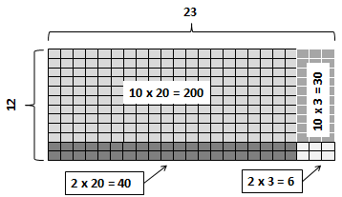

* Dividing by zero is undefined because it always leads to a contradiction. As demonstrated below, there is no single defined number possibility for dividing by 0, since zero multiplied by any number is zero:

12 ÷ 0 = r → r · 0 = 12

* Extensive research has been undertaken over the last several decades regarding different problem types. Many of these studies have been published in professional mathematics education publications using different labels and terminology to describe the varied problem types.
* Opportunities to experience a variety of problem types related to multiplication and division should be given. Examples are included in the chart below:

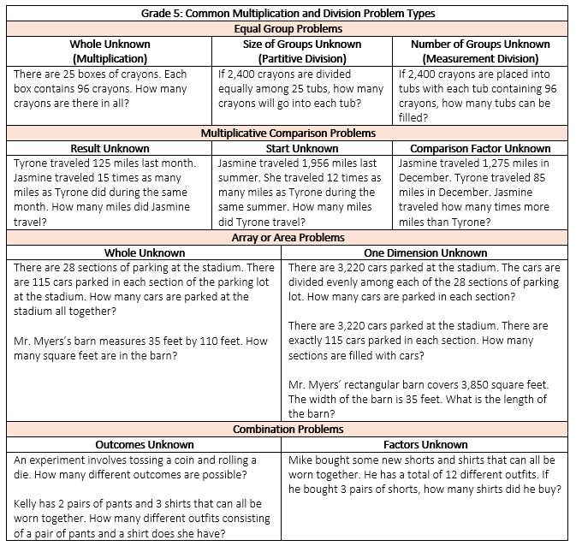

* Students need exposure to various types of contextual division problems in which they must interpret the quotient and remainder based on the context. The chart below includes an example of each type of problem.

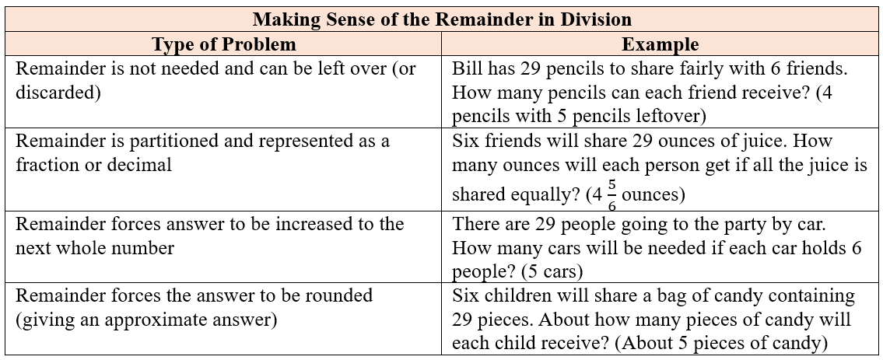

###### Skills in Practice

While the five process goals are expected to be embedded in each standard, the Skills in Practice highlight the most prevalent process goals in relation to the content presented.

**Mathematical Problem Solving:** When solving contextual problems, especially those that require multiple steps to solve, students may have difficulty approaching the problem and determining what operations are needed to solve the problem. Exposing students to a variety of problem types that require different operations to solve (see the chart “Multiplication and Division Problem Types” in Understanding the Standard) will help students become more comfortable with problem solving. In Grade 4, students began solving contextual division problems that included a remainder. It is important for students to have experience with types of problems that require the remainder to be interpreted in different ways as they solve more complex contextual problems in Grade 5 (see the chart “Making Sense of the Remainder in Division” in Understanding the Standard).

* An estimate is a number that lies within a range of the exact solution, and the estimation strategy used in a particular problem determines how close the estimate is to the exact solution. Estimates involve using friendlier numbers to mentally compute a reasonable answer before any exact computation is calculated. When estimating, students should consider whether it is important that the estimate is greater than or less than the exact answer. Opportunities should be given to examine the context and the demand for precision in deciding which estimation strategy to use. Reference the Understanding the Standards portion of this standard to review forms of estimation.
* As referenced in Grades 1-4, automatic retrieval of facts (automaticity) allows students more mental energy to devote to relatively complex mathematical tasks and execute multistep mathematical procedures. Thus, building automatic fact retrieval in students is one (of many) important goal when engaging in problem solving. Computational fluency is the ability to think flexibly in order to choose appropriate strategies to solve problems accurately and efficiently. The development of computational fluency relies on quick access to number facts. The patterns and relationships that exist in the facts can be used to learn and retain the facts. By studying patterns and relationships, students build a foundation for fluency with facts for all operations in order to transfer to the standard algorithm.
* Problem solving requires both an ability to correctly define a problem and find a solution to it. Model effective practices that demonstrate for students how to arrive at their solutions through estimation, exactness, and justification. To unpack contextual problems, guide students through the problem-solving process by taking care to annotate *essential vocabulary* (not “key words”) related to applied operations. For example –
  + Understand the problem by reading and then re-reading the problem; imagining the problem or drawing a picture; underlining or highlighting the important information and essential vocabulary within the problem.
  + Create a plan by deciding what to do and how to solve the problem using the applicable operation(s).
  + Carry out the plan by showing all work to represent thinking (e.g., using symbols, words, concrete manipulatives, pictorial representations).
  + Check the solution by determining if the solution answers the question asked in the contextual problem. During this phase of problem solving, it is essential that students are exposed to strategies that allow them to determine the reasonableness of their responses and solutions; and to support multiple mathematically sound and accurate ways of arriving at a solution.
  + Graphic organizers such as the four-square model (Polya method) can help students to organize their thinking as they solve contextual problems –

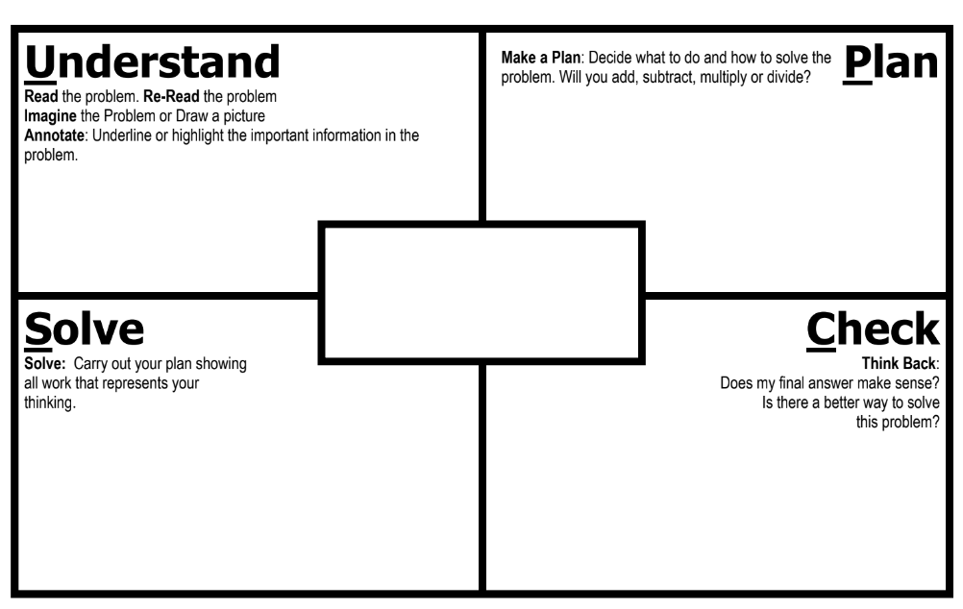

* As students solve contextual problems, ask questions such as –
  + Are there multiple ways to solve a single problem?
  + How do you know that you have provided a reasonable answer?
  + What role does estimation play in solving contextual problems?

**Mathematical Communication:** Teach students a solution method for solving each problem type. Introduce a solution method using a worked-out example. Talk through the problem-solving process and connect the relevant problem information to the worked-out example. Say out loud the decisions that were made to solve the problem at each step. Then demonstrate how to apply the solution method by solving a similar problem with students using that method. Discuss each decision made and ask students guiding questions to engage them as problems are solved.

**Mathematical Reasoning:** Solving problems in contextual situations enhances proficiency with estimation strategies. Reasoning skills are essential for solving problems effectively and strategically. Reasoning involves analyzing information, identifying assumptions, evaluating evidence, and drawing logical conclusions. When solving problems in context, students may have difficulty understanding which operation(s) to use and may use the wrong operation(s) when solving. Students may not realize that all numbers in a contextual problem are not always needed. To help students derive meaning of which operation to apply, ask students how thinking about the meaning of addition can help when solving word problems. Give students a chance to explain individually and share their thoughts with each other. Repeat this process for subtraction, multiplication, and division. *Have students explain the action of the word to move away from a reliance on “key words.”* For example –

* Addition:
  + Finding the total quantity of separate quantities
  + Combining two or more quantities
* Subtraction:
  + Finding how much more or how much less
  + Finding how much further
  + Finding the difference between two quantities
  + Determining a quantity when taking one amount from another
* Multiplication:
  + Finding the quantity needed for *x* number of people or *x* number of something
  + Having equal groups and finding the total of all groups
  + Finding a part (fraction) of a whole number
  + Taking a part of a part (fraction of a fraction)
* Division:
  + Dividing an item (or quantity) into equal sized pieces
  + Dividing a quantity into equal groups
  + Using an equal amount of something over time
  + Determining how many fractional groups can be made from a quantity

As students begin to solve computation problems with larger numbers, estimation is an important strategy that students can use to determine an approximate answer prior to solving, and to verify the reasonableness of a solution after solving. There are many ways to estimate, and students should have experiences estimating products and quotients in multiple ways (e.g., rounding, using compatible numbers). Students would benefit from hearing the estimation strategies of other classmates and from discussions about how different estimation strategies produce different answers (e.g., rounding numbers may produce an estimate closer to the exact answer than using front-end estimation).

**Mathematical Connections:** Students must connect fluency of facts, concepts, procedures, and mathematical language through mathematical reasoning to effectively solve contextual problems. Fluency with rational numbers at this grade level will help with improving logical reasoning skills, which will then lend themselves to solving contextual problems.

* As students recall multiplication and division facts with automaticity from previous grade levels, they should have experience using a variety of strategies and representations (e.g., partial products, friendly numbers, repeated addition, decomposition strategies). The exploration of multiple strategies and the connections between them help students become automatic with multiplication and division facts.

Provide systematic instruction to develop students’ understanding of mathematical ideas. For some students, the standard division algorithm is difficult because of the many steps involved in the procedure. Some students focus on individual digits when dividing rather than thinking about the whole number. Other students may ignore the place value of the number. To help students, remind them to describe both the place value as they divide and the place value of the digits in the quotients. Providing graph (or grid) paper will help students organize their work.

###### Concepts and Connections

Concepts

The operations of addition, subtraction, multiplication, and division, and estimation, allow us to model, represent, and solve different types of problems with whole numbers and positive rational numbers.

Connections

* *Within the grade level/course*:
  + 5.CE.2 – The student will estimate, represent, solve, and justify solutions to single-step and multistep problems, including those in context,

using addition and subtraction of fractions with like and unlike denominators (with and without models) and solve single-step contextual problems involving multiplication of a whole number and a proper fraction, with models.

* + 5.CE.3 – The student will estimate, represent, solve, and justify solutions to single-step and multistep problems, including those in context, using addition, subtraction, multiplication, and division with decimal numbers.
* *Vertical Progression*:
  + 4.CE.1 – The student will estimate, represent, solve, and justify solutions to single-step and multistep problems, including those in context, using addition and subtraction with whole numbers.
  + 4.CE.2 – The student will estimate, represent, solve, and justify solutions to single-step and multistep problems, including those in context, using multiplication with whole numbers, and single-step problems, including those in context, using division with whole numbers.
  + 4.CE.3 – The student will estimate, represent, solve, and justify solutions to single-step problems, including those in context, using addition and subtraction of fractions (proper, improper, and mixed numbers with like denominators of 2, 3, 4, 5, 6, 8, 10, and 12), with and without models; and solve single-step contextual problems involving multiplication of a whole number (12 or less) and a unit fraction, with models.
  + 4.CE.4 – The student will estimate, represent, solve, and justify solutions to single-step and multistep problems, including those in context, using addition and subtraction of decimals through the thousandths, with and without models.
  + 6.CE.1 – The student will estimate, demonstrate, solve, and justify solutions to problems using operations with fractions and mixed numbers, including those in context.
  + 6.CE.2 – The student will estimate, demonstrate, solve, and justify solutions to problems using operations with integers, including those in context.

###### Resources to Support Local Curriculum

* A list of approved textbooks and instructional materials is posted on the VDOE [website](https://www.doe.virginia.gov/teaching-learning-assessment/k-12-standards-instruction/mathematics/2024-mathematics-textbooks).

### 5.CE.2

##### The student will estimate, represent, solve, and justify solutions to single-step and multistep problems, including those in context, using addition and subtraction of fractions with like and unlike denominators (with and without models), and solve single-step contextual problems involving multiplication of a whole number and a proper fraction, with models.

1. Students will demonstrate the following Knowledge and Skills:
2. Determine the least common multiple of two numbers to find the least common denominator for two fractions.
3. Estimate and determine the sum or difference of two fractions (proper or improper) and/or mixed numbers, having like and unlike denominators limited to 2, 3, 4, 5, 6, 8, 10, and 12 (e.g., $\frac{5}{8}$ + $\frac{1}{4}$, $\frac{4}{5}$ − $\frac{2}{3}$, 3 $\frac{3}{4}$ + 2 $\frac{5}{12}$), and simplify the resulting fraction.*
4. Estimate and solve single-step and multistep contextual problems involving addition and subtraction with fractions (proper or improper) and/or mixed numbers having like and unlike denominators, with and without models. Denominators should be limited to 2, 3, 4, 5, 6, 8, 10, and 12. Answers should be expressed in simplest form.
5. Solve single-step contextual problems involving multiplication of a whole number, limited to 12 or less, and a proper fraction (e.g., 9 × $\frac{2}{3}$, 8 × $\frac{3}{4}$), with models. The denominator will be a factor of the whole number and answers should be expressed in simplest form.*

* On the state assessment, items measuring this objective are assessed without the use of a calculator.

###### Understanding the Standard

* Students should have exposure to a variety of representations of fractions, both concrete and pictorial (e.g., fraction bars, fraction circles, length models, area models, set models).
* Fractions can have five different meanings or interpretations: part-whole, division, measurement, ratio, and operator. In prior grades, students engaged with fractions as a numerical way of representing part of a whole region (area model), part of a group (set model), or part of a length (measurement model). In Grade 6, the ratio and operator interpretations will be introduced.
* When working with fractions, the whole must be defined.
* A unit fraction is a fraction in which the numerator is one.
* Proper fractions, improper fractions, and mixed numbers are terms often used to describe fractions. A proper fraction is a fraction whose numerator is less than the denominator. An improper fraction is a fraction whose numerator is equal to or greater than the denominator. An improper fraction may be expressed as a mixed number. A mixed number is written with two parts: a whole number and a proper fraction (e.g., $3\frac{5}{8}$).
* Estimation skills are valuable, time-saving tools that help students focus on the meaning of the numbers and operations, encourage reflective thinking, and help build informal number sense with fractions. Reasoning with benchmarks provides students with an opportunity to estimate without using an algorithm. Estimation can be used to check the reasonableness of an answer.
* Reasonable estimates to problems involving addition and subtraction of fractions can be established by using benchmarks such as 0, $\frac{1}{2}$, and 1. For example, $\frac{3}{5}$ and $\frac{4}{5}$ are both greater than $\frac{1}{2}$, so their sum is greater than 1.
* Students should explore reasons for estimation, using practical experiences, and use various estimation strategies to solve contextual problems. Estimation strategies include rounding, using compatible numbers, and front-end estimation.
* When estimating, students should consider whether it is important that the estimate is greater than or less than the exact answer. Students should be encouraged to examine the context and the demand for precision in deciding which estimation strategy to use.
* Students would benefit from hearing the estimation strategies of other classmates and from discussions about how different estimation strategies produce different answers (e.g., rounding numbers may produce an estimate closer to the actual answer than using front-end estimation).
* Fractions having like denominators have the same meaning as fractions having common denominators.
* Instruction involving addition and subtraction of fractions should include experiences with proper fractions, improper fractions, and mixed numbers as addends, minuends, subtrahends, sums, and differences.
* To add or subtract fractions and mixed numbers that do not have the same denominator, first find equivalent fractions with the least common denominator. The least common denominator (LCD) of two or more fractions is the least common multiple (LCM) of the denominators. Then add or subtract and write the answer in simplest form.
* The product of the number and any natural number is a multiple of the number. The least common multiple (LCM) of two or more numbers is the lowest number that is a multiple of all the given numbers. For example, the least common multiple of 12 and 18 is 36.

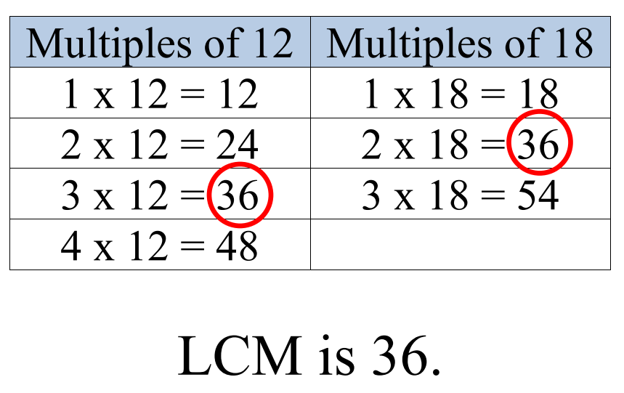

* Addition and subtraction with fractions and mixed numbers can be modeled using a variety of concrete and pictorial representations.
  + Addition of Mixed Numbers with Regrouping

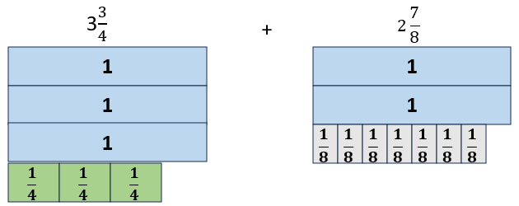

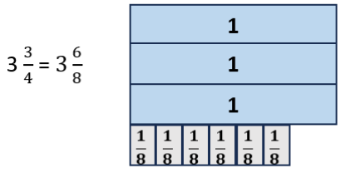

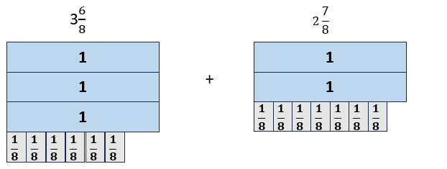

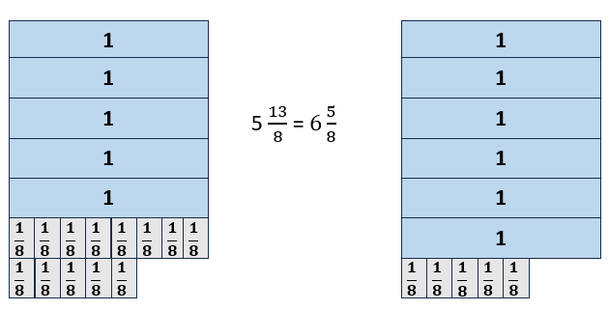

* + Subtraction of Mixed Numbers with Regrouping

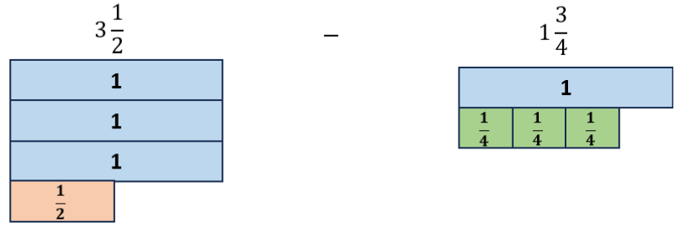

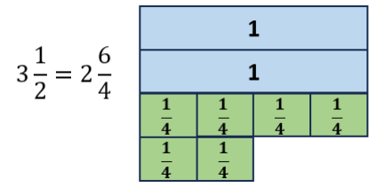

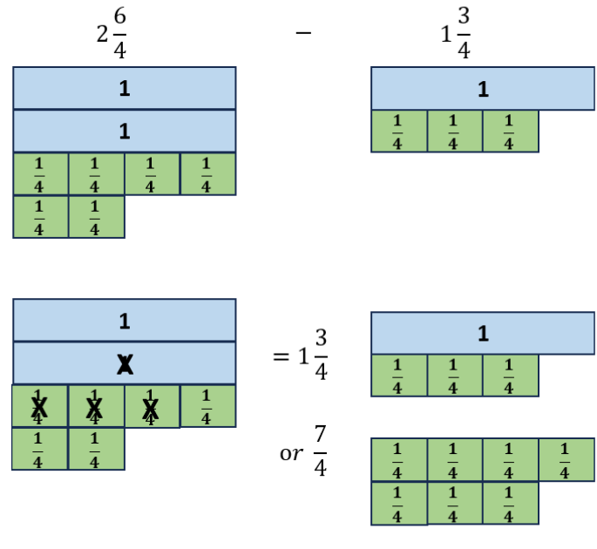

* Common multiples and common factors can be useful when simplifying fractions.
* Equivalent fractions are ways of describing the same quantity, the difference being in how the same size whole is partitioned. Simplifying fractions is finding the equivalent fraction with the fewest partitions represented in the denominator (e.g., $\frac{14}{12}$ can be simplified to $\frac{7}{6}$ because they are equivalent fractions and there are fewer partitions represented in the denominator. Each sixth is composed of two twelfths).
* A fraction is expressed in simplest form (simplest equivalent fraction) when the numerator and denominator have no common factors other than one. The numerator can be greater than the denominator.
* A factor is a number that divides evenly into another number, leaving no remainder. In other words, if multiplying two whole number[s](https://www.splashlearn.com/math-vocabulary/number-sense/whole-numbers) gives us a product, then the numbers we are multiplying are factors of the product because the product is divisible by the factors.
* A common factor of two or more numbers is a divisor that all of the numbers share.
* The greatest common factor (GCF), of two or more numbers is the largest of the common factors that all of the numbers share. Students previously worked with factors and GCF in Grade 4.
* One way to simplify a fraction is by modeling an equivalent fraction. Another way is to divide the numerator and denominator by their greatest common factor (GCF). This is the same as dividing by one whole (e.g., $\frac{75}{100}$ can be simplified to $\frac{3}{4}$ by dividing both the numerator and the denominator by 25).

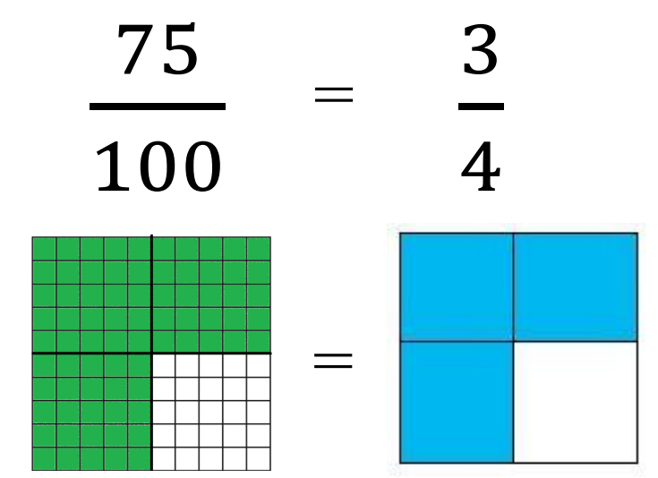

* Models for representing multiplication of fractions may include arrays, paper folding, repeated addition, fraction strips or rods, pattern blocks, or area models.
* In Grade 4, students began exploring multiplication with fractions by solving problems that involve a whole number and a unit fraction.
* When multiplying a whole number by a fraction such as 6 × $\frac{1}{2}$, the meaning is the same as with multiplication of whole numbers: six groups the size of $\frac{1}{2}$ of the whole.

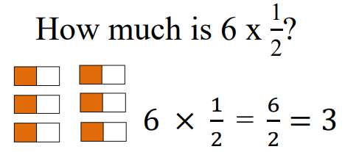

* When multiplying a fraction by a whole number such as $\frac{1}{2}$ × 6, we are trying to determine a part of the whole (e.g., one-half of six).

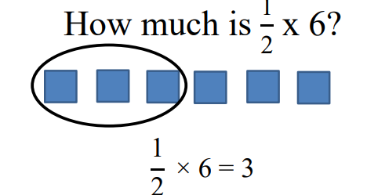

* Multiplying a whole number by a unit fraction can be related to dividing the whole number by the denominator of the fraction. For example, $\frac{1}{3}$ of 6 is equivalent to 2. This understanding forms a foundation for learning how to multiply a whole number by a proper fraction.



* In Grade 5, students will use models to solve problems that involve multiplication of a whole number, limited to 12 or less, and a proper fraction where the denominator is a factor of the whole number. For example, a model for $\frac{3}{4}$ × 8 or 8 × $\frac{3}{4}$ shows that the answer is three groups of $\frac{1}{4}$ × 8.

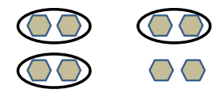

* Examples of problems grade five students should be able to solve include, but are not limited to the following:

- If nine children each bring $\frac{2}{3}$ cup of candy for the party, how many thirds will there be? What will be the total number of cups of candy?

- If it takes $\frac{3}{4}$ cup of ice cream to fill an ice cream cone, how much ice cream will be needed to fill eight cones?

* Resulting fractions should be expressed in simplest form.
* Problems where the denominator is not a factor of the whole number (e.g., $\frac{3}{8}$ × 6 or 6 × $\frac{3}{8}$) will be a focus in Grade 6.

###### Skills in Practice

While the five process goals are expected to be embedded in each standard, the Skills in Practice highlight the most prevalent process goals in relation to the content presented.

**Mathematical Problem Solving:**

Estimation strategies have been provided earlier in this Instructional Guide. Using estimation strategies will help students to self-correct errors in computation, if needed, as they determine the reasonableness of their solutions. Fluently completing each operation means that students can find either the sum, difference, or product efficiently and with accuracy. To obtain fluency, students must have frequent practice with each operation.

* Students extend their understanding of multiplication and division to thinking about these operations in terms of composing and decomposing numbers into factors, and then extending that understanding into computation and estimation with fractions. For example, 12 can be decomposed into factors of 1, 2, 3, 4, 6, and 12 by knowing the multiplication facts that result in a product of 12. Making arrays will help students build conceptual understanding of factors while reinforcing fluency of basic facts.
* Examples with common misconceptions follow –
  + Larry cuts grass for his dad and his neighbor. It takes him $\frac{2}{3}$ of an hour to cut his dad’s grass and $\frac{5}{6}$ of an hour to cut his neighbor’s grass. How long does it take him to cut both yards? Write your answer in simplest form.

Some students may compare the amount of time spent cutting each yard and find the difference, instead of finding the total number of hours.

Another common error occurs when students do not find common multiplies to create equivalent fractions with like denominators. Some students add the numerators and denominators, resulting in the fraction $\frac{7}{9}$. These students will need additional support with concrete models and estimation using benchmark fractions to check the reasonableness of their answer. When using benchmark fractions to estimate the sum, the fractions $\frac{2}{3}$ and $\frac{5}{6}$ are both more than one-half; therefore, the sum of the two fractions is more than one whole.

Representing the fraction in simplest form can be difficult for some students. Students may need additional support identifying the greatest common factor and applying this concept to simplifying fractions. To help students reach higher levels of understanding, students should use a variety of representations, employ multiple approaches, and be encouraged to explain and justify their answers.

* When planning for a dinner party, my mom purchased 3 pies of the same size for dessert. We ate $\frac{5}{6}$ of one pie and $\frac{7}{8}$ of another pie. How much pie was left over after the party?

If a student has an answer of 1 $\frac{17}{24}$, this student just determined one answer of a multistep problem; not completing the other steps to determine how much pie is remaining. Using concrete models or pictorial representations can help students see that this fraction represents the amount of pie that was eaten and is just one part of the problem. Discussing strategies to determine the amount of pie of remaining should be discussed with this student.

Other students may understand that 1 $\frac{17}{24}$ represents the amount of the pie that was eaten but are unable to determine the amount of pie remaining. There are several different strategies to determine the fraction of pie remaining; however, some students will attempt to subtract from a whole and not regroup. A common answer could be 2 $\frac{17}{24}$, just subtracting the two whole numbers disregarding the need to regroup.

Some students may attempt to regroup by creating a fraction of $\frac{24}{24}$, but will keep the whole the same (3 $\frac{24}{24}$- 1 $\frac{17}{24}$). These students will need additional support modeling fractions using a variety of representations. Drawing a pictorial representation, using manipulatives, or other strategies such as adding on to determine the missing part will be important for students to understand regrouping with fractions.

When determining a student’s misconception, it is important to look at the strategies used or models that were drawn in order to understand the student’s thinking. There are several different strategies that students could use when solving this particular problem. Some may find a common denominator and then subtract from the whole. Other students may find common denominators and add on to determine the missing part to equal 3 wholes ( $1\frac{17}{24}$ + ? = 3).

Drawing models and subtracting the amount of pie eaten could also be a strategy that a student may use. Some students may not even subtract, but instead notice that each pie was one unit fraction away from a whole. Adding $\frac{1}{6}$ and $\frac{1}{8}$ to the remaining one whole pie to get an answer of 1 $\frac{7}{24}$. Class conversations about the strategies used to solve this particular problem can aid in helping students make connections and develop a deeper understanding.

* In Science class, the students were growing plants as part of a scientific experiment. At the end of the experiment, the students measured the height (in inches) of both plants.
  + - Plant *A* grew to a height of $5\frac{1}{4}$ inches.
    - Plant *B* grew to a height of $3\frac{5}{8}$ inches.

What is the difference in height, in inches, between Plant *A* and Plant *B*?

A common error results when students find a common denominator but then subtract the numerator from the first fraction from the numerator from the second fraction rather than regrouping to subtract, resulting in an incorrect response of $2\frac{3}{8}$. Another common misconception is revealed when students attempt to regroup when subtracting fractions. When regrouping some students will take a whole, divide it into 10 equal pieces adding $\frac{10}{10}$ to the fraction, resulting in a number sentence of $4\frac{12}{8}$– $3\frac{5}{8}$. This indicates that students are trying to connect the idea of regrouping with whole numbers when regrouping with fractions and are ignoring how many pieces equal one whole.

Students should focus on estimation and benchmark fractions when solving problems. Using estimation not only encourages number sense but also supports the reasonableness of their answer. Students should explore a variety of strategies when working on problems that require regrouping. Drawing models, using manipulatives, using a number line to add or subtract, and decomposing fractions are just a few strategies that students should explore when subtracting fractions.

* Each morning Alfie the dog eats $\frac{3}{4}$ a can of dog food for breakfast. This model represents how much Alfie eats each morning.

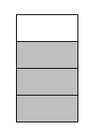

How many cans of dog food are needed in order to have enough food to feed Alfie for 8 days?

Some students may answer that 8 cans of dog food are needed. This misconception may indicate that students have difficulty multiplying the given fraction by 8. When multiplying a whole number by a fraction, it is important for students to recognize that it is the same concept as multiplication of whole numbers. Just as 8 × 4 can be thought of as 8 groups of 4, 8 × $\frac{3}{4}$ is the same as 8 groups of $\frac{3}{4}$.

**Mathematical Communication:** Develop mathematical vocabulary including *factor, factor pair, multiple, odd, even, prime, composite, least common multiple,* and *least common factor.* Students often confuse the terms factor and multiple. When listing multiples of a number, students may forget to include the number itself. Remind students that multiples are the products of a number and lead them into a discussion of why a number is a factor and a multiple of itself, which is a result of the identify element of multiplication (*a* × 1 = *a*).

**Mathematical Reasoning:** Students may recognize patterns as they explore numbers. Some numbers have exactly two factors and others have more than two factors. Students will then apply these structures as they begin to work with fractions. They use these same patterns to make and justify generalizations such as “all even numbers other than 2 are composite because they will have more than two factors.” This type of understanding leads students into formulating connections with prime and composite numbers and prime factorization (reference 5.NS.2).

**Mathematical Connections:** As students make lists of factors, provide opportunities for them to discuss patterns. Use a variety of activities for students to explore finding multiples by skip counting and relating multiples to the products of a number.

**Mathematical Representations:** Students need a variety of experiences representing multiplication of fractions through models such as arrays, paper folding, repeated addition, fraction strips or rods, pattern blocks, or area models.Reference the Understanding the Standard portion of this standard to review multiple ways that the four operations can be represented using concrete and pictorial representations before transitioning to the standard algorithms for each operation.

* Sally walked two-thirds of a mile for 6 days in a row. Use the model below to determine how far she walked in 6 days.

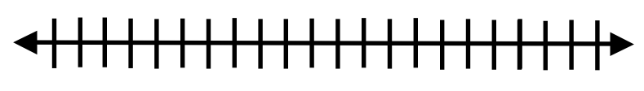

One common misconception when multiplying a fraction by a whole number is that students may multiply both the numerator and denominator by the whole number or add the denominators through repeated addition. If students get an answer of $\frac{12}{18}$, then these students will need additional support representing multiplication of fractions through models such as fraction strips, pattern blocks, repeated addition, or area models.

There are several different strategies to use when solving this problem. Students can use the given model to solve the problem by labeling the number line in thirds, identifying where 1 whole, 2 wholes, 3 wholes, etc. would be located. They can then make six jumps of $\frac{2}{3}$ each on the number line to represent the distance walked in 6 days. Other students may use repeated addition to solve this problem. Through class discussions the strategies should be connected in order for students to apply this skill when multiplying fractions. Students should identify that when multiplying a fraction by a whole number, they are finding a part of the whole. A big idea and key understanding for students is that when multiplying a fraction and a whole number, the product will be smaller than the whole number.

* A container of popcorn was purchased for a party. The container held exactly 12 cups of popcorn. If the children at the party ate exactly $\frac{3}{4}$ of the total amount of popcorn, how many cups of popcorn did the children eat?

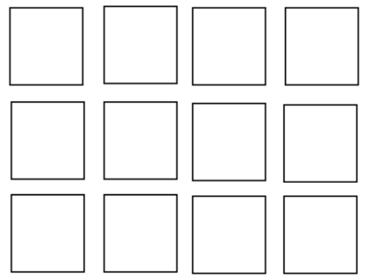

Some students have a difficult time identifying groups of a unit fraction using a set model. If students are unable to identify $\frac{1}{4}$ of 12, then they will have a difficult time applying this concept to identify the product of three groups of $\frac{1}{4}$ x 12. Exploring and using models to multiply a unit fraction by a whole number will be necessary in order to connect this concept to other fractions of the same denominator.

There are several different strategies that students can use when solving this problem. Did the students recognize the problem as $\frac{3}{4}$ of 12 or 12 groups of $\frac{3}{4}$? Discussing the commutative property of multiplication will be beneficial when discussing the strategies used to solve this

problem. It is important to first identify the strategies and the number sentence students used to determine the nature of the error or misconception.

*\*Reference 5.CE.1 Skills in Practice for guidance related to* ***Mathematical Problem-Solving****,* ***Mathematical Communication,******Mathematical Reasoning****,**and* ***Mathematical Connections*** *when solving contextual problems.*

###### Concepts and Connections

Concepts

The operations of addition, subtraction, multiplication, and division, and estimation, allow us to model, represent, and solve different types of problems with whole numbers and positive rational numbers.

Connections

* *Within the grade level/course*:
  + 5.NS.2 – The student will demonstrate an understanding of prime and composite numbers, and determine the prime factorization of a whole number up to 100.
  + 5.CE.1 – The student will estimate, represent, solve, and justify solutions to single-step and multistep contextual problems using addition, subtraction, multiplication, and division with whole numbers.
  + 5.CE.3 – The student will estimate, represent, solve, and justify solutions to single-step and multistep problems, including those in context, using addition, subtraction, multiplication, and division with decimal numbers (5.CE.3).
* *Vertical Progression*:
  + 4.CE.1 – The student will estimate, represent, solve, and justify solutions to single-step and multistep problems, including those in context, using addition and subtraction with whole numbers.
  + 4.CE.2 – The student will estimate, represent, solve, and justify solutions to single-step and multistep problems, including those in context, using multiplication with whole numbers, and single-step problems, including those in context, using division with whole numbers.
  + 4.CE.3 – The student will estimate, represent, solve, and justify solutions to single-step problems, including those in context, using addition and subtraction of fractions (proper, improper, and mixed numbers with like denominators of 2, 3, 4, 5, 6, 8, 10, and 12), with and without models; and solve single-step contextual problems involving multiplication of a whole number (12 or less) and a unit fraction, with models.
  + 4.CE.4 – The student will estimate, represent, solve, and justify solutions to single-step and multistep problems, including those in context, using addition and subtraction of decimals through the thousandths, with and without models.
  + 6.CE.1 – The student will estimate, demonstrate, solve, and justify solutions to problems using operations with fractions and mixed numbers, including those in context.
  + 6.CE.2 – The student will estimate, demonstrate, solve, and justify solutions to problems using operations with integers, including those in context.

###### Resources to Support Local Curriculum

* A list of approved textbooks and instructional materials is posted on the VDOE [website](https://www.doe.virginia.gov/teaching-learning-assessment/k-12-standards-instruction/mathematics/2024-mathematics-textbooks).
* Multiple Madness: Common Multiples, Least Common Multiples, and Fractions ([Word](https://www.doe.virginia.gov/home/showdocument?id=51805) | [PDF](https://www.doe.virginia.gov/home/showdocument?id=51807))

### 5.CE.3

##### The student will estimate, represent, solve, and justify solutions to single-step and multistep problems, including those in context, using addition, subtraction, multiplication, and division with decimal numbers.

1. Students will demonstrate the following Knowledge and Skills:
2. Apply estimation strategies (e.g., rounding to the nearest whole number, tenth or hundredth; compatible numbers, place value) to determine a reasonable solution for single-step and multistep contextual problems involving addition, subtraction, and multiplication of decimals, and single-step contextual problems involving division of decimals.
3. Estimate and determine the product of two numbers using strategies and algorithms, including the standard algorithm, when given:
   * 1. a two-digit factor and a one-digit factor (e.g., 2.3 × 4; 0.08 × 0.9; .16 × 5);*
     2. a three-digit factor and a one-digit factor (e.g., 0.156 × 4, 3.28 × 7, 8.09 × 0.2);* and
     3. a two-digit factor and a two-digit factor (e.g., 0.85 × 3.7, 14 × 1.6, 9.2 × 3.5).*

(Products will not exceed the thousandths place, and leading zeroes will not be considered when counting digits.)

1. Estimate and determine the quotient of two numbers using strategies and algorithms, including the standard algorithm, in which:*
   1. quotients do not exceed four digits with or without a decimal point;
   2. quotients may include whole numbers, tenths, hundredths, or thousandths;
   3. divisors are limited to a single digit whole number or a decimal expressed as tenths; and
   4. no more than one additional zero will need to be annexed.
2. Solve single-step and multistep contextual problems involving addition, subtraction, and multiplication of decimals by applying strategies (e.g., estimation, modeling) and algorithms, including the standard algorithm.

e) Solve single-step contextual problems involving division with decimals by applying strategies (e.g., estimation, modeling) and algorithms, including the standard algorithm.

* On the state assessment, items measuring this objective are assessed without the use of a calculator.

###### Understanding the Standard

* In Grade 4, students had experience with identifying, representing, comparing, and ordering decimals through the thousandths. Students in Grade 4 also solved problems involving addition and subtraction of decimals through the thousandths.
* The base 10 relationships that support the procedures developed for whole number computation apply to decimal computation, providing guidance for careful attention to the placement of the decimal point in the solution.
* Number lines are useful tools when developing a conceptual understanding of estimating with decimal numbers. A number line with benchmark numbers can be useful in rounding to the nearest hundredth, tenth, or whole number by determining which number is closer.

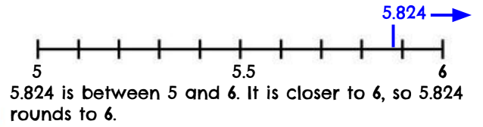

* Estimation skills are valuable, time-saving tools that help students focus on the meaning of the numbers and operations, encourage reflective thinking, and help build informal number sense with decimals. Reasoning with benchmarks provides students with an opportunity to estimate without using an algorithm (e.g., 2.75 + 3.2 is about 3 + 3, so the sum is about 6).
* In cases where an exact product is not required, the product of decimals can be estimated using strategies for multiplying whole numbers, such as front-end and compatible numbers, or rounding (e.g., 1.8 × 5 is about 2 × 5, so the product will be about 10; 0.85 × 2.3 is about 1 × 2, so the product will be about 2). In each case, determination of where to place the decimal point is necessary to ensure that the product is reasonable.
* Estimation can be used to determine a reasonable range for the answer to computation problems and to verify the reasonableness of sums, differences, products, and quotients of decimals (e.g., the quotient of 14.7 $÷$ 2 will fall between 14 $÷2$ and 16 $÷$ 2, thus the quotient will be between 7 and 8).
* The terms associated with multiplication are listed below:

*factor* 🡪 7.6

*factor* 🡪 × 2.3

*product* 🡪 17.48

* Multiplication with decimals is performed the same way as multiplication of whole numbers. The only difference is the placement of the decimal point in the product.
* The terms associated with division are listed below:

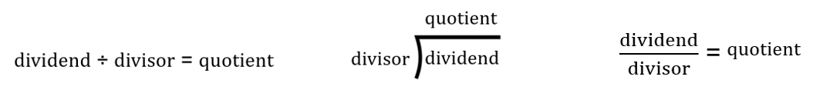

* Division with decimals is performed the same way as division of whole numbers. The only difference is the placement of the decimal point in the quotient.
* Multiplication and division of decimals can be represented with arrays, paper folding, repeated addition, repeated subtraction, base 10 models, and area models.
* The two examples below show models of decimal multiplication using base 10 blocks. In the second example, the purple shaded squares represent the overlap (i.e., the product of 0.4 $×$ 0.6).

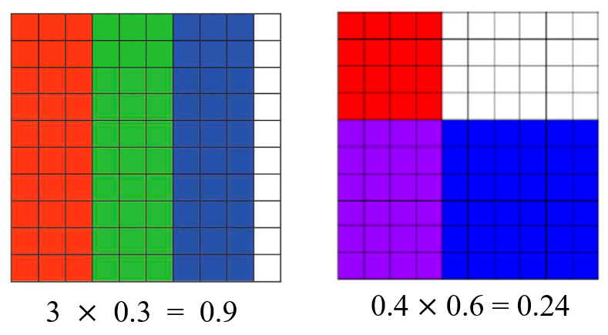

* The fair-share concept of decimal division can be modeled using manipulatives (e.g., base 10 blocks), as demonstrated in the example below.

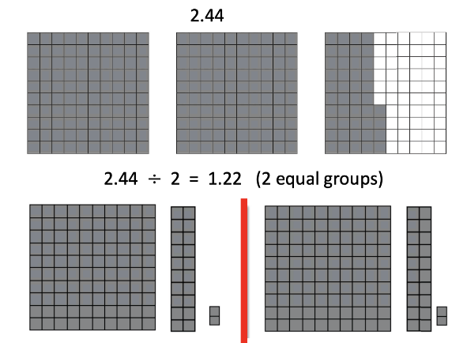

* Examples of appropriate decimal division problems for Grade 5 include, but are not limited to: 2.386 ÷ 2; 0.6 ÷ 2; 1.78 ÷ 5; etc.
* The following scenarios provide examples of contextual decimal division problems that would be appropriate for Grade students to solve:
  + A scientist collected three water samples from local streams. Each sample was the same size, and she collected 1.35 liters of water in all. What was the volume of each water sample?
  + There are exactly 12.5 liters of sports drink available to the tennis team. If each tennis player will be served 2 liters, how many tennis players can be served?
  + The 4-person relay team race is exactly 10.76 miles long. Each person on the team will run the same distance. How many miles will each person run?
* When solving division problems, numbers may need to be expressed as equivalent decimals by annexing zeros. This occurs when a zero must be added in the dividend as a placeholder.

###### Skills in Practice

While the five process goals are expected to be embedded in each standard, the Skills in Practice highlight the most prevalent process goals in relation to the content presented.

**Mathematical Problem Solving:**

* Estimation strategies have been provided earlier this in this Instructional Guide. Using estimation strategies will help students to self-correct errors in computation, if needed, as they determine the reasonableness of their solutions. Fluently completing each operation means that students can find the sum, difference, product, or quotient efficiently and with accuracy. To obtain fluency, students must have frequent practice with each operation.
* Explore multiplication of decimals by using problems in context and by returning to a model that students used successfully when multiplying whole numbers. Estimation should ground students’ thinking when developing the multiplication algorithm. Use problems involving whole-number multipliers. Multipliers such as 3.25 and 8.25 that involve common fractional parts are good choices.
* Have students compare a decimal product with one involving the same digits but no decimal. For example, ask students, “*How are 23.4 $×$ 6.5 and 234 $×$ 65 alike?”* Both products have the same digits: 15210 (the zero may be missing from the decimal product). Students can explore other products that are alike except the location of the decimal point. The digits in the answer are always the same. After seeing how the digits remain the same for related products, conduct an activity like the following –
  + Have students estimate the product of 21 × 73. Then have them determine the exact answer. Using the result of this computation, next have the students provide an estimation and exact answer to 0.21 × 7.3, 21 × 0.73, and 2.1 × 73. For each computation, students should provide a reason for how they determined where to place the decimal point.
* A reasonable algorithm for division is similar to multiplication. Ignore the decimal points and do the computation as if all numbers were whole numbers. When complete, place the decimal by estimation. This is reasonable for divisors greater than 1 or close to a benchmark value (e.g., 0.1, 0.5, and 0.01).

**Mathematical Communication:** Focus on the following vocabulary related to decimal computation – *estimate*, *multi-digit decimals*, and *algorithm*. Students should use these terms both orally and in writing when demonstrating their understanding of the standard and when justifying their reasoning when arriving at their solutions.

**Mathematical Reasoning:** Review estimating the sum and then finding the exact sum for adding decimals. For example, to estimate 15.2 and 7.65, an estimate of the sum could be 15 + 7 = 22. Teachers should expect that students know if their estimate is too high or too low. Ask students to reason, *“Why does it make sense that your answer must be larger than 22?”* Teach students to use their estimations to self-correct any errors in their actual computations. Consider this problem –

Tyler and Kevin each timed their own quarter mile run with a stopwatch. Tyler says that he ran the quarter mile in 74.5 seconds. Kevin was more accurate in his timing, reporting that he ran the quarter mile in 81.34 seconds. Who ran it the fastest and by how much?

Students should recognize that the difference is close to 7 seconds. Once students have determined the estimate, then they should find the exact answer. The estimate helps to avoid the common error of lining up the 5 under the 4. Students might note that 74.5 and 7 more is 81.5 and then figure out how much extra that is. Others might use counting on strategies from 74.5 by adding 0.5 and then 6 more seconds to get to 81 seconds and then add on the remaining 0.34 second. Students must apply their understanding of place value when solving problems in isolation and in context.

**Mathematical Connections:** This standard requires students to extend the models and strategies for the four operations previously developed for whole numbers not only at this grade level, but in previous elementary grades. Emphasis for addition, subtraction, multiplication, and division of multi-digits decimals is on using standard algorithms in context.

**Mathematical Representations:** Reference the Understanding the Standard portion of this standard to review multiple ways that the four operations can be represented using concrete and pictorial representations before transitioning to the standard algorithms for each operation.

*\*Reference 5.CE.1 Skills in Practice for guidance related to* ***Mathematical Problem-Solving****,* ***Mathematical Communication,******Mathematical Reasoning****,**and* ***Mathematical Connections*** *when solving contextual problems.*

###### Concepts and Connections

Concepts

The operations of addition, subtraction, multiplication, and division, and estimation, allow us to model, represent, and solve different types of problems with whole numbers and positive rational numbers.

Connections

* *Within the grade level/course*:
  + 5.CE.1 – The student will estimate, represent, solve, and justify solutions to single-step and multistep contextual problems using addition, subtraction, multiplication, and division with whole numbers.
  + 5.CE.2 – The student will estimate, represent, solve, and justify solutions to single-step and multistep problems, including those in context, using addition and subtraction of fractions with like and unlike denominators (with and without models), and solve single-step contextual problems involving multiplication of a whole number and a proper fraction, with models.
* *Vertical Progression*:
  + 4.CE.1 – The student will estimate, represent, solve, and justify solutions to single-step and multistep problems, including those in context, using addition and subtraction with whole numbers.
  + 4.CE.2 – The student will estimate, represent, solve, and justify solutions to single-step and multistep problems, including those in context, using multiplication with whole numbers, and single-step problems, including those in context, using division with whole numbers.
  + 4.CE.3 – The student will estimate, represent, solve, and justify solutions to single-step problems, including those in context, using addition and subtraction of fractions (proper, improper, and mixed numbers with like denominators of 2, 3, 4, 5, 6, 8, 10, and 12), with and without models; and solve single-step contextual problems involving multiplication of a whole number (12 or less) and a unit fraction, with models.
  + 4.CE.4 – The student will estimate, represent, solve, and justify solutions to single-step and multistep problems, including those in context, using addition and subtraction of decimals through the thousandths, with and without models.
  + 6.CE.1 – The student will estimate, demonstrate, solve, and justify solutions to problems using operations with fractions and mixed numbers, including those in context.
  + 6.CE.2 – The student will estimate, demonstrate, solve, and justify solutions to problems using operations with integers, including those in context.

###### Resources to Support Local Curriculum

* A list of approved textbooks and instructional materials is posted on the VDOE [website](https://www.doe.virginia.gov/teaching-learning-assessment/k-12-standards-instruction/mathematics/2024-mathematics-textbooks).
* Party Time: Computation and Estimation with Decimals Mathematics Instructional Plan ([Word](https://www.doe.virginia.gov/home/showpublisheddocument/51809/638398747134170000) | [PDF](https://www.doe.virginia.gov/home/showpublisheddocument/51811/638398747140430000))

### 5.CE.4

##### The student will simplify numerical expressions with whole numbers using the order of operations.

1. Students will demonstrate the following Knowledge and Skills:
2. Use order of operations to simplify numerical expressions with whole numbers, limited to addition, subtraction, multiplication, and division in which:*
   1. expressions may contain no more than one set of parentheses;
   2. simplification will be limited to five whole numbers and four operations in any combination of addition, subtraction, multiplication, or division;
   3. whole numbers will be limited to two digits or less; and
   4. expressions should not include braces, brackets, or fraction bars.
3. Given a whole number numerical expression involving more than one operation, describe which operation is completed first, which is second, and which is third.*

* On the state assessment, items measuring this objective are assessed without the use of a calculator.

###### Understanding the Standard

* An equation represents the relationship between two expressions of equal value (e.g., 12 ⋅ 4 = 60 − 12).
* The equal symbol (=) means that the values on either side are equivalent (balanced).
* The not equal symbol (≠) means that the values on either side are not equivalent (not balanced).
* An expression is a representation of a quantity. It is made up of numbers, variables, computational symbols, and grouping symbols. It does not have an equal symbol (e.g., 15 × 12).
* Expressions containing more than one operation can be simplified by using the order of operations.
* The order of operations is a convention that defines the computation order to follow when simplifying an expression that contains more than one operation. It ensures that there is only one correct value.
* The order of operations is as follows:
  + First, complete all operations within grouping symbols. If there are grouping symbols within other grouping symbols, do the innermost operation first. (Note that students in Grade 5 are not expected to simplify expressions having parentheses within other grouping symbols.)

Note: If there are multiple operations within the parentheses, apply the order of operations.

* + Second, evaluate all terms with exponents. (Note that students in Grade 5 are not expected to simplify expressions with exponents.)
  + Third, multiply and/or divide in order from left to right.
  + Fourth, add and/or subtract in order from left to right.
* Investigating arithmetic operations with whole numbers helps students learn about different properties of arithmetic relationships. These relationships remain true regardless of the set of numbers.

###### Skills in Practice

While the five process goals are expected to be embedded in each standard, the Skills in Practice highlight the most prevalent process goals in relation to the content presented.

**Mathematical Reasoning:** The foundational understandings of flexible counting strategies and automaticity learned in previous elementary grades will help students to become fluent in simplifying expressions using the order of operations. Examples with common misconceptions follow –

* Simplify the expression: 3 + 12 ÷ 3 × 2

There are several different misconceptions that a student may have when solving this expression. If students solved this problem from left to right, disregarding the order of operations, they an incorrect solution of 10. This indicates students need additional support understanding and applying order of operations. Using concrete manipulatives to model expressions with limited operations will help support student understanding when solving expressions with multiple operations. Connecting the order of operations to word problems and/or reading the expression aloud are other strategies that can be used to help strengthen students’ understanding of order of operations. An example of an expression with limited operations is 3 + 5 x 2. This expression can be read as “3 plus 5 groups of 2.”

Another common misconception occurs when students understand the order in which the operations should be applied (multiplication/division before addition/subtraction), but do not remember to work from left to right. When simplifying this expression, it is common for students to follow procedural rules instead of understanding why multiplication and division are solved in order from left to right. If students get a solution of 5 for the expression shown above, these students multiplied before dividing. They would benefit from additional practice simplifying expressions where division comes before multiplication. This student should also simplify expressions where subtraction comes before addition.

* The following students were simplifying the expression shown below. The students were asked to identify which operation should be completed first.

5 + 3(6 – 4)

Jessica first simplified 5 + 3.

Carl first simplified 3 × 6.

Melanie first simplified 6 – 4.

Which student correctly identified the first step in simplifying this expression?

Applying multiple operations within the parentheses can be difficult for some students. Students should explore a variety of different expressions.

Students who selected Jessica typically are not applying order of operations and are simplifying the expression from left to right. These students will need additional practice modeling and simplifying expressions limited to a few operations prior to simplifying expressions with multiple operations.

Students who selected Carl tend to understand that the part of the expression inside parentheses should be simplified first; however, these students are not applying order of operations. Instead, these students are using multiplication – thinking multiplication or division come first in the order of operations, neglecting the operation within the parentheses; therefore, the operation within the grouping symbol is first.

* Using the order of operations, simply the following expression.

16 + 5 – 3 + 8

When given an expression involving more than one operation, students should simplify using order of operations. In this particular expression, students should add/subtract in order from left to right.

A common misconception for students is to complete all addition operations first prior to subtracting. If a student simplified this expression with that misconception, their solution would be 10. Students will need additional practice solving expressions with more than one operation, especially when the operations change throughout the expression. When simplifying an expression, students should be encouraged to rewrite the expression each time an operation is completed. This will help to keep students organized and focused on using order of operations to simplify expressions.

**Mathematical Connections:** Students should connect their understandings of whole number operations, fact fluency, and procedural understanding when completing the order of operations.

###### Concepts and Connections

Concepts

The operations of addition, subtraction, multiplication, and division, and estimation, allow us to model, represent, and solve different types of problems with whole numbers and positive rational numbers.

Connections

* *Within the grade level/course*:
  + 5.CE.1 – The student will estimate, represent, solve, and justify solutions to single-step and multistep contextual problems using addition, subtraction, multiplication, and division with whole numbers.
* *Vertical Progression*:
  + 4.CE.1 – The student will estimate, represent, solve, and justify solutions to single-step and multistep problems, including those in context, using addition and subtraction with whole numbers.
  + 4.CE.2 – The student will estimate, represent, solve, and justify solutions to single-step and multistep problems, including those in context, using multiplication with whole numbers, and single-step problems, including those in context, using division with whole numbers.
  + 7.PFA.2 –The student will simplify numerical expressions, simplify and generate equivalent algebraic expressions in one variable, and evaluate algebraic expressions for given replacement values of the variables.

###### Resources to Support Local Curriculum

* A list of approved textbooks and instructional materials is posted on the VDOE [website](https://www.doe.virginia.gov/teaching-learning-assessment/k-12-standards-instruction/mathematics/2024-mathematics-textbooks).

## Measurement and Geometry

In K-12 mathematics, measurement and geometry allow students to gain understanding of the attributes of shapes as well as develop an understanding of standard units of measurement. Measurement and geometry are imperative as students develop a spatial understanding of the world around them. The standards in the measurement and geometry strand aim to develop students’ special reasoning, visualization, and ability to apply geometric and measurement concepts in real-world situations.

In Grade 5, students analyze and describe geometric objects and the relationships and structures among them. Students learn that the space that geometric objects occupy can be used to classify, quantify, measure, or count one or more attributes. At this grade level, students solve problems, including those in context, that involve length, mass, and liquid volume using metric units; solve problems involving area, perimeter, and volume; and classify and measure angles and triangles.

### 5.MG.1

##### The student will reason mathematically to solve problems, including those in context, that involve length, mass, and liquid volume using metric units.

1. Students will demonstrate the following Knowledge and Skills:
2. Determine the most appropriate unit of measure to use in a contextual problem that involves metric units:
   1. length (millimeters, centimeters, meters, and kilometers);
   2. mass (grams and kilograms); and
   3. liquid volume (milliliters and liters).
3. Estimate and measure to solve contextual problems that involve metric units:
   1. length (millimeters, centimeters, and meters);
   2. mass (grams and kilograms); and
   3. liquid volume (milliliters and liters).
4. Given the equivalent metric measure of one unit, in a contextual problem, determine the equivalent measurement within the metric system:
   1. length (millimeters, centimeters, meters, and kilometers);
   2. mass (grams and kilograms); and
   3. liquid volume (milliliters and liters).

###### Understanding the Standard

* Length is the distance between two points along a line. Metric units for measurement of length include millimeters, centimeters, meters, and kilometers. Appropriate measuring devices include centimeter rulers, meter sticks, and tape measures.
* Weight and mass are different. Mass is the amount of matter in an object. Weight is determined by the pull of gravity on the mass of an object. The mass of an object remains the same regardless of its location. The weight of an object changes depending on the gravitational pull at its location. In everyday life, most people are interested in determining an object’s mass, although they use the term *weight* (e.g., “How much does it weigh?” versus “What is its mass?”).
* Volume is the amount of space that an object or substance occupies and is measured in cubic units. Metric units to measure liquid volume (capacity) include milliliters and liters.
* Experiences measuring familiar objects help establish benchmarks and facilitate the use of the appropriate units of measure to make estimates.
* Students at this level will be given the equivalent measure of one unit when asked to determine equivalencies between units in the metric system. For example, students will be told one kilometer is equivalent to 1,000 meters. Then they will apply that relationship to determine:
  + the number of meters in 3.5 kilometers;
  + the number of kilometers equal to 2,100 meters; or
  + Seth ran 2.78 kilometers on Saturday. How many meters are equivalent to 2.78 kilometers?

###### Skills in Practice

While the five process goals are expected to be embedded in each standard, the Skills in Practice highlight the most prevalent process goals in relation to the content presented.

**Mathematical Problem Solving:**

* Provide meaningful, hands-on opportunities for students to develop an understanding of length, mass, and liquid volume. Particularly, as students work with capacity, they learn about the amount a container holds and will be weighing objects to tell how heavy the objects are. Allow students to explore by estimating, weighing, and measuring all kinds of objects and by filling containers to help them comprehend the size and weight using appropriate units. Sample questions have been provided below to help solidify students’ understanding of this concept –
* **Determine a unit of measure for a given scenario:** Which unit of measurement can be used to determine how many chairs can fit around a rectangular cafeteria table?
* **Select an appropriate unit of measurement:** Kali measured the length of her room. Which measurement could be the length of her room?

1. centimeters 4 meters 4 kilometers 4 millimeters

* Students must understand at this grade level that measure focuses on the *relationship* between the units. Students should understand that the *number* of units relates to the *size* of the unit (e.g., there are 100 centimeters in 1 meter). With this understanding, students will be able to determine whether they need to multiply or divide when making conversions. The following is an example requiring students to determine equivalent measurements involving length within the metric system –

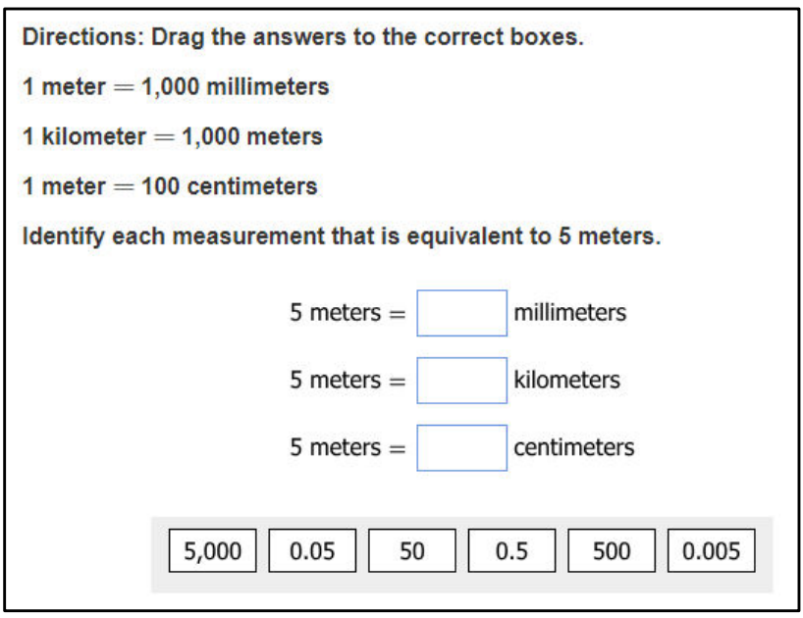

Linked to this understanding is the challenge to explain to students that going from smaller units to larger units will produce a smaller measure and vice versa. An activity like the following can help students unpack this concept –

Have students measure a length with a specified unit. Then, provide them with a different unit that is either twice as long or half as long as the original unit. Their task is to predict the measure of the same length using the new unit. Students should write down their estimations and discuss how they made their estimations. Then have students determine the actual measurement. Cuisenaire rods can be used as a model for this activity. Some students can be challenged with units that are more difficult multiples of the original unit.

In this activity, students learn the basic idea that when the unit is longer, the measure is smaller, and when the unit is smaller, the measure is larger. This activity is beneficial to complete just prior to introducing unit conversion with standard units and helps students to transition into proportional thinking.

* Help students convert measurements into larger or smaller units within a measurement system by reinforcing place value for whole numbers and decimals and then focus on the connection between fractions and decimals. For example, 1 $\frac{1}{2}$ centimeters can be expressed as 1.5 centimeters or 15 millimeters). Before converting, students should think about the units to be converted and be able to explain whether the converted amount will be more or less than the original unit.
* As students engage in this standard, they must choose the appropriate units of measure for contextual problems; understand the concept of mass in relationship to weight; understand the concept when a liquid takes up space it is measured by volume; and understand units of metric length and capacity. For the next example, students are to solve a contextual problem involving mass using metric units –

Image. Contextual problem. 1 kilogram = 1,000 grams. A large rock has a mass of 3 kilograms. What is the mass in grams of the rock? Answer choices:

A. 30,000 grams; B. 3,000 grams; C. 300 grams; or, D. 30 grams. 

**Mathematical Reasoning:**

* Measurement involves a comparison of an attribute of an item or situation with a unit that has the same attribute. Lengths are compared to units of length, mass to units of mass, etc. To measure something, students must decide on the attribute to be measured; select a unit that has that attribute; and compare the units by filling, covering, matching, or using some other method, with the attribute of the object being measured. The number of same-sized units required to match the object is the measure. For example –

Mason has a brick and 5 wood blocks.

* + The brick has a mass of 8.036 kilograms.
  + Each wood block has a mass of 1.097 kilograms.

What is the difference between the mass of the brick and the combined mass of the 5 wood blocks?

* Promote student practice with the use of conversion in solving contextual problems. This should occur after students understand the relationship between units and how to do the conversions. Focus on renaming units to representthe solution before experiencing problems that require renaming to find the solution. Examples with common misconceptions follow –
* Determine the equivalent measurements.

| 10 millimeters = 1 centimeter  100 centimeters = 1 meter |
| --- |

2 meters = ________ centimeters 5 centimeters = _________ millimeters

Some students may have difficulty determining the relationship between units, even though the unit equivalency is provided, preventing them from applying the pattern or rule necessary to fill in the missing information. Teachers may wish to provide experiences with manipulatives, such as meter sticks and centimeter rulers, to help students see the relationship between the unit measurement and how it shrinks and grows multiplicatively.

* Determine the equivalent measurements and fill in the missing spaces in the chart below.

| 1,000 meters = 1 kilometer |
| --- |

| **Kilometer(s)** | **Meter(s)** |
| --- | --- |
| 1 |  |
| 3 |  |
|  | 5,000 |
|  | 10,000 |
| 12 |  |

Some students may have difficulty finding the relationship between meters and kilometers because they may want to fill in the columns on the chart instead of working across the rows. Teachers may wish to focus row by row, identifying the horizontal rule as they move down the chart. Teachers may wish to provide experiences with input/output tables to help students see the connection between the given unit and the table.

Additionally, some students may have difficulty in conceptualizing the relative comparison between the actual length of a meter and a kilometer. This may indicate that the students need to engage in conversations about familiar locations that are about one kilometer apart from each other and compare them to the length of a meter stick.

**Mathematical Communication and Connections:**

* When engaging students in measurement activities, reiterate the use of approximate language. Approximate language is very useful for students because many measurements do not result in whole numbers. As students become fluent with measurements, they will begin to search for smaller units or will use fractional or decimal units to be more precise, which is an opportunity to develop the idea that all measurements include some error; thus, acknowledging that each smaller unit or subdivision produces a greater degree of precision.
* The use of appropriate vocabulary – *measure, convert/conversion, relative size, liquid volume, mass, standard units, metric, grams, kilograms, liters*, etc. as students are studying this standard is essential. Expect students to use the terms as they estimate, measure, weigh, and communicate their understandings and findings.
* Measurement estimation is the process of using mental and visual information to measure or make comparisons without using measuring instruments. Estimation helps students focus on the attribute being measured and the measuring process. When standard units are used, estimation helps develop familiarity with the unit. For example, if the height of a door were to be measured in meters before measuring, students must think about the size of a meter. The use of a benchmark to make an estimate promotes multiplicative reasoning. An example related to estimation with a common misconception follows –
* Describe a container that would hold about 5 liters.

Some students may have difficulty with this problem if they do not understand the relative size of metric measurements. Teachers may wish to have students physically pour liquids into different sized containers to gain a conceptual understanding of the size of a liter. Have students think about the size of a container that would hold 1 liter, 2 liters, etc., and relate to containers they may be familiar with (such as 2-liter bottles of soda).

###### Concepts and Connections

Concepts

Analyzing and describing geometric objects, the relationships and structures among them, or the space that they occupy can be used to classify, quantify, measure, or count one or more attributes.

Connections

* *Within the grade level/course*:
  + 5.MG.2 – The student will use multiple representations to solve problems, including those in context, involving perimeter, area, and volume.
  + 5.MG.3 – The student will classify and measure angles and triangles, and solve problems, including those in context.
* *Vertical Progression*:
  + 4.MG.1 – The student will reason mathematically to solve problems, including those in context, that involve length, weight/mass, and liquid volume using U.S. Customary and metric units.
  + There are no formal standards beyond Grade 5 that address length, mass, and liquid volume.

Across Content Areas [Theme – Modeling]

* *Science:* 
  + 5.4b – The student will develop models using an analogy, example, or abstract representation to describe a scientific principle or design solution.
  + 5.4b – The student will identify limitations of models and create a model of a simple circuit and explain how it works.
  + 5.6a – The student will construct a model of a transverse wave and label a wavelength, crest, and trough.
  + 5.6b – The student will create models illustrating high- and low-energy light waves.
  + 5.7a – The student will construct a simple model to show that matter is composed of atoms and identify the advantages and the limitations of the model.
  + 5.8b – The student will model the movements of plates at tectonic boundaries (divergent, convergent, and transform), explain how the movement of tectonic plates relates to the changing surface of Earth, and describe the benefits and limitations of the models created.
  + 5.8c – The student will draw and label a simple diagram of the rock cycle and describe the major processes and rock types involved.
  + 5.8d – The student will model weathering, erosion, and deposition and explain the benefits and limitations of the model(s) created.
* Computer Science:
  + 5.DA.2 – The student will create multiple data representations to make predictions and conclusions (b) collect data to use in creating charts, graphs, and models.

###### Resources to Support Local Curriculum

* A list of approved textbooks and instructional materials is posted on the VDOE [website](https://www.doe.virginia.gov/teaching-learning-assessment/k-12-standards-instruction/mathematics/2024-mathematics-textbooks).

### 5.MG.2

##### The student will use multiple representations to solve problems, including those in context, involving perimeter, area, and volume.

1. Students will demonstrate the following Knowledge and Skills:
2. Investigate and develop a formula for determining the area of a right triangle.
3. Estimate and determine the area of a right triangle, with diagrams, when the base and the height are given in whole number units, in metric or U.S. Customary units, and record the solution with the appropriate unit of measure (e.g., 16 square inches).
4. Describe volume as a measure of capacity and give examples of volume as a measurement in contextual situations.
5. Investigate and develop a formula for determining the volume of rectangular prisms using concrete objects.
6. Solve problems, including those in context, to estimate and determine the volume of a rectangular prism using concrete objects, diagrams, and formulas when the length, width, and height are given in whole number units. Record the solution with the appropriate unit of measure (e.g., 12 cubic inches).
7. Identify whether the application of the concept of perimeter, area, or volume is appropriate for a given situation.
8. Solve contextual problems that involve perimeter, area, and volume in standard units of measure.

###### Understanding the Standard

* Perimeter is the path or distance around any plane figure. Perimeter is a measure of length (e.g., the perimeter of the book cover is 38 inches).

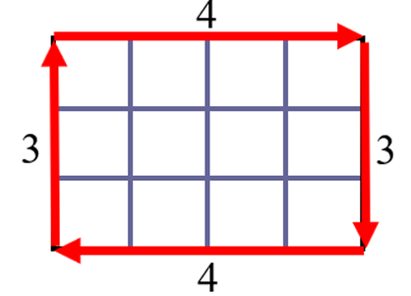 3 + 4 + 3 + 4
Perimeter = 14 units

* Area is the surface included within a plane figure. Area is measured by the number of square units needed to cover a surface or plane figure (e.g., the area of the book cover is 90 square inches or 90 in.2).

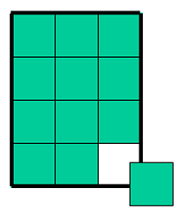 l x w
4 x 3 = 12
Area = 12 square units

* Volume is the measure of capacity of a 3-D figure. Volume is measured in cubic units (e.g., the volume of the box is 150 cubic inches or 150 in3).

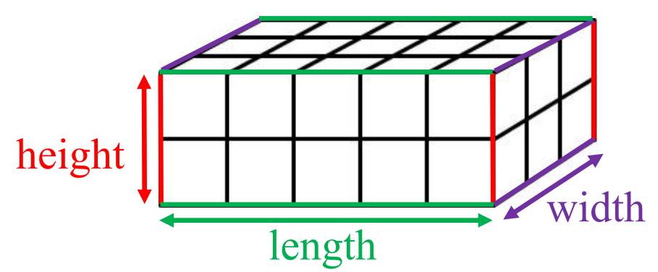 l x w x h 
5 x 3 x 2
Volume = 30 cubic units

* Students should have opportunities to label the perimeter, area, and volume with the appropriate units of measure. At this level, students are not expected to represent square units using an exponent of 2 (e.g., 24 ft.2) or cubic units as an exponent of 3 (e.g., 60 ft.3).
* The formula for the area of a rectangle is one of the first that is developed and is usually given as *A = l x w*, or “area equals length times width”. Thinking ahead, an equivalent but more unifying idea is *A = b x h*, or “area equals *base* times *height*”. The base-times-height formulation can be generalized to all parallelograms (not just rectangles) and is helpful when students are developing the area formulas for triangles and trapezoids in Grade 6.
* Any side of a figure can be called a *base*. For each base that a figure has, there is a corresponding *height*. The height is the perpendicular distance to the base. The formula *A = b x h* generates the same area through the commutative property regardless of which side is considered the base.
* Furthermore, the same approach can be extended to three dimensions. For example, the volume of a rectangular prism can be found by multiplying *length x width x height* (as in the formula *V = l x w x h)*, or by multiplying the *area of the base (B)* times the *height (h)* (as in the formula *V = Bh*). Volumes of cylinders – explored in Grade 7 – are given in terms of the *area of the base* (*B*) times the *height* (*h*), or *V = Bh*. Therefore, base times height connects a large family of formulas that otherwise must be mastered independently.
* A right triangle has one right angle. The distance from the top of the right triangle to its base is called the height of the triangle. Two congruent right triangles can always be arranged to form a square or a rectangle.
* The diagonal of the rectangle shown below divides the rectangle in half creating two right triangles. The legs of the right triangles are congruent to the side lengths of the rectangle. The representation illustrates that the area of each right triangle is half the area of the rectangle. Students should make the connection that finding the area of the rectangle and dividing by two gives the same result as using the formula $A=\frac{1}{2}bh$.

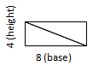

* Students should have opportunities to use manipulatives (e.g., tangrams, attribute blocks, grid paper, geoboards) to discover and use the formula for the area of a right triangle.
* Exploring the decomposition of shapes helps students discover algorithms for determining area of various shapes (e.g., area of a triangle = $\frac{1}{2}$ × base × height).
* Students should have opportunities to use cubes to build rectangular prisms to discover and use the formula for the volume of a rectangular prism.

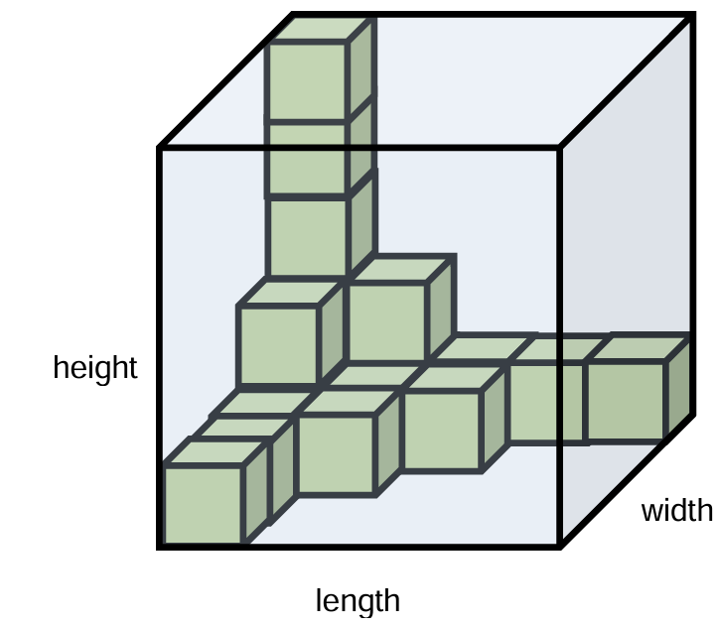 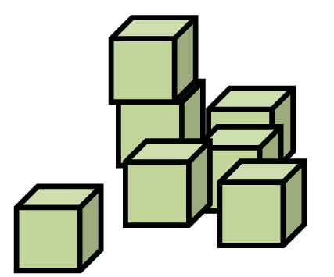

* To develop the formula for determining the volume of a rectangular prism (i.e., volume = length × width × height), students should have opportunities to fill rectangular prisms (e.g., shoe boxes, cereal boxes) with cubes by first covering the bottom of the box and then building up the layers to fill the entire box or building a rectangular prism with cubes.

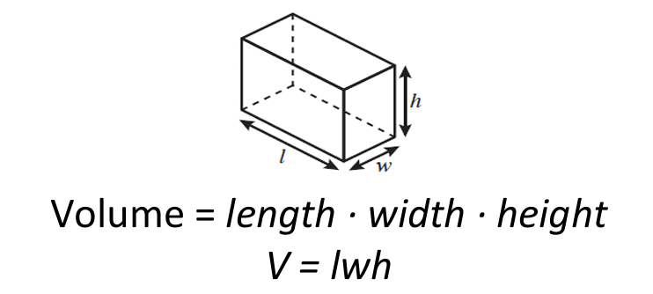 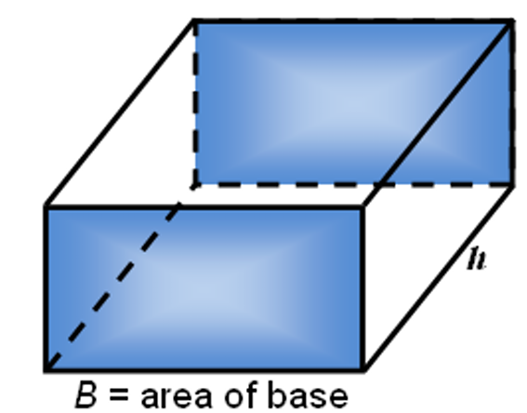

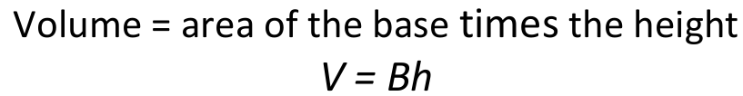

###### Skills in Practice

While the five process goals are expected to be embedded in each standard, the Skills in Practice highlight the most prevalent process goals in relation to the content presented.

**Mathematical Problem Solving:**

* Stress that there are four steps to solving contextual problems related to perimeter, area, and volume: determining which application should be used (when not explicitly stated to find the perimeter, area, or volume), writing the formula, substituting the values, and solving including proper units. Examples with common misconceptions follow –
  + Determine the area of the triangle.

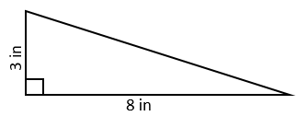

Some students may multiply the base times the height (or length times width), as when finding the area of a rectangle, but not divide by two to determine the area of the triangle. Teachers may wish to use grid paper and manipulatives to help students decompose rectangles to discover the relationship between the area of a rectangle and a triangle.

* + Ms. Hamilton has a large piece of paper for her bulletin board that is 4 feet in width and 8 feet in length. What are the perimeter and area of the piece of paper?

Some students may have more difficulty finding perimeter and area in a practical problem without a visual representation. Teachers may wish to expose students to various types of perimeter and area problems, emphasizing the benefit of drawing a figure and labeling it to help them solve. Additionally, students often confuse how to label the answer with appropriate units. Teachers may wish to engage students in hands-on activities to help them distinguish that perimeter is measured in linear units, while area is measured in square units.

* Julie has an aquarium with dimensions of 6 meters long, 5 meters wide, and 3 meters high. How much water can the aquarium hold?
* Formulas should be used in tandem with this standard to help students use the appropriate formula when solving stand-alone problems or problems in context.

* Questions to further elicit students’ understanding of this standard are –
  + How do you determine the perimeter and area of a triangle?
  + How do you determine the perimeter and area of a rectangle?
  + How do you determine the volume of a rectangular prism?
  + What is the relationship between the area of the base of a rectangular prism and its height?
  + Is there a difference between *A* = *l* × *w* or *A* = *b* × *h*? Why or why not?
  + Is there a difference between *V* = *l* × *w* × *h* or *V* = *Bh*? Why or why not?
  + Describe the minimum amount of information needed to find the perimeter (or area) of a rectangle (or triangle).

**Mathematical Reasoning:** Students must understand that when solving contextual problems, they must look for essential vocabulary to determine whether the problem is requiring applications of perimeter, area, or volume. Contexts such as filling a tank (volume) or determining an amount of fencing needed for a backyard (perimeter) are not always explicitly written in the phrasing like “find the volume or perimeter of *x* figure.” Therefore, students should have exposure to problems that are in context as these represent real-world applications of perimeter, area, or volume using standard units of measure. Examples with misconceptions follow:

* What are the area and perimeter of the shaded figure on this grid?

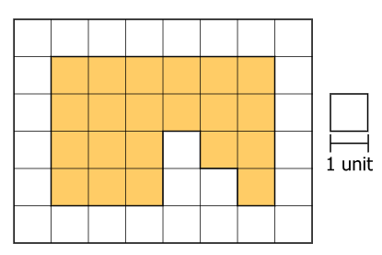

A common misconception that students may exhibit is not calculating each dimension of the shaded figure when determining the perimeter. Students should be encouraged to use color-coding, hash marks, or writing down each unit of length as they navigate around the figure. Students may use subdivision and mental math to determine the area of the shaded figure instead of counting each unit individually.

* Grayson filled his fish tank with water. Its length is 10 inches, its width is 3 inches, and its height is 6 inches. How much water can his fish take hold?

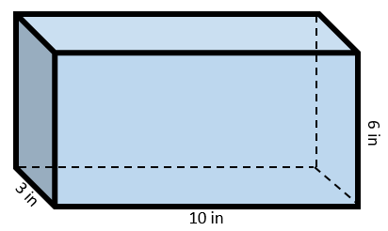

Some students may be unfamiliar with finding the volume in cubic inches in a practical problem because of text comprehension and lack of experience. It may also be difficult for them to contextualize volume in cubic units. In addition to hands-on experiences with measuring volume with cubic units, teachers may also wish to use a sort with perimeter, area, and volume situations that requires students to comprehend and differentiate among contextual situations and words or phrases that represent these concepts (e.g., fill – volume, paint – area, fencing – perimeter).

* Describe a situation where –
  + you would need to know the perimeter. Explain your thinking using pictures, numbers, and words.
  + you would need to know the area. Explain your thinking using pictures, numbers, and words.
  + you would need to know the volume. Explain your thinking using pictures, numbers, and words.

Some students may have difficulty describing situations where perimeter, area, and volume are applicable due to a lack of experience with these three measurements. Teachers may wish to have students explore and describe the concepts of perimeter, area, and volume using representations and physical objects or spaces.

**Mathematical Connections:**

* **Perimeter:** At this grade level, students must understand that perimeter is a length measure, and as such it is additive. Students should be able to calculate the perimeter given side measures as well as identify missing side lengths. Two examples are provided below as applications of perimeter of a rectangle (figures are not drawn to scale) –
  + What is the perimeter of this figure?

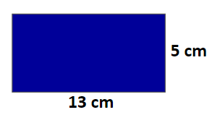

* + The perimeter of the rectangle below is 32 centimeters. What is the length of the side marked with the question mark?

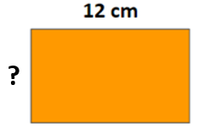

* + As an example, when addressing misconceptions about the differences between area and perimeter, it is important to contrast the two concepts as follows –
* ***Fixed Perimeters*:** Give students a loop of non-stretching string that is 24 centimeters in circumference (fold the string in half and at 12 cm tie a knot) and 1-cm grid paper or only use the grid paper. Determine what different-sized rectangles can be made with a perimeter of 24 cm. Each different rectangle can be recorded on the grid paper with the area noted inside the figure. Ask students, “*Will the areas remain the same? Why or why not? Which rectangle creates the largest area? The smallest area?”*
* ***Fixed Areas*:** Provide students with 1-cm grid paper. Determine how many rectangles can be made with area of 36 squared cm – make filled-in rectangles, not just borders. Each new rectangle should be recorded by sketching the outline and the dimensions on grid paper. For each rectangle, students should determine and record the perimeter measurement inside the figure. Ask students, “*Will the perimeters be the same? If not, what can be said about the shapes with longer or shorter perimeters?”* 
  + Provide students with ways to generate perimeter problems. As in the orange rectangle example above, it is common for students to be given a perimeter problem in which only one length and one width are illustrated (or given in context). If students consider only adding the two numbers, discussing the formula, *P* = *l* + *l* + *w* + *w,* will emphasize that there are four dimensions that should be added. This connection to the equation will help avoid the common misconception of only adding the two given dimensions. An alternative perimeter formula for rectangles that might emerge from discourse would be *P* = 2(*l* + *w*), which will reinforce the multiplication of the pair of sides. This formula also illustrates the use of the Distributive Property, or *P* = 2*l* + 2*w* and emphasizes that the perimeter involves combining lengths and widths.
* **Area:** At this grade level, students should recognize area as an attribute of two-dimensional regions. Students should measure the area of a shape by finding the number of square units needed to cover the shape. Then, transition to students learning that rectangular arrays can be decomposed into identical rows or into identical columns. Students will connect the concept of area to multiplication by decomposing rectangles into rectangular arrays of squares.
  + A square with a side length of 1 unit, called a “unit square,” is said to have “one square unit” of area, and can be used to measure area. A plane figure which can be covered without gaps or overlaps by *n* squares is said to have an area of *n square units.*
  + Provide experiences for students to explore the concept of covering a region with unit squares. Start by supplying students with a variety of rectangles of varying sizes. Using one-inch color tiles (unit squares), have students cover the rectangles in square inches. Discuss with students the idea that area is a measure of covering. Explain that area describe the side of an object that is two-dimensional. Ask students to count and record the number of tiles for each rectangle.
  + Utilize geoboards where students can determine the area. As shapes are created, remind students that the unit of area on the geoboard is the smallest square that can be made by connecting four pegs on the geoboard (see Figure 1 below at left). In Figure 1, students can count the square units and describe the rectangle as having an area of six square units (see Figure 1 below at left). Likewise, students can count the square units and describe the rectangle has having an area of two square units (see Figure 2 below at right). Creating a diagonal will result in the formation of two right triangles (or half of the area of the rectangle). Because of this, the area of the resulting triangle is one square unit (see Figure 2 below at right).

**Figure 1 Figure 2**

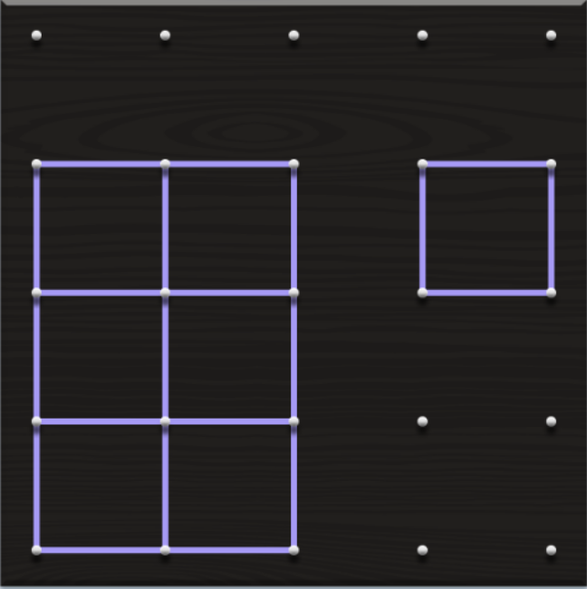 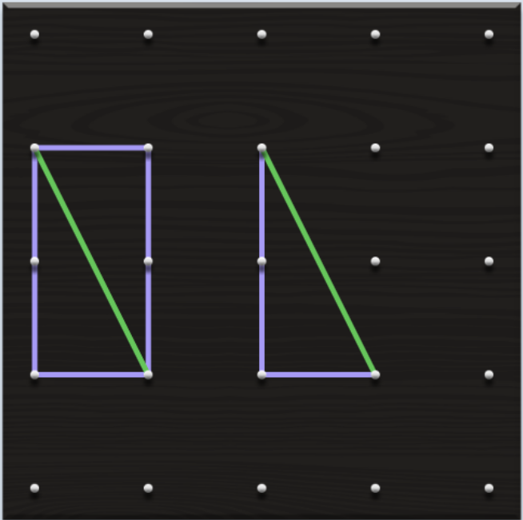

After various experiences with the color tiles and geoboards, have students transition to grid or graph paper. Focus on the idea of graph paper unit squares to measure the area. Have students count the square units.

* + Students will need to make a connection of the area of a rectangle to the area model used to represent multiplication. This connection justifies the formula for the area of a rectangle, and the resulting formula for the area of a triangle being derived from it.
* Exploring the decomposition of shapes helps students discover algorithms for determining area of various shapes (e.g., area of a triangle = $\frac{1}{2}$ × base × height). Students must develop the formula for determining the area right triangles using pictorial representations and concrete manipulatives. For example, start with a rectangle to derive the formulas for a triangle –
  + Give students two 3 x 5 index cards, scissors, tape, and two markers of different colors. Students will highlight the lengths and widths of each index card.
    - Rectangle (Index Card 1): Students will determine that the area of any rectangle is *A* = *l* × *w* or *A* = *b* × *h*, where *l* is the length and *w* is the width; or *b* is the base and *h* is the height. As students formulate an approach to area based on the idea of a row of squares (determined by the length of a side) multiplied by the number of these rows will fit the rectangle (determined the length of the other side), consolidate these ideas and explain to students that the idea of measuring one side to tell how many square will fit in a row along that side is the base, and the other side would be called the height. Ensure that students conclude that either side could be the base and if you use the formula A = *b* × *h,* then the same area will result using either side as the base.
    - Triangle (Index Card 2): Students will determine that the area of any triangle is determined by computing one-half of the product of the base and the height or *A $=\frac{1}{2}$* × *b* × *h,* where *b* is the base and *h* is the height. Have the students take out the second index card. Ask them what the area of it is, and then have them use a marker or highlighter to mark the lengths (both) and the widths (both). Have them color along the edges of the card. Using their rulers, have students draw in a diagonal of the figure (see pictures below). As students use the rectangle, they will see that once the diagonal is cut, then they will have created two right triangles.

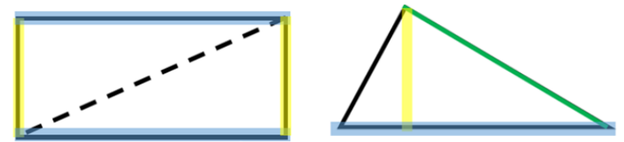

* + - Questions to further elicit students’ understanding and developing connections are –
      * How are the areas of a triangle and rectangle related? Explain and provide your reasoning.
      * What is the relationship between the area of a triangle and the area of a rectangle?
* **Volume:** At this grade level, students must recognize volume as an attribute of solid figures and as a measure of capacity. They must understand concepts of volume measurement.
  + A cube with side length 1 unit, called a “unit cube” is said to have “one cubic unit” of volume, and can be used to measure volume. A solid figure which can be packed without gaps or overlaps using *n* unit cubes is said to have a volume of *n cubic (cube) units*.
  + Provide activities to experience finding the volume of rectangular prisms by counting cubes. Finding the volume by counting cubes means figuring out the capacity or number of cubes it takes to fill a rectangular prism.
    - Give students one-inch cubes (or unit cubes or linking cubes) and ask them to cover the bottom of a box (e.g., shoe box, cereal box, tissue box).
    - After students cover the bottom layer of the box with cubes, ask them to determine how many additional layers of cubes should be added in order to fill the box. Students will begin to make observations about the bottom layer of their box:
      * For example, a small group of students may say that their rectangular prism has a bottom layer of 10 cubes for the length and 5 cubes for the width or 50 cubes for their bottom layer. The students may say that there are 4 layers of 50 cubes or 200 cubes in all, resulting in a volume of 200 cubic units.
    - As this process unfolds, students will begin to recognize that volume can be found by multiplying the length x width x height, or by multiplying the area of the base times the height. can be connected to the Associative Property of Multiplication.
  + Guide students to recognize that volume is additive (finding volumes of solid figures composed of two non-overlapping rectangular prisms by adding the volumes of the non-overlapping parts). Apply the formulas *V* = *l* × *w* × *h* or *V* = *b* × *h* for rectangular prisms to find volumes in the context of solving real-world and mathematical problems. Students should have experiences to describe and reason about why the formula works before applying the abstract algorithm. For example, *“The length of a cereal box is 30 cm, the width of the box is 8 cm, and the height is 5 cm. What is the volume of the cereal box in cubic centimeters?”* When doing so, some students may think about only one of the dimensions needed to find the volume. Some students may believe that because the object is tall, it will have more volume, therefore ignoring the other two dimensions. Provide additional experiences for students to measure and compare a variety of objects by using all three dimensions to address this misconception. For example –
    - *Comparing Prisms*: Give pairs of students centimeter cubes (or unit cubes, linking cubes). Students are to use 64 (or 36) cubes to build different rectangular prisms. Create a table of the results and have students compare dimensions of the prisms and note what happens to the volume as dimensions change.
    - *Cubic Units*: Provide students with small boxes that have been folded from cardboard. Use unit dimensions that match the blocks that you have for units. Students are given two boxes, exactly one block, and an appropriate rule. Students are to determine which box has the greater volume or if the boxes have the same volume. Students should use words, pictures, and numbers to explain and justify their answers.

###### Concepts and Connections

Concepts

Analyzing and describing geometric objects, the relationships and structures among them, or the space that they occupy can be used to classify, quantify, measure, or count one or more attributes.

Connections

* *Within the grade level/course*:
  + 5.MG.1 – The student will reason mathematically to solve problems, including those in context, that involve length, mass, and liquid volume using metric units.
  + 5.MG.3 – The student will classify and measure angles and triangles, and solve problems, including those in context.
* *Vertical Progression*:
  + 4.MG.3 – The student will use multiple representations to develop and use formulas to solve problems, including those in context, involving area and perimeter limited to rectangles and squares (in both U.S. Customary and metric units).
  + 6.MG.1 – The student will identify the characteristics of circles and solve problems, including those in context, involving circumference and area.
  + 6.MG.2 – The student will reason mathematically to solve problems, including those in context, that involve the area and perimeter of triangles and parallelograms.

Across Content Areas

Reference 5.MG.1.

###### Resources to Support Local Curriculum

* A list of approved textbooks and instructional materials is posted on the VDOE [website](https://www.doe.virginia.gov/teaching-learning-assessment/k-12-standards-instruction/mathematics/2024-mathematics-textbooks).
* Area of a Right Triangle Classroom Activity (Word)
* Volume of a Rectangular Prism Classroom Activity ([Word](https://www.doe.virginia.gov/home/showdocument?id=61389))

### 5.MG.3

##### The student will classify and measure angles and triangles, and solve problems, including those in context.

1. Students will demonstrate the following Knowledge and Skills:
2. Classify angles as right, acute, obtuse, or straight and justify reasoning.
3. Classify triangles as right, acute, or obtuse and equilateral, scalene, or isosceles and justify reasoning.
4. Identify congruent sides and right angles using geometric markings to denote properties of triangles.
5. Compare and contrast the properties of triangles.
6. Identify the appropriate tools (e.g., protractor, straightedge, angle ruler, available technology) to measure and draw angles.
7. Measure right, acute, obtuse, and straight angles, using appropriate tools, and identify measures in degrees.
8. Use models to prove that the sum of the interior angles of a triangle is 180 degrees and use the relationship to determine an unknown angle measure in a triangle.
9. Solve addition and subtraction contextual problems to determine unknown angle measures on a diagram.

###### Understanding the Standard

* Angles can be classified according to their measures as right, acute, obtuse, or straight. Angles are measured in degrees. A degree is $\frac{1}{360}$ of a complete rotation of a full circle. There are 360 degrees in a circle.
* An acute angle measures greater than zero degrees but less than 90 degrees.
* A right angle measures exactly 90 degrees.
* An obtuse angle measures greater than 90 degrees but less than 180 degrees.
* A straight angle measures exactly 180 degrees.
* Examples of acute, right, obtuse, and straight angles are shown in the table below.

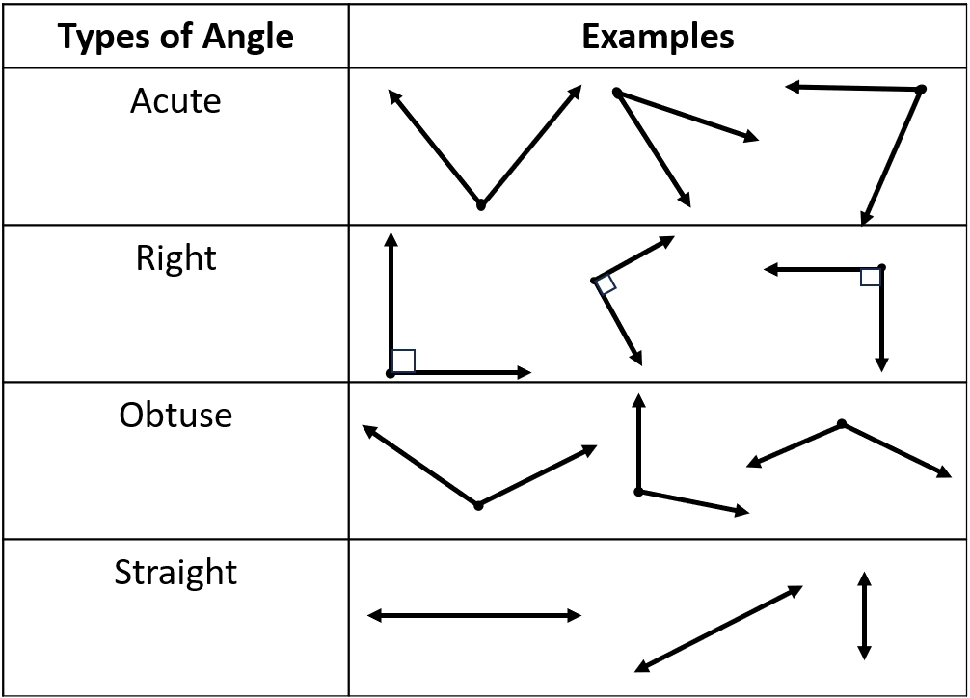

* Protractors, straight edges, or angle rulers are tools that could be used to measure the number of degrees in an angle. Students should have experiences using protractors, angle rulers, or straight edges – as well as available technology – to draw and measure angles. A straight edge may be a ruler or another tool with one accurately straight edge.

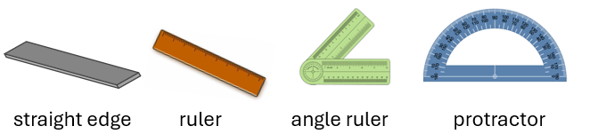

* Right angles can be used as an important benchmark. Before measuring an angle, first compare the angle to a right angle to determine whether the measure of the angle is less than or greater than 90 degrees.
* Angle measures are additive. When an angle is decomposed into non-overlapping parts, the angle measure of the whole is the sum of the angle measures of the parts.
* Students should have opportunities to measure the three angles of various triangles to find that the sum of the three angles in a triangle is 180 degrees.
* Given the measures of two angles in a triangle, the third angle measure can be determined through problem solving.
* A triangle can be classified according to the measure of its largest angle:
  + A right triangle has one right angle.
  + An obtuse triangle has one obtuse angle.
  + An acute triangle has three acute angles.
* A triangle can be classified according to the length of its sides:
  + An isosceles triangle has at least two congruent sides.
  + An equilateral triangle has three congruent sides. All angles of an equilateral triangle are congruent and measure 60 degrees.
  + An equilateral triangle is a special case of an isosceles triangle (which has at least two congruent sides).
  + A scalene triangle has no congruent sides.
* Triangles can be classified by the measure of their largest angle and by the measure of their sides, as shown in the following example:

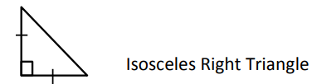

* Examples of right, obtuse, acute, equilateral, isosceles, and scalene triangles are shown in the chart below. Congruent sides are denoted with the same number of hatch (or hash) marks on each congruent side.

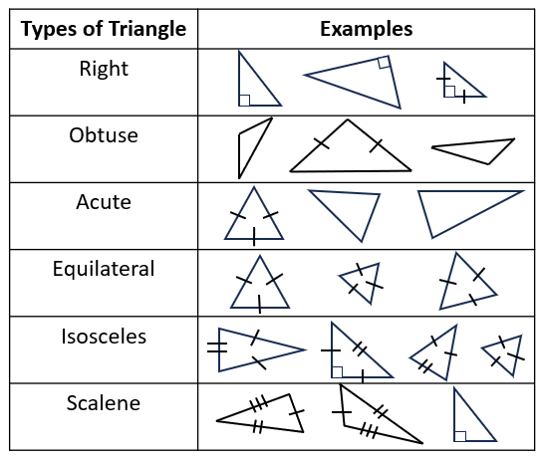

###### Skills in Practice

While the five process goals are expected to be embedded in each standard, the Skills in Practice highlight the most prevalent process goals in relation to the content presented.

**Mathematical Problem Solving:** Using models to prove that the sum of the interior angles of a triangle is 180 degrees and using this relationship to determine an unknown angle measure in a triangle are interrelated. In addition, students can apply problem types (e.g., join, separate), number bonds, and part-part-whole models from previous grades to determine an unknown angle measure when given the other two angles in a triangle.

* **Investigating the sum of the interior angles using concrete manipulatives:** Using a straightedge, pencil, and paper, instruct students to draw a triangle. Have students highlight or color over the sides of the triangle, making sure that some of the coloring appears just inside the triangle. Students should then cut out the triangle.

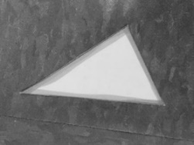

Example of a cut-out triangle with highlighted sides.

* Have students to work with a partner. Students should determine the type of triangle created based on its sides and its angles. Circulate around the room, listening to students’ descriptions of their triangles, informally assessing student understanding. Listen for words like *isosceles, scalene, equilateral, right, obtuse,* and *acute*. For example, the triangle above can be described as a scalene acute triangle.
* Next, have students tear off each angle of the triangle, making sure the angles are large enough to handle. Have each student draw a straight angle using their straightedges and pencils. Students should be able to describe a straight angle as an angle that measures 180 degrees.

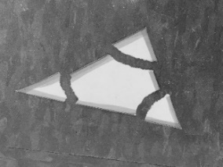

Example of a triangle with torn off angles.

* Next, have students line up the three angles they have torn off the triangle along the straight angle they have drawn, making sure the angles’ vertices are lined up with the straight angle’s vertex. (The highlighted sides of each angle should be touching.)

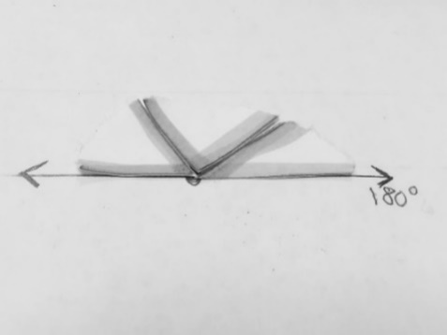

* Students should be able to see that the angles of their triangles form a straight angle when lined up. Ask students, *“What statement can we make about the sum of the interior angles of a triangle?”* Students should be heard discussing how a straight angle measures 180 degrees and the three angles of a triangle form a straight angle. As a class, create a formal statement about the sum of the angles of a triangle: *“The sum of the interior angles of a triangle equals 180 degrees.”*
* **Investigating the sum of the interior angles using pictorial representations to transition to the standard algorithm when an angle measure is unknown:**
* Consider triangle *ABC* as shown below:

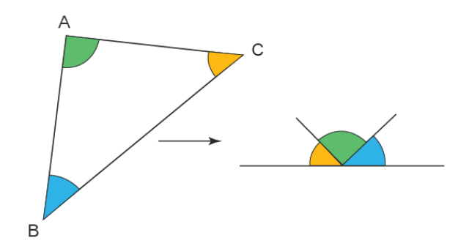

All three angles of the triangle when rearranged, constitute one straight angle. Therefore, $∠A+∠B+∠C={180}^{o}$.

Consider the next example to understand using the standard algorithm to find the unknown angle measure.

Triangle ABC has angles ∠ $A={40}^{o}$ and ∠ $B={60}^{o}$. The measure of ∠ $C$ is unknown.

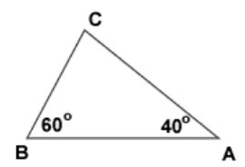

Determine the measure of ∠ $C$.

Because the sum of interior angles of a triangle equal 180o, ∠ can be calculated by:

* + - ∠ ∠ + ∠ = 180o
* 40o + 60o + ∠ = 180o  and 40 o + 60 o = 100 o
* 100 o + ∠ = 180o  = 180o – 100o
* Therefore, ∠ = 80o
* Examples with common misconceptions follow:
* Below are two straight angles. Use the given angles to help you determine the missing angle measure.

Top left picture is a straight angle. The angle given is 140 degrees. There is a question mark above the missing angle. 
The top right picture is a straight angle. A 45 degree angle and a 90 degree angle are labeled. There is a question mark above the missing angle. Each picture has a blank box underneath to record the missing angle measure.

The map below shows where Pine Street, Oak Street, and Maple Street intersect. Oak Street and Pine Street intersect at a right angle. Pine Street and Maple Street form a 35-degree angle where they intersect. What is the measure of angle x, formed where Maple Street and Oak Street intersect?

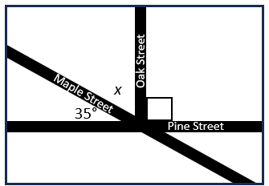

Some students may have difficulty because they may not recall that the measure of a straight angle is 180 degrees, making the task of finding the missing angle measure challenging. Also, some students who recall this information may have difficulty finding the missing measure to make the 180-degree measure. Teachers may wish to have students use part-part-whole organizers to help students see the part they are trying to determine and how it relates to the whole measure of the straight angle. Teachers may facilitate discussions where students can communicate their strategies for determining missing angles using the properties of angles.

* Explain your strategy for determining the measure of ∠B in the triangle below.

Right Triangle Pictured

The Right Triangle has a square corner labeled at angle A and a 45 degree angle labeled at angle C. Angle B is not labeled. 

Some students may have difficulty recalling the symbolic notation for right angles in addition to not understanding the sum of a triangle’s angle measurement. Teachers may wish to review symbolic notation using anchor charts. Teachers may wish to facilitate discussions where students share their strategies for determining a missing angle measure and have students write in math journals about their strategies for finding a missing angle measurement. Teachers should be aware that some students will get this answer correct only because they use the same number that they already see in the figure. It is important that they be able to explain why they are correct.

**Mathematical Reasoning:**

* **Classifying angles:** Use angle manipulatives, pictorial representations, and graphic organizers to help students to classify angles. Graphic organizers like the one below will help students use the appropriate vocabulary and provide a visual reference and definition. Other graphic organizers such as Frayer models where students define, provide characteristics, and create examples and non-examples will be helpful to students as they classify angles.

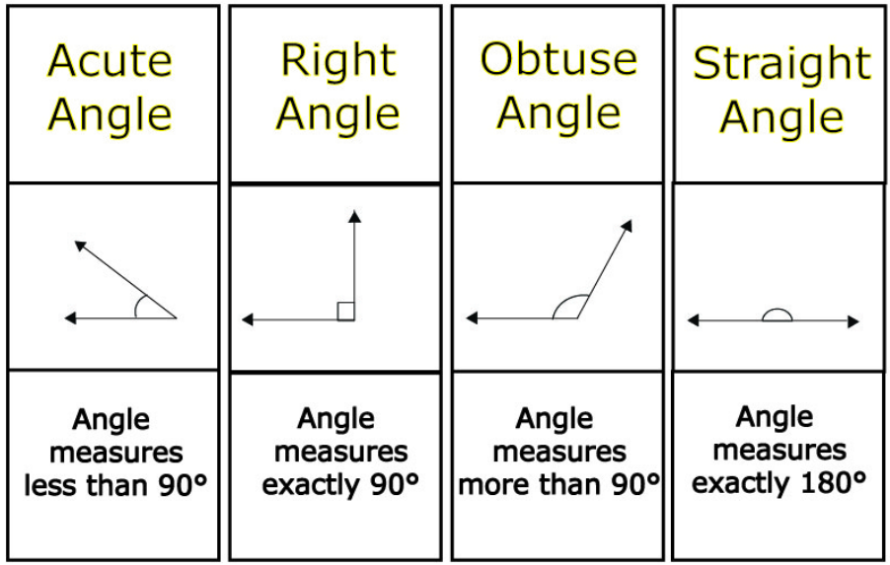

* **Classifying triangles:** Students at a visualization stage can observe, build, take apart, or work with geometric figures within some manner. As students learn about the properties of triangles, teachers should construct activities that progress them through the (van Hiele) levels of visualization, analysis, informal deduction, and deduction. There are multiple methods to help students classify triangles by their sides and angles (right, acute, or obtuse and equilateral, scalene, or isosceles).
  + **Triangle Sort:** Have students work in groups of four with a set of triangles as pictured, doing the following related activities in order:

Each student selects a triangle. In turn, students share 1-2 things that they notice about their triangle. Students each randomly select two triangles and try to find something that is alike about their two shapes and something that is different.

The group selects one target triangle at random and places it in the center of the workspace. Students are to find all of the other triangles that are like the target triangle according to the same rule. For example, students may say, “This triangle is like the target triangle because it has three acute angles.” Then all other triangles that students put in the collection must have that property.

Create a secret sort, where students (or the teacher) create a collection of four triangles that fit a secret rule (see example triangles below). Leave others that belong in the group in the pile. The other students are to find the additional pieces that belong to the set and/or guess the secret rule.

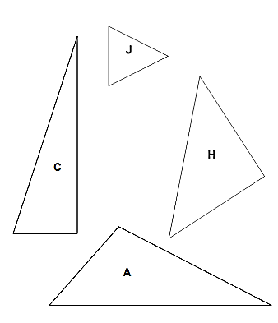 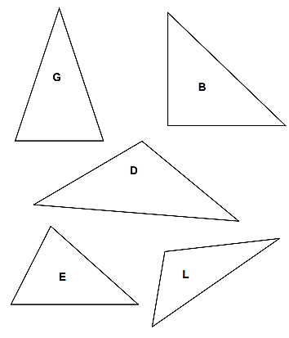 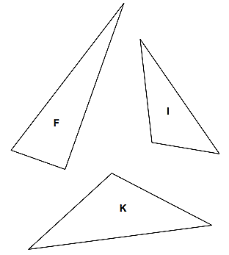

* + **Triangle Sort (Partner Extension):** Have one student select at least two triangles (see figures above) that are alike and explain to their partner why they chose those triangles. Then, have partners switch roles.
  + Encourage students to use vocabulary they have learned about special types of angles. Similarly, each student should select two triangles that are different and explain to their partner why they chose them. Allow teams some time to go through several rounds. Walk around and note the vocabulary students are using, making note of which students appear to have misconceptions. Debrief with the whole class by allowing volunteers to share the triangles they chose and their observations. The teacher writes their responses on the board. Possible answers might be, *“I chose triangles C and F because both are long and skinny,”* or “*Triangle C and Triangle E are different because one is tall and skinny, and the other is short and fat.”* For this type of answer, the teacher might encourage the student to use vocabulary that they learned related to angles; these statements could be rephrased, *“I chose triangles C and F because both appear to have right angles,”* or *“Triangle E has all acute angles, and Triangle K has an obtuse angle.”*
  + Students may also put triangles together based on side lengths*, “I put triangles D and G together because the sides are all the same,”* or *“Triangles D and I are both tall triangles.”* For these, encourage students to measure the lengths of the sides with rulers to justify their answers.
  + Have partners sort the triangles into groups that have similar characteristics and describe each group in writing. As students are sorting the triangles, circulate around the room looking for students who have grouped the triangles by sides (equilateral, isosceles, scalene) and/or angles (right, acute, obtuse). When students have finished grouping, ask specific groups of students to share how they grouped the triangles, and give those triangles a name. For example, if a group of students put triangles together in a group because each one has three equal sides, the teacher can define these as *equilateral triangles,* a special type of isosceles triangle because they have three equal sides.

The teacher should indicate sides that are the same length with hash/hatch marks, as shown below.

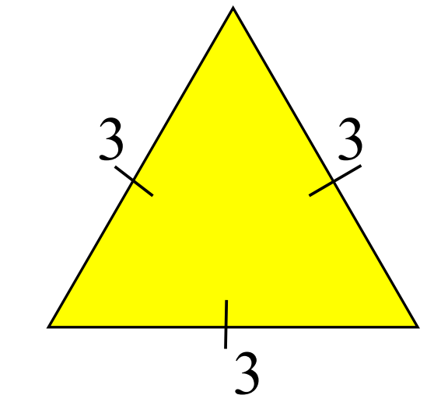

Similarly, for isosceles triangles, the hash/hatch marks would be as shown below, with marks on the two congruent sides.

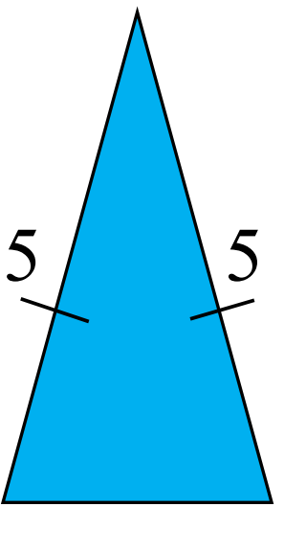

Continue discussing the groupings of each type of triangle until all three types of triangles are named by angle (acute triangle, obtuse triangle, and right triangle) and all three types of triangles are named by sides (equilateral triangle, isosceles triangle, and scalene triangle). For triangles defined by lengths of their sides, encourage students to prove each type by measuring each side with a ruler.

**Mathematical Representations:** As students measure right, acute, obtuse, and straight angles, they must use appropriate tools (e.g., protractor, straightedge, angle ruler, available technology), and identify measures in degrees. Some students may have difficulty visualizing both obtuse and acute angles. To address this, the students may need to compare two angles by using a transparency to trace an angle and place it over another angle. This can help them notice the rays of the angles. Additional strategies follow –

Introduce a protractor and show the difference between an acute angle and an obtuse angle. Students will need this understanding to determine whether the measure of an angle is reasonable based on the relationship of the angle to the right angle.

* Direct students to sketch angles of specified measure. To do this, begin by drawing a ray that is the line of reference for the angle. The other ray of the angle will be drawn from this one. Place the origin of the protractor at a point on the ray. The point will become the vertex. Align the base line of the protractor with the ray just created. Make a spot on the paper at the degree of measurement, such as 75 degrees, and draw the ray past the protractor’s arc. Students will need many examples to be able to create sketches of angles.
* Demonstrate how to use a protractor by placing the origin of the protractor over the point or vertex of the angle to be measured. Next, align the bottom line of the angle with the base line and follow the top line of the angle up to the measurements on the protractor’s arc. Remember that smaller angles will be less than 90 degrees and wider angles will be more than 90 degrees. It will be beneficial that students engage in the Mathematics Tools Practice and Grade 5 Mathematics Practice Problems in TestNav8 to become comfortable with the rendering and orientation of the protractor. For example –

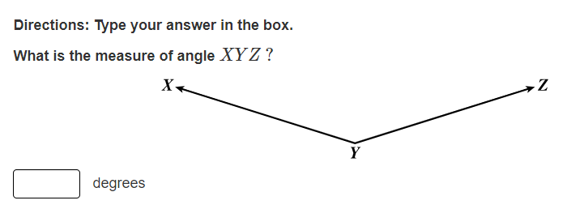 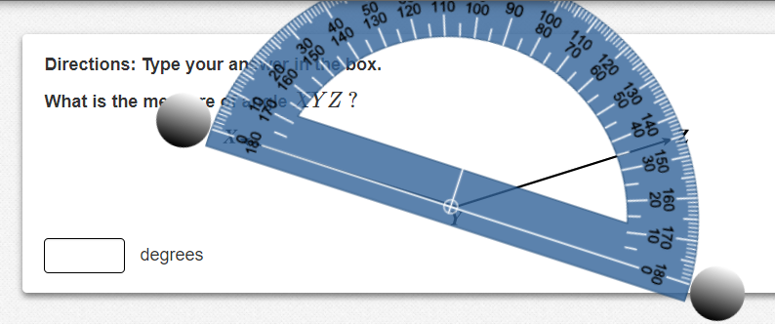

###### Concepts and Connections

Concepts

Analyzing and describing geometric objects, the relationships and structures among them, or the space that they occupy can be used to classify, quantify, measure, or count one or more attributes.

Connections

* *Within the grade level/course*:
  + 5.MG.1 – The student will solve problems, including those in context, that involve length, mass, and liquid volume using metric units.
  + 5.MG.2 – The student will use multiple representations to solve problems, including those in context, involving perimeter, area, and volume.
* *Vertical Progression*:
  + 4.MG.5 – The student will classify and describe quadrilaterals (parallelograms, rectangles, squares, rhombi, and/or trapezoids) using specific properties and attributes.
  + 4.MG.6 – The student will identify, describe, compare, and contrast plane and solid figures according to their characteristics (number of angles, vertices, edges, and the number and shape of faces), with and without models.
  + 6.MG.1 – The student will identify the characteristics of circles and solve problems, including those in context, involving circumference and area.
  + 6.MG.2 – The student will reason mathematically to solve problems, including those in context, that involve the area and perimeter of triangles and parallelograms.

Across Content Areas

Reference 5.MG.1.

###### Resources to Support Local Curriculum

* A list of approved textbooks and instructional materials is posted on the VDOE [website](https://www.doe.virginia.gov/teaching-learning-assessment/k-12-standards-instruction/mathematics/2024-mathematics-textbooks).

## Probability and Statistics

In K-12 mathematics, probability and statistics introduce students to the concepts of uncertainty and data analysis. Probability involves understanding the likelihood of events occurring, often using concepts such as experiments, outcomes, and the use of fractions and percentages. The formal study or probability begins in Grade 4. Statistics focuses on collecting, organizing, and interpreting data and includes a basic understanding of graphs and charts. Probability and statistics help students analyze and make sense of real-world data and are fundamental for developing critical thinking skills and making informed decisions using data.

In Grade 5, students learn that the world can be investigated through posing questions and collecting, representing, analyzing, and interpreting data to describe and predict events and real-world phenomena. At this grade level, students apply the data cycle (formulate questions; collect or acquire data; organize and represent data; and analyze data and communicate results) with a focus on line plots (dot plots) and stem-and-leaf plots. Students solve contextual problems using measures of center and the range; and determine the probability of a simple event by constructing a model of a sample space and use the Fundamental (Basic) Counting Principle.

### 5.PS.1

##### The student will apply the data cycle (formulate questions; collect or acquire data; organize and represent data; and analyze data and communicate results) with a focus on line­­ plots (dot plots) and stem-and-leaf plots.

1. Students will demonstrate the following Knowledge and Skills:
2. Formulate questions that require the collection or acquisition of data.
3. Determine the data needed to answer a formulated question and collect or acquire existing data (limited to 30 or fewer data points) using various methods (e.g., polls, observations, measurements, experiments).
4. Organize and represent a data set using a line plot (dot plot) with a title, labeled axes, and a key, with and without the use of technology tools. Line plots (dot plots) may contain whole numbers, fractions, or decimals.
5. Organize and represent numerical data using a stem-and-leaf plot with a title and key, where the stems are listed in ascending order and the leaves are in ascending order, with or without commas between the leaves.
6. Analyze data represented in line plots (dot plots) and stem-and-leaf plots and communicate results orally and in writing:
   1. describe the characteristics of the data represented in a line plot (dot plot) and stem-and-leaf plot as a whole (e.g., the shape and spread of the data);
   2. make inferences about data represented in line plots (dot plots) and stem-and-leaf plots (e.g., based on a line plot (dot plot) of the number of books students in a bus line have in their backpack, every student will have from two to four books in their backpack);
   3. identify parts of the data that have special characteristics and explain the meaning of the greatest, the least, or the same (e.g., the stem-and-leaf plot shows that the same number of students scored in the 90s as scored in the 70s);
   4. draw conclusions about the data and make predictions based on the data to answer questions; and
   5. solve single-step and multistep addition and subtraction problems using data from line plots (dot plots) and stem-and-leaf plots.

###### Understanding the Standard

* Students should explore the entire data cycle with a question and set of data that has been collected or acquired. Student reflection should occur throughout the data cycle. The data cycle includes the following steps: formulating questions to be explored with data, collecting or acquiring data, organizing and representing data, and analyzing and communicating results.

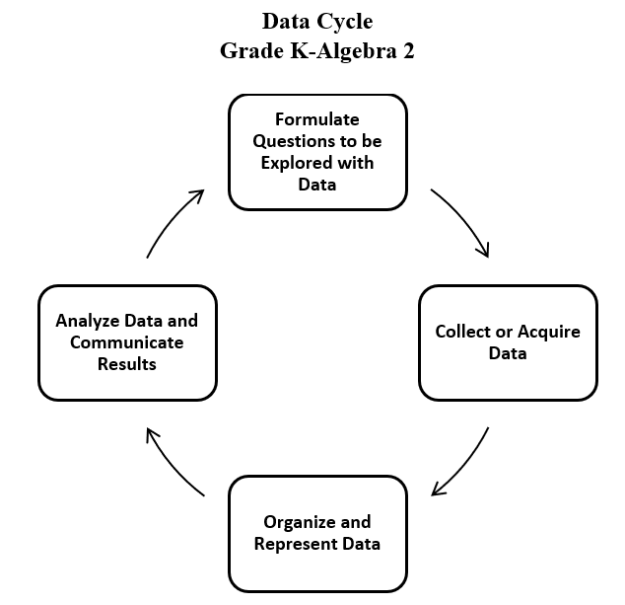

* Statistics is the science of conducting studies to collect, organize, summarize, analyze, and draw conclusions from data.
* The emphasis in all work with statistics should be on the analysis of the data and the communication of the analysis. Data analysis should include opportunities to describe the data, recognize patterns or trends, and make predictions.
* Statistical investigations should be active, with students formulating questions about something in their environment and determining ways to answer the questions.
* Investigations that support collecting data can be brief class surveys or more extended projects occurring over multiple days.
* There are two types of data: categorical and numerical. Categorical data can be sorted into groups or categories while numerical data are values or observations that can be measured. For example, types of fish caught would be categorical data while weights of fish caught would be numerical data. While students need to be aware of the differences, at this level, they do not have to know the terms for each type of data.
* Prior to Grade 5, students engaged with object graphs, picture graphs, pictographs, tables, bar graphs, and line graphs. In Grade 5, students focus on data represented in line plots (also referred to as dot plots) and stem-and-leaf plots.
* A line plot shows the frequency of data on a number line. Line plots are used to show the spread of the data, to include clusters (groups of data points) and gaps (large spaces between data points), and quickly identify the range, mode, and any extreme data values.
* To create a line plot, ​first create a part of a number line that includes all the values in the data set.
* Provide a title for the line plot that communicates the context from which the data was collected.
* Next, place an X (or dot) on the number line above each value in the data set. If a value occurs more than once in a data set, place ​an X​ over that number for *each* time it occurs. Provide a key for the line plot.

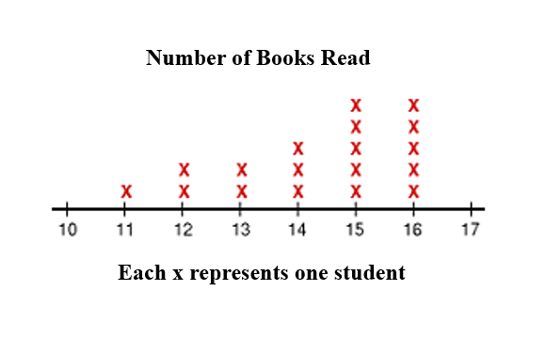 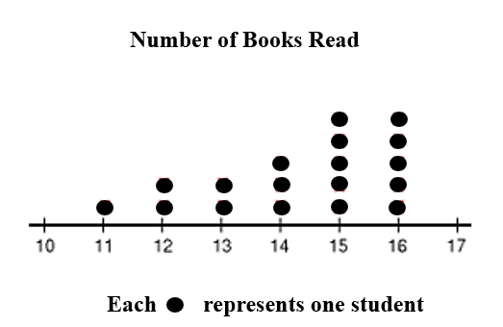

* In the line plot above, the number of X’s shows that 18 students provided data.
* The range (e.g., the spread) of a data set is the difference between the largest value and the smallest value in the data set. In the line plot above, the range can be found by subtracting 11 from 16 which is 5.
* The mode of a data set is the value that occurs the most often. The line plot above has two modes, 15 and 16.
* By observing the line plot above, one can see that every student read more than ten books, and most of the students read more than 13 books.
* Line plots (dot plots) may contain whole numbers, fractions, or decimals. The dot plot below represents times, in seconds, for a 100-yard dash:

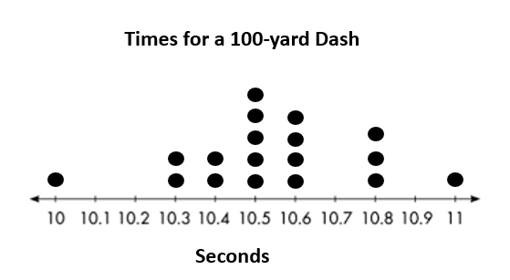

* A stem-and-leaf plot, like the one shown below, has the following characteristics:
  + A stem-and-leaf plot uses columns and rows to display a summary of discrete numerical data while maintaining the individual data points.
  + The data are organized from least to greatest.
  + Each value is separated into a stem and a leaf (e.g., two-digit numbers are separated into stems (tens) and leaves (ones)).
  + The stems are listed vertically from least to greatest with a line to their right. No stem can be skipped. For example, in the stem-and-leaf plot below, there are no data for the stem 5, thus 5 is listed but shows no leaves.
  + The leaves are listed horizontally, also from least to greatest, and can be separated by spaces or commas. Every value in the data set is recorded, regardless of the number of repeats (e.g., in the line plot below, the number 62 is represented three times).
  + A title is displayed to provide context for the data and a key is included to explain how to read the stem-and-leaf plot.
* A stem-and-leaf plot displays each piece of data to show the shape and distribution of the data as a whole.

|  |  |
| --- | --- |
| **Minutes Walked Per Student During the Weekend** | |
| Stem | Leaf |
| 0 | 6 |
| 1 | 5,7,8 |
| 2 | 1,4,5,6 |
| 3 | 1,3,7,7,7 |
| 4 | 0,0,4,8 |
| 5 |  |
| 6 | 2,2,2,3,8 |
| Key 2|5 = 25 | |

* The stem-and-leaf plot above displays data for the number of minutes each student in class walked last weekend. Using the shape and distribution of the stem-and-leaf plot the following interpretations can be made:
  + The number of leaves shows that 22 students submitted data.
  + The least number of minutes walked was 6 and the greatest number of minutes walked was 68.
  + The difference between 6 and 68 is the range of the data or 62 minutes.
  + The same number of students walked 37 as walked 62 minutes.
  + A prediction could be made that based on the shape of the data and the clustering in the 20s, 30s, and 40s, it is likely that a new student entering the class would walk more than 20 minutes but less than 50 minutes.
* Different situations call for different types of graphs (e.g., visual representations). The way data are displayed is often dependent upon what question is being investigated and what someone is trying to communicate.
* Students should have experiences displaying data in a variety of graphical representations, and determining which representation is most appropriate (e.g., a representation that is more helpful in analyzing and interpreting the data to answer questions and make predictions). Interpretations of the data that include comparisons, inferences, and recognizing trends that may exist are made by examining characteristics of a data set displayed in a variety of graphical representations.
* Comparing different types of representations (e.g., charts, graphs, line plots, stem-and-leaf plots) provides students with opportunities to learn how different graphs can show different aspects of the same data. Following the construction of representations, discussions around what information each representation provides or does not provide should occur.
* Tables or charts organize the exact pieces of data collected and display numerical information. They do not show visual comparisons, which generally means it takes longer to notice and identify trends.
* Grade 5 introduces some ways to describe data sets using measures of center (e.g., mode, mean, and median) and measures of spread of the data (e.g., range). Standard 5.PS.2 explains the knowledge and skills for the standard and provides information about using measures of center and spread.
* At this level, students may start to notice characteristics about the data, such as clusters or outliers. While students are not expected to mathematically determine outliers in a data set, they may visually notice when one data point is by itself. For example, in the line plot below, students may notice that the data is clustered around the values 36 to 38 or they may observe that the X over 31 is an outlier in the data set.

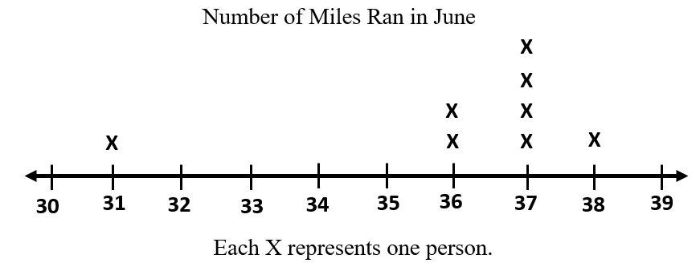

* When comparing different data representations, it is important to ask questions such as:
  + What inferences can you make?
  + What do you notice about the data?
  + In which representations can you identify individual data points?
  + In which representations can you quickly identify the mode or median? The range?
* Students would benefit from exploring previously taught graphical representations when justifying how to best represent data clearly and accurately. Comparing different types of representations (charts and graphs) provides an opportunity to learn how different graphs can show different things about the same data. Discussions around what information different graphs representing the same data provides is beneficial for determining which graphical representation best represents the data.

###### Skills in Practice

While the five process goals are expected to be embedded in each standard, the Skills in Practice highlight the most prevalent process goals in relation to the content presented.

**Mathematical Communication:** Students should be led to discussions of discrete numerical data – data that can only take certain values and has a limited range of values (e.g., whole numbers). At this grade level, students should ask questions that are answered with a numerical answer falling within a reasonable range.

* As students are formulating questions, they should consider –
  + What type of data can be collected for this question?
* Line (dot) plots and stem-and-leaf plots require a count.
  + Can the question be answered with numerical data?
  + Is there a limited range of values?
* Data displays are intended to illustrate the shape and distribution of the data set.
  + Does the line (dot) plot or stem-and-leaf address the question?
* The labels are key to communication.
  + What title and labels are necessary to clearly communicate?
  + Does a key need to be included?

**Mathematical Reasoning:** The purpose of analyzing data is to inform decisions. When analyzing data, students should be looking for patterns and make predictions based on those patterns. Statements that represent an analysis and interpretation of the data of the plot should be created by students and shared in writing and orally. Further, these statements should express predictions based on analysis and interpretation of the data in plots. Consider the following examples and misconceptions students may have interpreting and analyzing data:

* Tammie recorded the number of envelopes received in the mail on each of ten days.

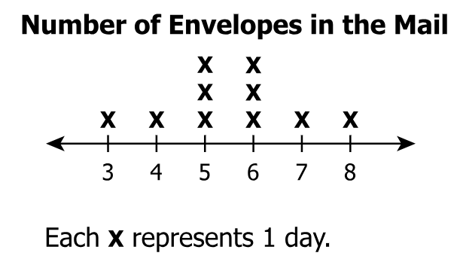

* + What is the total number of days on which Tammie received at least 6 envelopes in the mail?

Students may not include the number of days when 6 envelopes were received and incorrectly determine the answer to be 2 instead of 5. Students often do not understand the terminology “at least” to be inclusive of the number given. Multiple experiences and discussions with real world situations involving “at least” will be helpful in solidifying this understanding (e.g., minimum height required to ride a roller coaster, minimum age required to have an online account, etc.).

* Mrs. Yi recorded the total number of minutes each student in her class read during a four-day period. The stem-and-leaf plot shows the total number of minutes each student read during the four-day period.

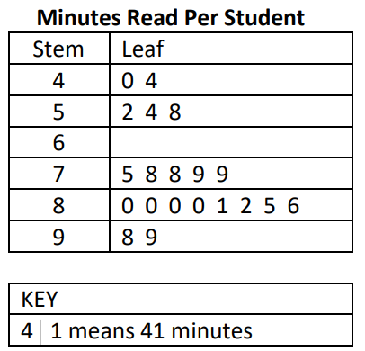

* How many students read between 75 and 80 minutes?

Students may not understand the meaning of “between” two numbers. Students with this misconception may benefit from using a number line. Have students shade “less than”, “between”, and “greater than” given numbers on a number line. This will provide them a visual representation of the vocabulary terms. Be sure to also include practice with “greater than or equal to” and “less than or equal to.”

Similar misconceptions may exist with the terminology “fewer”, or “no more than”. Creating anchor charts or word wall cards with these vocabulary terms and examples will also benefit students.

**Mathematical Representations:** Students should be given opportunities to look at the same data presented in different plots and determine which is the most effective representation. Students could also consider which question types would be best represented by different types of plots. Students should return to their question to see if their data answers the question and if not, consider at which point in the cycle they would want to modify their process to gather better data or represent the data in a more meaningful way. Consider the following example and questions that can guide student thinking when representing data:

* Mr. Fox recorded the grades 16 students earned on a quiz.

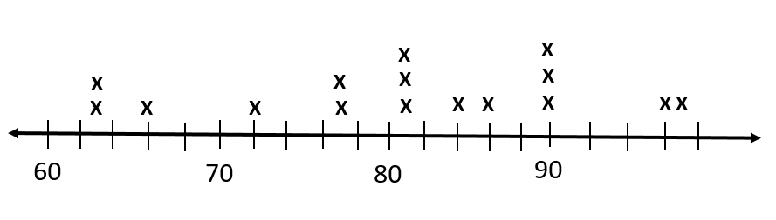 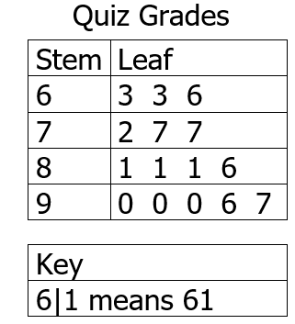

* What is the interval for the scale in the line plot?
* Mr. Fox thought he recorded the same data on both representations. Which data point did Mr. Fox forget to include on the stem-and-leaf plot?
* Which grade occurred most often? Is it easier to identify this information in the line plot or the stem-and-leaf plot?
* What questions could be answered about this data using these representations?

###### Concepts and Connections

Concepts

The world can be investigated through posing questions and collecting, representing, analyzing, and interpreting data to describe and predict events and real-world phenomena.

Connections

* *Within the grade level/course*:
  + 5.PS.2 – The student will solve contextual problems using measures of center and the range*.*
  + 5.PS.3 – The student will determine the probability of an outcome by constructing a model of a sample space and using the Fundamental (Basic) Counting Principle.
* *Vertical Progression*:
  + 4.PS.1 – The student will apply the data cycle (formulate questions; collect or acquire data; organize and represent data; and analyze data and communicate results) with a focus on line graphs.
  + 6.PS.2 – The student will apply the data cycle (formulate questions; collect or acquire data; organize and represent data; and analyze data and communicate results) with a focus on circle graphs.

Across Content Areas [Theme – Using Data]

* *Science:* 
  + 5.3b – The student will plan an experiment to collect time and position data for a moving object in a table and line graph and interpret the data to determine if the speed of the object was increasing, decreasing, or remaining the same.
  + 5.3c,d – The student will interpret data in graphs, charts, and/or diagrams related to force and the motion of objects
  + 5.3c,e – The student will plan and conduct an investigation to test the question, “What is the relationship between motion and mass?”
  + 5.3e – The student will plan and conduct an investigation to determine the effect of friction on moving objects.
  + 5.5a – The student will collaboratively plan and conduct an investigation to demonstrate that vibrating materials can produce sound and transmit energy, determine data that should be collected and organized to identify patterns, and communicate findings.
  + 5.9a – The student will analyze and interpret data showing human consumption of energy over the last century and infer what might happen if the trend in energy consumption continues.
* *Computer Science:* 
  + 5.CSY.1 – The student will explain how computing systems are used to collect and exchange data (a) identify and explain how computing systems store data representations, including images and sound; and (b) describe the role of processing speed and storage capacity when collecting and exchanging data.
  + 5.DA.1 – The student will collect data or use data sets to solve a problem or investigate a topic (a) identify accurate ways data can be collected; (b) evaluate reliability of data source; (c) organize data based on similarities or patterns; and (d) compare and contrast various data elements.
  + 5.DA.2 – The student will create multiple data representations to make predictions and conclusions (a) formulate questions that require the collection or acquisition of data; (b) collect data to use in creating charts, graphs, and models; (c) analyze data as evidence to draw conclusions and make predictions; and (d) propose solutions to problems or questions based on data analysis.

Across Content Areas [Theme – Graphing]

* *Science:* In fifth grade students are expected to represent and analyze data using tables and graphs and organize simple data sets to reveal patterns that suggest relationships. Depending on the data collected in an investigation, they may use graphs to visualize the data.
  + 5.3b – The student will plan an experiment to collect time and position data for a moving object in a table and line graph and interpret the data to determine if the speed of the object was increasing, decreasing, or remaining the same.
  + 5.3c,d – The student will interpret data in graphs, charts, and/or diagrams related to force and the motion of objects.
  + 5.7c – The student will measure and graph quantities to demonstrate that, regardless of the type of change that occurs when heating, cooling, or mixing substances, the total mass of matter is unchanged.
  + 5.8d – The student will analyze and interpret data showing human consumption of energy over the last century and infer what might happen if the trend in energy consumption continues.
  + 5.9b – The student will locate, chart, and report weathering, erosion, and deposition at home or on the school grounds; create and implement a plan to reduce weathering, erosion, and/or deposition problems that may be found and discuss the results of the experiment.
* *Computer Science:* 
  + 5.DA.2 – The student will create multiple data representations to make predictions and conclusions (b) Collect data to use in creating charts, graphs, and models.
* *Digital Learning Integration:*
  + 3-5 CT.B. Students select and use appropriate technologies to represent data, which will be used for interpretation and evidence-based decision making.

###### Resources to Support Local Curriculum

* A list of approved textbooks and instructional materials is posted on the VDOE [website](https://www.doe.virginia.gov/teaching-learning-assessment/k-12-standards-instruction/mathematics/2024-mathematics-textbooks).
* Statistics: Learning About Data ([Word](https://www.doe.virginia.gov/home/showpublisheddocument/51817/638398747157300000) | [PDF](https://www.doe.virginia.gov/home/showpublisheddocument/51819/638398747163100000))
* Data Cycle Teacher Resource ([PPT](https://www.doe.virginia.gov/home/showdocument?id=52083&t=638411641481970000) | [PDF](https://www.doe.virginia.gov/home/showdocument?id=52081&t=638411641475400000))

### 5.PS.2

##### The student will solve contextual problems using measures of center and the range.

1. Students will demonstrate the following Knowledge and Skills:
2. Describe mean as fair share.
3. Describe and determine the mean of a set of data values representing data from a given context as a measure of center.
4. Describe and determine the median of a set of data values representing data from a given context as a measure of center.
5. Describe and determine the mode of a set of data values representing data from a given context as a measure of center.
6. Describe and determine the range of a set of data values representing data from a given context as a measure of spread.

###### Understanding the Standard

* Students should have opportunities to build a conceptual understanding of the measures of center (e.g., mean, median, and mode) and the spread (e.g., range) of various data sets.
* The mean, median, mode, and range are four ways that data can be analyzed.
* The mean, or average, represents a fair share of the data. Equally dividing the sum of all values in the data set by the number of values in the data set constitutes a fair share. Mean can be thought of as a number that each member of a group would have if all the data values were combined and distributed equally among the members.
* The idea of dividing as sharing equally should be demonstrated visually and with manipulatives to develop the conceptual foundation for the arithmetic process.
* Using connecting cubes, as in the following problem, is one way of visually representing mean as fair share.

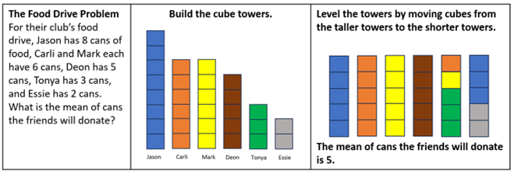

* In Grade 6, students will learn about the mean as the balancing point.
* The median is the middle number of a data set that has been ordered from least to greatest. If there are an odd number of data values, the median is the middle value in ranked order. For example –

List of numbers: 6, 7, 8, 9, 9
Arrow pointing to 8
8 = median

* If there are an even number of data values, the median is the average of the two middle values. For example –

List of numbers: 5, 6, 8, 9, 11, 12
Number line showing the midpoint between 8 and 9.
8.5 = median

* The mode is the data value that occurs most frequently in the data set. There may be one, more than one, or no mode in a data set. Organizing the data from least to greatest supports an efficient observation of the data and makes it easier to identify the mode(s) of a data set. Consider the following examples:

List of numbers: 6, 7, 8, 9, 9
9 = mode List of numbers: 6, 8, 10, 11, 15, 20
no mode List of numbers: 2, 2, 2, 3, 7, 9, 9, 9
2 and 9 = mode

* The range is the spread of a set of data. The rangeof a set of data is the difference between the greatest and least values in the data set. It is determined by subtracting the least number in the data set from the greatest number in the data set. For example –

List of numbers: 6, 7, 8, 9, 9
6 least value in the data set
9 greatest value in the data set
range = 9 - 6 = 3

* Given the following data set of students’ test scores 73, 77, 84, 87, 89, 91, 94:
  + the mean can be determined by adding the test scores then dividing by the number of values in the data set. 73 + 77 + 84 + 87 + 89 + 91 + 94 = 595. Then 595 $÷$ 7 = 85. The mean, or average score, is 85.
  + the median can be determined by the value of the middle number when ordered from least to greatest. Because this data set has seven values, the mode is the fourth value, which is 87.
  + the mode can be determined by seeing if any individual value appears more than the other values. In this data set of test scores, there is no mode because each score appears one time.
  + the range can be determined by subtracting the least value from the greatest value in the data set. Thus, the range is 94 – 73 = 21.
* Opportunities to build a conceptual understanding of what the range tells about the data, and seeing the values in context of other characteristics of the data should be given.
* Line plots and stem-and-leaf plots (see “Understanding the Standard” for SOL 5.PS.1) are visual representations that allow students to quickly determine the range and mode(s) of a data set. They can also be used to determine the median and mean of a data set.

###### Skills in Practice

While the five process goals are expected to be embedded in each standard, the Skills in Practice highlight the most prevalent process goals in relation to the content presented.

**Mathematical Connections:**

* The mean can be thought about in terms of “fair share” or “leveling out.” Specifically, the mean can be thought of as a number that each member of a group would have if all the data values were combined and distributed equally among the members. For example –

Suppose there are 5 bottles that contain the following amounts of water: 1 liter, 4 liters, 2 liters, 3 liters, and 0 liters.

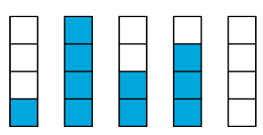

To find the mean, add up all of the values: 1 + 4 + 2 + 3 + 0 = 10.

Image. The values from each of the 5 bottles above are added. One horizontal unit of 10 is shaded completely based on the sum of the 5 bottles in the previous picture. 

To find the fair share, equally divide the 10 liters into the 5 containers: 10 $÷$ 5 = 2

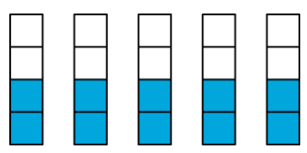

* Students must have opportunities to describe the mean as a fair share. This idea of dividing as sharing equally should be demonstrated visually and with manipulatives to develop the foundation for the arithmetic process. Examples with common misconceptions follow –

A family of chipmunks are storing acorns for the winter. Each of the five chipmunks has gathered some acorns as shown in the table below. Each chipmunk in this family wants to have the same number of acorns. Draw a picture to show a fair share of acorns each chipmunk should receive. What measure of center did you use in your drawing?

| **Chipmunk** | **Acorns** |
| --- | --- |
| A | 2 |
| B | 4 |
| C | 3 |
| D | 6 |
| E | 5 |

A common misconception some students may demonstrate is to draw a picture of exactly what is represented in the table as their final answer. This may indicate that a student does not understand that a fair share of acorns can only be achieved by dividing all the acorns gathered equally among the five chipmunks. A teacher may find it helpful to ask follow-up questions about the students’ pictures such as, *“Does each chipmunk have the same number of acorns? What changes can be made to your picture so that each chipmunk has a fair share?”* It might be beneficial to use manipulatives such as linking cubes to model the problem if students appear to have difficulty deciding how to draw a revised picture. It is important for students to make the connection that mean represents a fair share concept of the data.

* There are apples in each of four displays at a grocery store.
  + - * + The first display has 20 apples.
        + The second display has 14 apples.
        + The third display has 12 apples.
        + The fourth display has 22 apples.

A grocery store employee wants each display to have the same number of apples. Explain what the grocery store employee should do in order for each display to have the same number of apples.

A common misconception some students may have is to consider mean as the sum of the values of the data set. This may indicate that the student organizes all of the apples into one display rather than equally dividing the apples into four displays. It might be beneficial to use manipulatives to model the problem if students appear to have difficulty determining the number of apples for each of the four displays. It is important for students to make the connection that mean represents a fair share concept of the data.

* Opportunities to build a conceptual understanding of what the range tells about the data, and seeing the values in context of other characteristics of the data should be given. The range is a measure of spread and is found by taking the greatest data value and subtracting the least data value. It is the difference between the maximum and minimum data points. For example –
  + - Find the range for the number of yards gained by Robert during his seven carries in the football game:

{2, 6, 20, 11, 8, 12, 4}

To find the range, identify the greatest and least value is 20 and the least value is 2.

The standard algorithm to determine the range is 20 – 2 = 18.

* To understand the concept of range as a measure of spread, the following example is provided with common misconceptions –

Cathy took five quizzes in her history class. Each quiz was worth 100 points. Her scores for four of the five quizzes are shown below.

85, 83, 86, 73

The spread on the quiz scores was 19. The score on the fifth quiz was either ________ or __________.

A common error students may make is finding the fifth quiz score using the range value provided and the greatest possible score (100) a student could receive on a quiz. This might indicate that a student uses the greatest possible value of the practical situation rather than the greatest value contained in the data set. For example, students might subtract 19 from 100 to find 81 as a possible fifth quiz score. In this case, it may be helpful to support students by providing them several practice sets of data to compare that the greatest value possible of the context to the greatest value contained in the data set.

Another common error students might make is subtracting 19 from both the first score and the last score in the data set to determine the fifth quiz scores. This may indicate that a student neglects to consider that the first and last score in the data set do not represent the greatest and least scores earned. In this case it might be beneficial to provide students with additional practice ordering data points from least to greatest before starting any computation to find the range or statistical measure.

**Mathematical Representations:** Mean, median, and mode are different measures of center in a numerical data set. They each try to summarize a data set with a single number to represent a “typical” data point from the data set.

* The mean minimizes error in the prediction of any one value in a data set because it produces the least amount of error from all other values in the data set. The mean includes all values in the data set as a part of the calculation.
* The median represents the middle point in a data set – half of the data points are smaller than the median and half of the data points are larger. When calculating the median, the numbers in the data set must be listed from least to greatest. If the number of data points is odd, the median is the middle data point in the list. If the number of data points is even, the median is the mean (average) of the two middle data points on the list. The median is important because it gives an idea of where the center value is located. The median is useful when the data set is skewed or has outliers. Students will observe patterns in data to identify outliers and determine their effect on mean, median, mode, or range in Grade 6 (6.PS.2c).
* The mode is the most commonly occurring data point in a data set. The mode is useful when there are a lot of repeated values in a data set. There can be no mode, one more, or multiple modes in a data set.
* Examples of describing and determining the mean, median, or mode of a set of data from a given context as a measure of center are provided below, including common misconceptions –
* David wants to find out which month has the most birthdays among the students in his class. Which measure of center is David trying to find?

Some students may incorrectly think this situation describes finding the mean. This may indicate that a student confuses finding the average number of birthdays as the highest number of occurrences. Teachers should encourage students to associate mode as occurring “most often” or being the most frequent number in a data set.

* Eighteen students in a math class lined up to get their class picture taken. The teacher asked them to line up according to their height, shortest to tallest. Which measure of center represents the height of the person in the middle of the line?

A common misconception that a student may have is to think the mean represents the height of the person in the middle of the line. Since there are 18 students in the class, to find the right median, students will need to determine the arithmetic average of the heights of the two middle students. Students may benefit from using a number line to conceptualize the meaning of median.

* This data set shows the number of balloons each of six friends has at a party: {8, 1, 6, 2, 5, 7}. Write a statement to describe the mode of the data set.

A common error for some students is to describe the range of a data set. This may indicate that a student believes the mode is described by the difference between the greatest and least values in the data set. Students would benefit from hands on experiences to develop an understanding of the measures of center in order to be able to describe them. Hands-on experiences may also help students understand why range is not included as a measure of center. Students would benefit from building an understanding of what each measure tells them about the data, and relate those values in the context of other characteristics of the data.

Another common error that some students may make is to identify the mode as 0, instead of no mode.

###### Concepts and Connections

Concepts

The world can be investigated through posing questions and collecting, representing, analyzing, and interpreting data to describe and predict events and real-world phenomena.

Connections

* *Within the grade level/course*:
  + 5.PS.1 – The student will apply the data cycle (formulate questions; collect or acquire data; organize and represent data; and analyze data and communicate results) with a focus on line­­ plots (dot plots) and stem-and-leaf plots*.*
  + 5.PS.3 – The student will determine the probability of an outcome by constructing a model of a sample space and using the Fundamental (Basic) Counting Principle.
* *Vertical Progression*:
  + There are no formal standards prior to Grade 5 that address measures of center.
  + 6.PS.2 – The student will represent the mean as a balance point and determine the effect on statistical measures when a data point is added, removed, or changed.

Across Content Areas

Reference 5.PS.1.

###### Resources to Support Local Curriculum

* A list of approved textbooks and instructional materials is posted on the VDOE [website](https://www.doe.virginia.gov/teaching-learning-assessment/k-12-standards-instruction/mathematics/2024-mathematics-textbooks).

### 5.PS.3

##### The student will determine the probability of an outcome by constructing a model of a sample space and using the Fundamental (Basic) Counting Principle.

1. Students will demonstrate the following Knowledge and Skills:
2. Determine the probability of an outcome by constructing a sample space (with a total of 24 or fewer equally likely possible outcomes), using a tree diagram, list, or chart to represent and determine all possible outcomes.
3. Determine the number of possible outcomes by using the Fundamental (Basic) Counting Principle.

###### Understanding the Standard

* A spirit of investigation and experimentation should permeate probability instruction. Opportunities should be given that allow for explorations and the use of manipulatives, tables, tree diagrams, and lists.
* Probability is the measure of likelihood that an event will occur. An event is a collection of outcomes from an investigation or experiment. Likelihood is expressed in informal terms (e.g., impossible, likely, certain). Probability is expressed as a fraction from 0 to 1. In Grade 5, students are not expected to simplify the fraction that represents the probability of a contextual situation.
* The probability of an event can be expressed as a fraction, where the numerator represents the number of favorable outcomes, and the denominator represents the total number of possible outcomes. At Grade 5, students are not expected to simplify fractions representing probability. If all the outcomes of an event are equally likely to occur, the probability of the event is equal to:

Probability of event = $\frac{number of favorable outcomes}{total number of possible outcomes}$

* Probability is quantified as a number between zero and one. An event is “impossible” if it has a probability of zero (e.g., the probability that the month of April will have 31 days). An event is “certain” if it has a probability of one (e.g., the probability that if today is Thursday, then tomorrow will be Friday).
* When a probability experiment has very few trials, the results can be misleading. The more times an experiment is done, the closer the experimental probability comes to the theoretical probability (e.g., a coin lands heads up half of the time).
* Opportunities to describe the degree of likelihood of an event occurring in informal terms (e.g., *impossible*, *unlikely*, *equally likely*, *likely*, and *certain*) should be given. Activities should include contextual examples.
* A sample space represents all possible outcomes of an experiment. The sample space may be organized in a list, chart, or tree diagram.
* Determining the sample space for combinations problems is important for Grade 5 students. For example, how many different outfit combinations be made from two shirts (red and blue) and three pairs of pants (black, white, khaki)? The sample space displayed in a tree diagram would show the outfit combinations: red-black; red-white; red-khaki; blue-black; blue-white; blue-khaki. There are six possible combinations, or outcomes.
* Patterns may be generalized when determining the sample space. The Fundamental (Basic) Counting Principle is a computational procedure to determine the total number of possible outcomes when there are multiple choices or events. It is the product of the number of outcomes for each choice or event that can be chosen individually. For example, the possible final outcomes or outfits of four shirts (green, yellow, blue, red), two pairs of shorts (tan or black), and three types of shoes (sneakers, sandals, flip flops) is 4 × 2 × 3 = 24 outfits.
* Exploring the use of tree diagrams for modeling combinations helps students develop the Fundamental Counting Principle. For the ice cream combinations problem below, applying the Fundamental Counting Principle shows there are 3 × 3 × 2 = 18 outcomes.

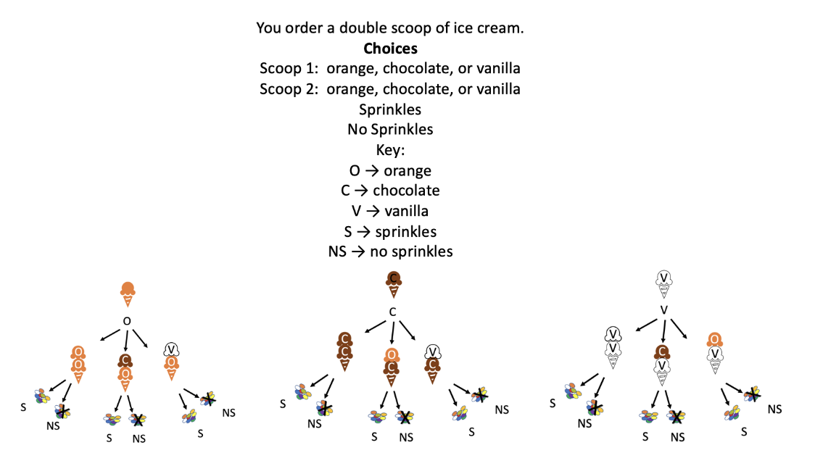

###### Skills in Practice

While the five process goals are expected to be embedded in each standard, the Skills in Practice highlight the most prevalent process goals in relation to the content presented.

**Mathematical Problem Solving:** Opportunities to describe the degree of likelihood of an event occurring in informal terms (e.g., impossible, unlikely, equally likely, likely, certain) should be given. Activities should include contextual examples. For example –

* + Ask students to find partners. Using the think-pair-share strategy, brainstorm a list of situations that involve probability. List these ideas on the board, and if the context allows, list the probability it will happen. For instance, if all of the students’ names were put into a hat, what is the probability the name will begin with a consonant? A vowel? Use words like *impossible, unlikely, equally likely, likely,* and *certain*. Emphasize that the chance or likelihood of an event occurring can range from zero (impossible) to 1 (certain).
  + Draw a number line on the board with the numbers 0 and 1. Draw a tic mark in the middle of the line. Under 0, write “impossible.” Under 1, write “certain.” In the middle, write “equally likely” and the fraction $\frac{1}{2}$. Between 0 and the middle, write “unlikely.” Between the middle and 1, write “likely.”

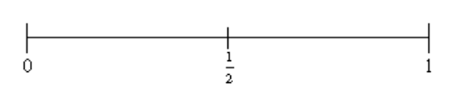

An unlikely event would have a probability between 0 and $\frac{1}{2}$. A likely event would have a probability between $\frac{1}{2}$ and 1. Provide students with scenarios to help them to determine the likelihood of an event such as –

* + - Chris rolls a fair dice and gets an even number.
    - Valentine’s Day is in the next twelve months.
    - Lamont picks a card from a normal deck of cards and gets an ace.
    - It will snow at the North Pole during the month of January.
* An important aspect of probability is the ability to determine the total number of possible outcomes when multiple events are considered. The Fundamental Counting Principle is a way of finding how many possibilities can exist when combining choices, objects, or results. This is done by multiplying each total choice count from each group being combined. For example, Mark is planning a vacation and can choose from 15 different hotels, 6 different rental cars, and 8 different flights. How many combinations of hotels, cars, and flights can he choose?

Total = 15 × 6 × 8

Total = 720 combinations

* **Students should understand the difference between an event and a sample space. An event is a set of outcomes during an experiment, while a sample space is all of the possibilities that can occur during the experiment. Therefore, an event is a subset of a sample space. Examples follow –**

**The occurrence of a head when a coin is flipped:** The occurrence of a head when a coin is flipped is only once. It can either show heads or tails. Event, E = {occurrence of head}; Sample space, S = {occurrence of head, occurrence of tail}

**The occurrence of 1 when a dice is rolled:** The occurrence of 1 when a die is rolled is only once. It can show 1, 2, 3, 4, 5, or 6. Event, E = {occurrence of 1}; Sample space, S = {occurrence of 1, occurrence of 2, occurrence of 3, occurrence of 4, occurrence of 5, occurrence of 6}.

**Categorizing events and sample spaces:** Max needs to categorize the following responses as events and sample spaces. How can these be sorted?

Image. Determine the difference between an event and a sample space. Events are in the left column and sample spaces are in the right column. Scenarios presented as:
Rolling a dice and getting 4. 
Tossing a coin can either result in a head or a tail. 
Rolling a dice can result in 1, 2, 3, 4, 5, or 6. 
Tossing a coin and getting a head. 

**Mathematical Representations:** The probability of an event can be represented using a tree diagram, list, or chart. An example with common misconceptions follows –

An ice cream shop offers the choices of a cup or a cone; vanilla, chocolate, or strawberry ice cream; and sprinkles, whipped cream, or hot fudge toppings. There must be one of each choice (e.g., whipped cream and hot fudge cannot be selected).

* **List or chart:** *Make a list or chart of the possible choices offered by the ice cream shop*. A student may miss some possibilities by only listing the combinations with either the cup or cone or just select one flavor and topping for each. A student may double count some of choices if they are not systematic in making the list.

* **Tree diagram:** *Create a tree diagram of the possible ice cream choices.* A student may create a separate tree for each possibility, rather than one tree branching out to each choice.

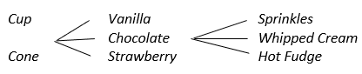

A student may also have their branches coming from the middle of a choice instead of each one. Students should be encouraged to check that each choice should have branches extending from it to show the next set of possible outcomes. It may also be beneficial for students to say each possible selection as they are creating the tree diagram to help make sense of it.

* **Probability of an event:** *What is the probability of a customer choosing a cup of vanilla ice cream with sprinkles?* This is the most specific probability with just one option out of 18 total options. A student may miss one or more parts of it. They may only look at sprinkles and count each with sprinkles. Students can be shown a strategy such as highlighting, underlining, or circling each of the choices mentioned in the question and then also in the list or tree diagram.
* **Fundamental Counting Principle:** *Use the Fundamental Counting Principle to prove all possible outcomes have been found.* A student may only multiply two of the three numbers involved. They may also add the numbers of choices instead of multiplying. This error indicates that the student may not have conceptualized the Fundamental Counting Principle. One method is to have students write the number the choices under each section of the tree so they can visualize the connection between 2 × 3 × 3 and the tree diagram. They can also number the combinations at the end of the branches to check their work.

###### Concepts and Connections

Concepts

The world can be investigated through posing questions and collecting, representing, analyzing, and interpreting data to describe and predict events and real-world phenomena.

Connections

* *Within the grade level/course*:
  + 5.PS.1 – The student will apply the data cycle (formulate questions; collect or acquire data; organize and represent data; and analyze data and communicate results) with a focus on line­­ plots (dot plots) and stem-and-leaf plots*.*
  + 5.PS.2 – The student will solve contextual problems using measures of center and the range.
* *Vertical Progression*:
  + 4.PS.2 – The student will model and determine the probability of an outcome of a simple event.
  + 7.PS.1 – The student will use statistical investigation to determine the probability of an event and investigate and describe the difference between the experimental and theoretical probability.

Across Content Areas

Reference 5.PS.1.

* *Digital Learning Integration:*
  + 3-5 CT.A. With guidance from an educator, students create, identify, explore, and solve problems by selecting technology-assisted methods such as data analysis, modeling, and algorithmic thinking.

###### Resources to Support Local Curriculum

* A list of approved textbooks and instructional materials is posted on the VDOE [website](https://www.doe.virginia.gov/teaching-learning-assessment/k-12-standards-instruction/mathematics/2024-mathematics-textbooks).

## Patterns, Functions, and Algebra

In K-12 mathematics, the patterns, functions, and algebra strand focuses on the recognition, description, and analysis of patterns, functions, and algebraic concepts. Students develop an understanding of mathematical relationships and represent these using symbols, tables, graphs, and rules. In later grades, students use models as they solve equations and inequalities and develop an understanding of functions. This strand is designed to develop students’ algebraic thinking and problem-solving skills, laying the foundation for more advanced mathematical concepts.

In Grade 5, students learn relationships can be described and generalizations can be made using patterns and relations. At this grade level, students identify, describe, extend, and create increasing and decreasing patterns with whole numbers, fractions, and decimals using various representations; and investigate and use variables in contextual problems.

### 5.PFA.1

##### The student will identify, describe, extend, and create increasing and decreasing patterns with whole numbers, fractions, and decimals, including those in context, using various representations.

1. Students will demonstrate the following Knowledge and Skills:
2. Identify, describe, extend, and create increasing and decreasing patterns using various representations (e.g., objects, pictures, numbers, number lines, input/output tables, function machines).
3. Analyze an increasing or decreasing single-operation numerical pattern found in lists, input/output tables, and function machines, and generalize the change to identify the rule, extend the pattern, or identify missing terms. (Patterns will be limited to addition, subtraction, multiplication, and division of whole numbers; addition and subtraction of fractions with like denominators of 12 or less; and addition and subtraction of decimals expressed in tenths or hundredths).
4. Solve contextual problems that involve identifying, describing, and extending increasing and decreasing patterns using single-operation input and output rules (limited to addition, subtraction, multiplication, and division of whole numbers; addition and subtraction of fractions with like denominators of 12 or less; and addition and subtraction of decimals expressed in tenths or hundredths).

###### Understanding the Standard

* The ability to recognize, interpret, and generalize patterns supports understanding of many mathematical concepts. Primary grades develop the knowledge and skills to recognize regularity in a sequence of numbers or shapes found in repeating patterns. In Grade 3, students engaged with sequences of numbers or shapes to recognize and describe growing patterns. In Grade 4, students applied generalizations to extend patterns and find missing terms. In Grade 5, students are expected to describe “rules” for patterns and use this to find missing terms.
* Students should have opportunities to explore increasing and decreasing growing patterns using concrete materials and calculators. Calculators are valuable tools for generating and analyzing patterns. The emphasis is not on computation but on identifying and describing patterns.
* Patterns at this level may include addition, subtraction, multiplication, and division of whole numbers; addition or subtraction of fractions (with like denominators 12 or less); or addition and subtraction of decimals expressed in tenths or hundredths. Several sample numerical patterns are included below:
  + 1, 2, 4, 7, 11, 16, …
  + 2, 4, 8, 16, 32, …
  + 32, 30, 28, 26, 24, …
  + $\frac{1}{4 }$, $\frac{3}{4}$, 1 $\frac{1}{4}$, 1 $\frac{3}{4}$…
  + 0.25, 0.50, 0.75, 1.00, …
* Generalizing patterns to identify rules and apply rules to solve problems builds the foundation for functional thinking. Sample input/output tables that require determination of the rule and missing terms can be found below.

|  |  |  |  |  |
| --- | --- | --- | --- | --- |
| **Rule: ?** | |  | **Rule: ?** | |
| Input | Output | Input | Output |
| 4 | 8 | 20 | 4 |
| 5 | ? | 15 | 3 |
| 6 | 12 | ? | 1 |
| ? | 20 | 25 | 5 |

* Teachers may make a connection to SOL 5.PFA.2 and have students state the rule of an input/output table as a verbal expression.
* A verbal expression involving one operation can be represented by a variable expression that describes the relationship. Numbers are used when they are known; variables are used when the numbers are unknown. The example in the table below defines the relationship between the input number (*x*) and output number (*y*) as *x* + 3. Students may orally describe the pattern below as “plus three” or “given any number, *x*, add three.”

|  |  |
| --- | --- |
| ***x*** | ***y*** |
| 6 | 9 |
| 7 | 10 |
| 11 | 14 |
| 15 | 18 |

###### Skills in Practice

While the five process goals are expected to be embedded in each standard, the Skills in Practice highlight the most prevalent process goals in relation to the content presented.

**Mathematical Reasoning and Connections:** In Grade 3, students engaged with sequences of numbers or shapes to recognize and describe growing patterns. In Grade 4, students applied generalizations to extend patterns and find missing terms. In Grade 5, students are expected to describe “rules” for patterns and use this to find missing terms. Learning to look for patterns and how to describe, translate, and extend them is a part of thinking algebraically. Besides extending patterns using materials or drawing, students should translate patterns from one representation to another. For example, a pattern made with triangles and circles can be translated into one involving red and yellow counters and then translated into numerals. From the pictorial representation, a rule about the pattern can then be developed.

* Students not only extend patterns, but also look for a generalization or algebraic relationship that will tell them what the pattern will be at any point along the way. Growing patterns also demonstrate the concept of function and can be used as an entry point to this mathematical idea. Building the patterns with tiles, counters, or blocks help students conceptualize this understanding. Growing patterns also have a numeric component – the number of objects in each step. When discussing a pattern, students should try to determine how each step in the pattern differs from the preceding step. The focus of the discussion should be how to operate on the value of the current step to get to the next step. Examples should encourage students to use both additive and multiplicative strategies.
* Analyzing patterns should include progression of reasoning by looking a visual, then numerical relationships, and then extending to a larger (*n*th) case. An example of extending a number pattern and writing a rule for the pattern is shown below –

The first six numbers of a number pattern are shown.

5, 8, 11, 14, 17, 20…

The pattern continues by adding the same number each time.

* What is the next number in the pattern?
* Write a rule that can be used to find any number in the pattern, after the first number.
* Examples aligned to this standard with common misconceptions follow –
* What is the rule when given, $\frac{1}{8}, \frac{3}{8}, \frac{5}{8}, \frac{7}{8}, …$? What are the next two numbers in the pattern? Create a pattern that follows the same rule.

Some students may have trouble determining the rule and the next two numbers in the pattern because they struggle to understand that a fractional partis added each time. Patterns with fractions require students to apply what they know about patterns and connect that knowledge to what they know about adding, subtracting, and simplifying fractions, as well as improper fractions and mixed numbers. Extending the pattern results in fractions that are greater than one whole. This may be a concept that needs further exploration if students have difficulty determining the next numbers in the sequence.

Students may have difficulty creating a pattern of their own that follows the same rule due to their lack of understanding of unit fractions. For example, they may create a pattern similar to the following:

$$\frac{1}{4}, \frac{3}{4}, \frac{5}{4}, \frac{7}{4}, …$$

Students may have a misconception that the denominator must stay the same and the numerator must follow the pattern of 1, 3, 5, 7…etc. Fraction manipulatives and focusing on the operation between each fraction would be beneficial. Revisiting determining the rule for patterns with whole numbers may be necessary.

Student may make the connection between $\frac{2}{8}$ simplified as $\frac{1}{4}$. The understanding that fractions can be simplified could lead to additional errors if students do not simplify correctly or confusion if students do not have a solid understanding of fractional operations. Strategic sharing and discussion of student-created patterns facilitated by the teacher could provide opportunities for these building connections.

* A number machine uses a rule to change input numbers to output numbers. The table shows the results. What is the rule? Based on this rule, what is the missing number in the table?

| **Input** | **Output** |
| --- | --- |
| 8.0 | 7.5 |
| 5.5 | 5.0 |
| ? | 3.5 |
| 2.0 | 1.5 |

Students may incorrectly find a relationship between 8.0 and 5.5 – they may think they need to subtract 2.5 each time and not look at the relationship between input and output numbers. Students may also determine the rule as subtracting 0.5 but incorrectly determine the missing number to be 4.0 because they disregard the fact that they are determining the input, not output. Shifting their thinking to working backwards, knowing the rule is subtract 0.5, but that to find the missing number 0.5 must be added, may be difficult for students.

* The figures below form a pattern. The pattern continues in the same way. How many squares are needed to make Figure 7?

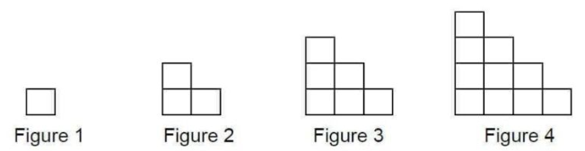

Students may have difficulty making the connection to what they know about patterns and applying that understanding to objects in a graphic. Because the question does not explicitly ask students to determine the rule, students may try to skip this step. It may be beneficial to break this problem down into a series of steps. Teachers may consider modeling how to show thinking on paper while solving, first determining how many squares are in each figure and then determining how many squares are being added between Figure 1 and Figure 2, Figure 2 and Figure 3, Figure 3 and Figure 4. A common error is for students to incorrectly find the number of squares in Figure 5 or Figure 6, rather than the number of squares in Figure 7.

Students may also benefit from using manipulatives such as centimeter cubes or color tiles. Have students build Figure 1 and physically add the squares to the figure using manipulatives. Have students draw each figure as they build it, making note of how many squares are added each time. Another option would be to have students color code the squares for each figure in the next figure so they can visually see the changes happening each time. Transferring the numbers into an input/output table would help students make connections to previous work with patterns and provide them with an additional strategy to use when working with patterns containing objects in the future.

###### Concepts and Connections

Concepts

Relationships can be described, and generalizations can be made using patterns and relations.

Connections

* *Within the grade level/course*:
  + 5.PFA.2 – The student will investigate and use variables in contextual problems.
* *Vertical Progression*:
  + 4.PFA.1 – The student will identify, describe, extend, and create increasing and decreasing patterns (limited to addition, subtraction, and multiplication of whole numbers), including those in context, using various representations.
  + There are no standards about patterns in subsequent grade levels, although knowledge of patterns and algebraic thinking will be used beyond Grade 5.

Across Content Areas [Theme – Numbers, Number Sense, and Patterns]

* *Science*:
  + 5.8e – The student will identify evidence from patterns in rock formations and fossils in rock layers to support an explanation for changes in a landscape over time.
* Computer Science:
  + 5.AP.1 – The student will apply computational thinking to identify patterns, make use of decomposition to break down problems or processes into sub-components, and design algorithms (a) identify patterns and repeated steps in an algorithm, problem, or process; and (b) decompose a problem or process into a subset of smaller problems or groups of sequential instructions.

###### Resources to Support Local Curriculum

* A list of approved textbooks and instructional materials is posted on the VDOE [website](https://www.doe.virginia.gov/teaching-learning-assessment/k-12-standards-instruction/mathematics/2024-mathematics-textbooks).

### 5.PFA.2

##### The student will investigate and use variables in contextual problems.

1. Students will demonstrate the following Knowledge and Skills:
2. Describe the concept of a variable (presented as a box, letter, or other symbol) as a representation of an unknown quantity.
3. Write an equation (with a single variable that represents an unknown quantity and one operation) from a contextual situation, using addition, subtraction, multiplication, or division.
4. Use an expression with a variable to represent a given verbal expression involving one operation (e.g., “5 more than a number” can be represented by *y* + 5).
5. Create and write a word problem to match a given equation with a single variable and one operation.

###### Understanding the Standard

* An equation is a statement that represents the relationship between two expressions of equal value using variables, numbers, and operation symbols, and an equal sign symbol.
* An expression is a representation of a quantity. It is made up of numbers, variables, and/or computational symbols. It does not have an equal symbol (e.g., 8, 15 × 12).
* A variable is a symbol that can stand for an unknown number (e.g., *a* + 4 = 6) or for a quantity that changes (e.g., the rule or generalization for the pattern for an input/output table such as *x* + 2 = *y*).
* A relationship with two unknown values will have more than one variable used for the unknown values that make a true statement (e.g., the rule or generalization for the pattern for an input/output table such as *x* + 3 = *y*). In this situation there will be more than one replacement for *x* and *y* to make the statement true. For example, if *x* is replaced with 8, then *y* must be replaced with 11. If *x* is replaced with 24, then *y* must be replaced with 27.
* An equation may contain a variable and an equal symbol (=). For example, the sentence, “A full box of cookies and four extra equal 24 cookies,” can be written as *b* + 4 = 24, where *b* stands for the number of cookies in one full box. The sentence, “Three full boxes of cookies contain a total of 60 cookies,” can be written as 3*b* = 60.
* Another example of an equation is *b* + 3 = 23. This equation could be used to represent the contextual situation, “How many cookies are in a box if the box plus three more equals 23 cookies?” where *b* stands for the number of cookies in the box.
* By using story problems and numerical sentences, students begin to explore forming equations and representing quantities using variables.
* An equation containing a variable is neither true nor false until the variable is replaced with a number and the value of the expressions on both sides are compared and are equal.
* Teachers should consider varying the letters used (in addition to *x*) to represent variables.
* The symbol • is sometimes used to represent multiplication and can be confused with the variable *x.* In addition to varying the use of letters as variables, this confusion can be minimized by using other mathematics conventions for showing multiplication (e.g., 4(*x*) = 20 or 4*x* = 20 in addition to 4 • *x* = 20).

###### Skills in Practice

While the five process goals are expected to be embedded in each standard, the Skills in Practice highlight the most prevalent process goals in relation to the content presented.

**Mathematical Problem Solving:** As students write equations (with a single variable that represents an unknown quantity and one operation) from a contextual situation, using the four basic operations or creating and writing word problems to match a given situation, students may have trouble setting up the equation. Some students may need to use a box or a line for the unknown number first and then replace it with a variable. The use of manipulatives to set the problem can be used as a tool to determine what is occurring within the problem. A graphic organizer such as the one below would also be beneficial.

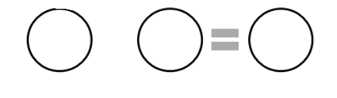

Because stories can utilize a variety of equality and expression structures, consider graphic organizers that accommodate for these structures. Equation mats are helpful graphic organizers because the total/parts can go on either side of the mat.

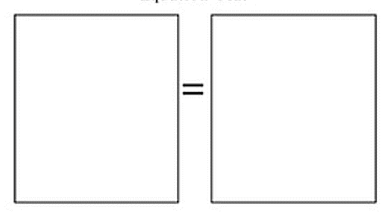

A more concrete model that could be used to set up an equation would be a balance scale, shown below. Consider what the student would use for variables and what they would use for constants.

*A model of a balance scale.*

**Mathematical Communication:**

* In open sentence explorations, the is a precursor of a variable used as an unknown or missing value. At this grade level, open boxes, as well as letters can be used in open sentences or missing value problems; therefore, beginning with boxes and then transitioning to variables helps to make this connection explicit while communicating students’ understanding of this standard.
* Context can help students develop meaning for variables. Many story problems involve situations in which the variable is a specific unknown, as in the following example –

Steph ate 5 oranges and Lesley ate some too. The container of 12 oranges was gone. How many did Lesley eat?

Although students could solve this problem using mental math and not algebra, they can begin to learn about variables by expressing this problem in symbols, 5 + = 12 🡪 5 + *n* = 12, where the *n* represents the oranges that Lesley ate.

**Shift language:** Begin to shift language. Rather than asking students, *“What number goes in the box?”* ask, *“What number could the letter be to make the number sentence true?”*

**Avoid letter association:** Avoid using the first letter of the word as a variable in problems (e.g., using *o* for oranges instead of *n*). A common error is that many students confuse those “first letter in a word” variables with shortened versions of the word (more like a label) instead of thinking of the variable as a quantity.

* Pose prompting questions to help students explain how they represented the concepts and/or procedures. As students become more comfortable using representations, routinely ask them to use the representations to explain their solution approach. This helps reinforce the mathematics not only for the student explaining their thinking, but also for the students who are listening to the explanation the student is giving.

**Mathematical Representations:** Provide ample and meaningful opportunities for students to use representations of variables, expressions, and equations, to help solidify the use of representations as “thinking tools.” Students need many opportunities to work with representations before they will successfully use them to model concepts and procedures, solve problems, and use standard algorithms. Over time, students will begin to understand mathematics concepts and grasp how representations more deeply can be used as “thinking tools,” which are tools used to model and solve problems.

* Representations can be used when students explain their thinking. At first, students may need help articulating how they used the representations to depict the mathematical concepts as they transition to the algebraic representation. The following example provides context in action –

Michael mows lawns in his town. He earns $10.00 per yard that he mows. Last week he earned $160.00. Explain what *x* means in the equation 10*x* = $160.

* Students may not know what a variable is or understand the concept of a variable. Students will benefit from exposure to practice problems in which there is an unknown value and from questions on how or what can be used to represent the unknown value. A student may identify “*x*” as multiplication in the equation, rather than as a variable. This may indicate that a student does not understand that “*x*” represents the number of lawns mowed. In addition, a student may not understand what implied operation occurs when a variable directly follows a quantity.
* Students will benefit from exposure to practice problems in which there is a quantity followed by a variable. Question the student on how or what can be used to represent the unknown value. Students should have experiences that focus on the use of variables in different ways. First, variables as *unknown values*, such as in an equation. Alternatively, in an *expression*, the variable represents a quantity that can change. If students are struggling with describing the purpose and meaning of a variable, have students look at contextual problems that show variables representing different quantities. Ask students, *“How are the following problems the same? How are they different? What is the variable and what does it represent?”*
  + Olivia gave 10 brownies to her sister. Then she gave more to her mom. All 23 brownies are gone. How many brownies, *b*, did Olivia give to her mom (10 + *b* = 23)?
  + Olivia gave 10 brownies to her sister. Then she gave more to her mom. How many brownies did Olivia give to her mom and her sister (10 + *b*)? How many total brownies could there have been?

Problems can also be accompanied by representations, such as number lines, to help students make sense of where the variable is in the story problem and its meaning as the algebraic algorithm is established. For example, ask students, *“Is the variable an exact value or can it change? Can it be any number? Can you think of a number it cannot be? How do you know?”*

###### Concepts and Connections

Concepts

Relationships can be described, and generalizations can be made using patterns and relations.

Connections

* *Within the grade level/course*:
  + 5.PFA.1 – The student will identify, describe, extend, and create increasing and decreasing patterns with whole numbers, fractions, and decimals, including those in context, using various representations.
* *Vertical Progression*:
  + There are no formal standards that address variables prior to Grade 5.
  + 6.PFA.3a – Identify and develop examples of the following algebraic vocabulary: equation, variable, expression, term, and coefficient.

Across Content Areas

Reference 5.PFA.1.

###### Resources to Support Local Curriculum

* A list of approved textbooks and instructional materials is posted on the VDOE [website](https://www.doe.virginia.gov/teaching-learning-assessment/k-12-standards-instruction/mathematics/2024-mathematics-textbooks).